MID-TERM REVIEW SWIOFish1 PROJECT
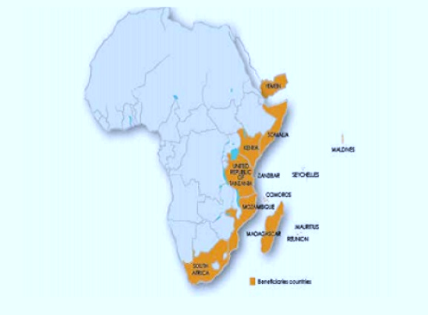
Regional Project Coordinator
Indian Ocean Commission
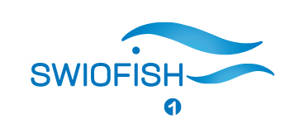
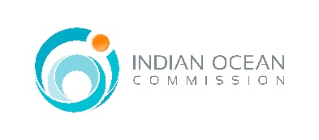
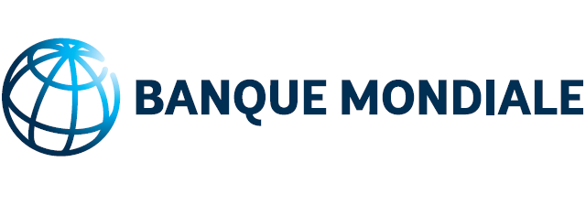



Implementing Agency – Indian Ocean Commission
Service : DI3 – Center for blue and green regional growth, development & economic specialization.

Reporting period : This report covers the activities of the Grant Funds for the period from 8th May 2015 to 30th April 2018.

- Executive Summary

- Achievements
- SWIOFC has been strengthened under SWIOFish1 with a regional IDA grant. This grant is not only funding all the activities of the commission inclusive its operation costs (except the salary of the FAO staff) but also its Statutory bodies of the Commission, namely the SWIOFC Scientific Committee and the Working Party for Coordination and Cooperation in Tuna Fisheries.
- A much increased and more effective workplan and capacity to support the member countries – This was due to the support to fund meetings and most of workplan activities of the SWIOFC – particularly important is the link between country level support and the regional activities of the SWIOFC- but also by the direct support to the activities of the Secretariat, that allowed it to be more effective.
- SWIOFish1 project has been successful in its networking in establishing partnerships with other ongoing projects, RFMOs and RECs in the region. Increased capacity of member countries to participate in the regional activities led by SWIOFC . Increased capacity of the SWIOFC to respond to requests of specific initiatives by its members in a reasonable time-frame.
- Flexibility in the implementation approach enabling new activities to be incorporated in the project to adapt to changing circumstances and needs as requested by the WPCCTF and the Commission.
- SWIOFish1 project has been instrumental in building a regional cooperation mechanism for effective networking with a view to ascertaining a regional identity.
- SWIOFish1 has in partnership with IOC PRSP (Smartfish) been on the forefront of combatting IUU fishing in the IOC and East African waters bringing three SWIOFC members, namely Mozambique, Kenya and Tanzania on board of this operation. In the same vein SWIOFish1 has assisted in the capacity building of SWIOFC inspectors and observers to be part of the MCS activities as well as being part of the Scientific Observer Scheme.
- The Journal workshop held from 17-19 February 2018 in Seychelles was an amazing event whereby SWIOFC Members and Journalists of the region were exposed to fact-based reporting on various issues and programs cross cutting the fisheries sector at large. The workshop effectively served as an essential exercise in building awareness as well as informing the public at large on how to promote the sustainable development of the regional fisheries resources.
- The film on Fisheries and Aquaculture on Best Practices and lessons Learned in the SWIO region sponsored jointly by SWIOFish1/ World Bank and IOC/ European Union showcased a plethora of such remarkable, but unpublicised initiatives at the grass root level that need to be vented, adapted or replicated on a wider scale through an effective regional cooperation and networking. This film was well received and subsequently posted on YouTube for a wider circulation.
- The development of an MTC guidelines represents a multi-partite effort, bringing together governmental, inter-governmental and non-governmental actors in the drive to define what conditions, or common standards, should apply to foreign fleets seeking access to the SWIO region’s tuna resources – agreeing to work together, and to build on each other’s work and initiatives.
- The financial support of SWIOFish1 to SWIOFC members for preparing proposals for IOTC commission meeting and as well support for implementation and compliance of IOTC resolutions is an indication of the readiness of Members in addressing the sustainability driven issues of IOTC in respect of its core tuna species. The voice of the SWIOFC at IOTC has now its weight and SWIOFC Members are playing a more active role in the activities of the commission.
- The Trade and Development Forum sponsored by SWIOFish1 and SmartFish was another success story that has helped to promote fish and seafood value chains and market development in the participating countries of the Eastern Southern Africa-Indian Ocean (ESA-IO)region.
- A regional Fisheries Ministers Conference was convened to take stock of the achievements as well as the prospects and challenges ahead of IOC-PRSP in partnership with the SWIOFish1 in their crusade to combat IUU fishing in all its forms in the industrial tuna fisheries of the SWIO.
- A Ministerial Declaration, renewed the mandate for the IOC-PRSP and the strengthening of trust/bond between the participating countries, including the three East African Countries of SWIOFC, to combat IUU fishing in the industrial tuna fisheries in the SWIO region.
- Improving data collection management and statistics, and human capacity for fisheries research and management, which in turn has improved the quality of information/ reporting and the level and quality of participation in the activities of the Scientific Committee.

- Challenges
- Significant challenges to accommodate all SWIOFC members on board due to the prevailing conflict in Yemen and at times accommodating Somalia also poses problem due to visa issue.
- Procurement issues (difficulty of the procurement section in acceding on STEP, timely availability of consultants, shortlisted consultants do not respond to expression of interests for consultancy, unavailability of goods and services as per specifications) have been detrimental to the implementation of the project as per established time frame. (Please refer to Annex 3 : Procurement Status for further information)
- Staffing of the SWIOFC Secretariat has been slow. Some constraints still exist.The first is the fact that the SWIOFish1 coordinator is not in place in the SWIOFC headquarters, as was originally planned. Another is the interim situation of the SWIOFC Secretary, whose time is being covered by the Subregional Office for Southern Africa and also with the support of the Technical Secretary of the SWIOFC.
- At least some members should be committing towards the establishment of a Trust fund for the SWIOFC, and should be encouraged to do so again in the next Session. The main challenge in this is the difference of levels of capacity, resources available and also political will to do this; that the different members have.
- It is important for the work linked to the Commission to remain and be more active in support to policy and management of Small Scale Fisheries in the SWIO, at regional and in particular at country level.
- The SWIOFish1 project had undergone changes in the list of activities since its inception. Most of the SWIOFC activities had no budget at all and the Commission decided that these activities be funded by the SWIOFish1 project.
- These new activities were not forseen at the preparation phase. Yet we had to implement them as they are approved by the Members at the Commission meeting. Besides in the light of support needed to fast track the activities icw the Minimum Terms and Conditions (MTC) for fisheries access in the SWOFC area of competence and the SWIOFish1 Framework agreement necessitated the setting up of an MTC TaskForce and the SWIOFish1 project has to incorporate this taskforce in the budget. (Please refer to Annex 4.5 &SWIOFish1 Regional Budget)
- This explained the challenges we have had as at date in the project and most of our budget had consequently been subject to substantial cost overruns. (Please refer to Annex 4 and 5 for further clarifications).

- Future results
- The objectives set in the First South West Indian Ocean Fisheries Governance and Shared Economic Growth will be materialized as conceived in the project design. The Project Development Objectives through relevant indicators would amply demostrate the outputs of the project.
- The MTC guidelines (may be reshaped into Protocol), the SWIOFish1 Framework Agreement, the number of bilateral and multilateral agreements on fisheries, the national and regional observers, the regional cooperation mechanism, the regional financing mechanism, the aerial and sea patrol surveillance in collaboration with the forthcoming Ecofish and the regional investment strategy, are expected project outputs and achievements of some of them are within the reach of the beneficiaries.

- Modifications
There is very little likehood of modifications in the activities of the SWIOFish1 project. As pointed out earlier all SWIOFish1 activities not initially earmarked in the project have already been incorporated. However there may be exceptional requests from the SWIOFC Scientific Committee in case of need and this need has to be justified and approved by the SWIOFish1 Steering Committee and the Commission. It must be noted that as from year 4 onward SWIOFish1 would implement a series of consultancies icw the strategy to maximize regional benefits with focus on regional investment, trade issues, wealth creation, fisheries industry transparency, code of conduct for responsible tuna fisheries besides the ongoing consultancy on GDP & Wealth generated in the SWIOFC region and the Scoping Socio Economic Indicators of IOTC fisheries ( partial funding from SWIOFish1 project). There may also be inclusion of certain specific activities once the ECOFish project is on track as its core focus would be on sustainability of the MCS activities,namely the Scientific Observer Program and the continued sea / aerial patrol surveillance in tracking down IUU fishing in the SWIO area. All these activities are in alignment with the governance issue which is inbuilt in the SWIOFish1 project.

- Lessons Learnt
- The key lessons learnt is that the project design matches the needs and requirement of the SWIOFC Region. Flexibility in approach regarding incorporation of new activities has served its purpose so far as the SWIOFish1 governance and shared growth project does across other ongoing projects in the region. Thus the rationale behind the push towards the regional mechanism with a view to avoiding duplication of resources in the implemention of similar activities by other relevant RECS and RFMOs and NGOs. This objectives set are realistic and the outputs will only be tangible when reaching year 5 of the project implementation.
- However the prospect for sustainability of this project upon its completion by the beneficiaries is one of of the most fundamental question as till date the SWIOFC members have not been responsive to support the creation of a Trust Fund. FAO cannot support financially SWIOFC except its staffs costs.
- Hence it is recommended that SWIOFC members ensure a minimum contribution to the Trust Fund as such move will trigger donor institutions to contribute further being given that that is gesture from SWIOFC members would indicate to the International Community and Financial institutions the willingness of SWIOFC Members for ownership of the project where the sustainability driven issue and shared economic growth are of high pertinence to the socioeconomic development of their coastal fishermen communities and their fisheries sector at large.
- More focus on the intersessional activities and less pressure for organizing meetings - to spend budget of the project. Although the Commission may be well placed to evolve into a management body, as long as it is an ARtVI, the Scientific Committee and Session may only be required biennially. This would also mean that more outputs can be achieved with less money spent.
- This means that SWIOFish1 could focus a bit more on supporting the actual delivery of work of regional importance in the member countries, thus increasing the efficiency of the work of the SWIOFC.

- Introduction to SWIOFish project
Project Background
Given the important achievements of the South West Indian Ocean Fisheries Project, (SWIOFP), the member countries of the SWIOFC have requested support from World Bank for a follow-on operation, which would continue to support regional integration around fisheries management, while expanding the approach beyond research to strengthen sector governance and promote shared growth through harnessing the value of coastal and marine fisheries to regional economies.
The First Southwest Indian Ocean Fisheries governance and Shared Growth Project (SWIOFish1) Global Environmental Facility Grant agreement between the Indian Ocean Commission (on behalf of the participating countries) and the International Bank for Reconstruction and Development (on behalf of GEF) was signed on May 8, 2015 and became effective on December 18, 2015. The project is intended to run for six years, with a closing date in the grant agreement specified as September 30, 2021.
The Project is part of a Series of Projects, under the SWIOFish Program, with the overarching objective of increasing the economic, social, and environmental benefits to SWIO countries from sustainable marine fisheries.
The following countries are participating in the SWIOFish1 project: Comoros, France (by virtue of its outermost regions- Reunion in the region), Kenya, Madagascar, Maldives, Mauritius, Mozambique, Seychelles, Somalia, South Africa, Tanzania and Yemen. All these countries are party to the South West Indian Ocean Fisheries Commission(SWIOFC).
Project Development and Global Objective:
The Project Development Objective is to improve the management effectiveness of selected priority fisheries at regional, national and community level.
Specific Objectives:
The specific objectives of the first project (SWIOFish1) is to improve the management effectiveness of selected priority fisheries at regional, national and community level, through
(i) consolidating and strengthening regional cooperation on fisheries and marine resource management among the country members of the SWIOFC and strengthening the capacity for fisheries’ economic governance;
(ii) harnessing fisheries to regional economy starting with Comoros, Mozambique and Tanzania. The primary country-level targets for the first phase are (a) the economic management of the most economically important fisheries, (b) co-management of the small-scale fisheries and (c) planning and/or implementing critical hard and soft infrastructure investments to increase contribution of fisheries to national economies. The project will build the capacity and leadership required.

Project Beneficiaries :
- The main Project beneficiaries are the SWIOFC Secretariat, the SWIOFC Members and by extensio the coastal fishing communities of the SWIO region and in the island countries where fish is a vital component of a food security basket.
- Regional and national institutions in the fisheries sector and associated with the project benefit from improved capacity to formulate and analyze policy and to promote coordination as a result of project-financed institutional development activities.
Project Implementation
Progress towards the development objective is considered satisfactory. The implementation of the project activities is moving at a moderately reasonable pace. Total disbursement from the Bank to the IOC Designated Account was US$ 2,542,762.84 on 30th April 2018. It represents 51% of the grant. Total Project Expenditure is US$ 2,246,568.69 at 30th April 2018. This represents 44.93% of the grant. The procurement plan is being partially implemented.
Project Components
Component 1. Enhanced regional collaboration.
Activities in this component aim to enhance regional public goods, in particular to support the active participation of all countries in the SWIO region to fisheries management, data sharing and analyses, and collective regional decisions, including for the countries that do not have national investment yet.
Sub-component 1.1.1. Enhancing capacity for managing priority regional fisheries and challenges
Minimum Terms and Conditions (MTC) for fisheries access in EEZ of the South West Indian Ocean and MTC Task Force meeting - signature of guidelines in pipeline.
Seven technical meetings on the MTC funded jointly by SWIOFish1 and IOC Smart fish took place since the start of the SWIOFish1 project. WWF, IOC Smart Fish and SWIOFish1 each funded one consultancy on the relevant Articles of the MTC.
MTC guidelines were sent to FAO LEGN upon Bureau meeting held last year, 26-27 October 2017.
The FAO LEGN shared another version of the guidelines with SWIOFC Secretariat in March 2018.
The MTC guidelines are undergoing a final vetting by the FAO LEGN following last inputs from Members.
The MTC guidelines will be tabled for adoption at the next SWIOFC meeting in Cape Town once the WPCCTF meeting recommends same to the Commission.

SWIOFish1 Framework Agreement for Cooperation on Fisheries of Common Interest for the South West Indian Ocean region - ongoing
Two Consultancies were undertaken on the SWIOFish1 Framework Agreement for Cooperation on Fisheries of Common Interest for the SWIO region.
Consutancy No1- Processing with technical discussions on the SWIOFish1 Framework Agreement for the South West Indian Ocean countries and Fisheries Accord for shared fish stocks(African Union/WWF) under the common process and driven by SWIOFish1/SWIOFC (Funded by SWIOFish1)
Consutancy No2- Legal, Policy, Institutional and Budgetary implications of formulating, adopting and implementing a Regional Fisheries Cooperation and Coordination Agreement by the South West Indian Ocean Range States (Funded by WWF).
Regional training Course on the implementation of Ports State Measures to prevent, deter and Eliminate IUU fishing focusing on the monitoring of landings and transshipment – Completed
Support KMFRI in operationalizing the SWIOFP data base – on hold (decision at Commission meeting)
Workshop on best practices and lessons learnt / Journal Workshop - Completed
The journal workshop held from 17-19 February 2018 in Seychelles was an amazing event whereby SWIOFC Members and Journalists of the region were exposed to fact-based reporting on various issues and programs cross cutting the fisheries sector at large. The workshop effectively served as an essential exercise in building awareness as well as informing the public at large on how to promote the sustainable development of the regional fisheries resources.
A number of journalists from the South-West Indian Ocean region and the technical experts were exposed to media training on how to better report in the digital age and how to adopt solutions journalism in their reporting.
The essence of the training dispensed by the World Bank Communication Team was to ensure that Journalists better assimilate, comprehend and ultimately disseminate these types of scientific data and information correctly to the public at large in very simple language as the scientific terms used in the fisheries sector can be difficult for most people to grasp.
The workshop also underlined that Journalism must relay the successes to the consumer so that they understand that not only are management decisions made for their own interest but also in the interest of the future generation.”
The film on Fisheries and Aquaculture on Best Practices and lessons Learned in the SWIO region sponsored jointly by SWIOFish1/ World Bank and IOC/ European Union showcased a plethora of such remarkable, but unpublicised initiatives at the grass root level that need to be vented, adapted or replicated on a wider scale through an effective regional cooperation and networking. This film was well received and subsequently posted on you tube for a wider circulation.
This workshop was followed by a conference on ‘Financing Sustainable and Climate-Resilient Ocean Economy in Africa’ co-hosted by the World Bank and the Government of Seychelles. SWIOFish1 project funded the participation costs of Journalists and Directors of Fisheries not beneficiaries of National SWIOFish projects.
Regional support for implementation and compliance of IOTC resolutions – on going
SWIOFish1 assisted SWIOFC Members in the preparation of resolutions for IOTC meetings
At S21 meeting SWIOFC/SWIOFish1 tabled four proposals and two were adopted.
The core one being: Amendment to Res 16/01 on Yellowfin tuna.

The limitations of drifting FADS now stand at 350 active instrumented buoys per purse seiner compared to the outgoing 425 active instrumented buoys in Res16/01.
The supply Vessels is now 2 for 5 purse seiners compared to 1 supply for 2 purse seiners in Res 16/01. In short, the total number of supply vessels in 2016 by CPC on the IOTC active list shall not exceed half of the number of Purse seine vessels reported per CPC on the IOTC active list for the same year.

The CPC can register supply vessels up to end of 2017. No new supply vessels will be registered on the positive list of IOTC as from 2018.

Contribution of Fisheries to GDP and Wealth Generated in the SWIOFC Member States -Consultancy – Not implemented
Trade Events (in partnership with IOC SmartFish) - Completed
The main objective of the Trade and Development Forum was to promote fish and seafood value chains and market development in the participating countries of the Eastern Southern Africa-Indian Ocean (ESA-IO)region. This Trade Event provided a useful platform for all stakeholders of the fisheries industry to present their products and services and explore business opportunities with counterparts from the region. A total of 18 exhibitors from eight countries were represented in the event.

The conference was held on 15 and 16 March 2018. It was attended by 111 persons from 22 countries. Ten international speakers from 9 different countries made presentations on various topics with regards to the Small-scale fisheries, namely Small-scale fisheries and the blue economy, Economics of the small-scale value chain and climate change, Management, governance and MCS, Technology, modernisation and social innovation and Investment and Financing in Fisheries.

The trade and development forum must be considered a very successful event which created a lot of interest and discussion among the participants. While one would have wished for a broader selection of exhibitors, the ones present did represent various parts of the value chain and served as very useful and practical illustrations to the main themes of the conference.

Information on marketing and trade are of the greatest importance to the further development of the industry in the region, In fact,it has been observed that upgrading the region’s capacity on marketing, trade and market information would be crucial if the region’s industry is to develop and compete with the rest of the world.

Sub Component 1.1.2 Improving Regional Monitoring Control and Surveillance

Development of bilateral and multilateral protocols and procedures to combat illicit fisheries activities and support of enhanced and cost-effective MCS capacity – not implemented

Technical/legal/finacial studies to facilitate joint patrols – not implemented

Regional MCS directors meetings/ regional node of the International MCS Network - completed

Joint monitoring Control and Surveillance Patrols – Completed

The Regional Coordination Unit of the Smart Fish / PRSP in partnership with the Regional Implementation Unit of SWIOFish1 effected joint regional patrol (aerial/sea surveillance) as from early 2016 till the closure of the Smart Fish programme in April 2018. The indicators are listed below:

- Monitoring Control and Surveillance (in Partnership with EU SmartFish Programme

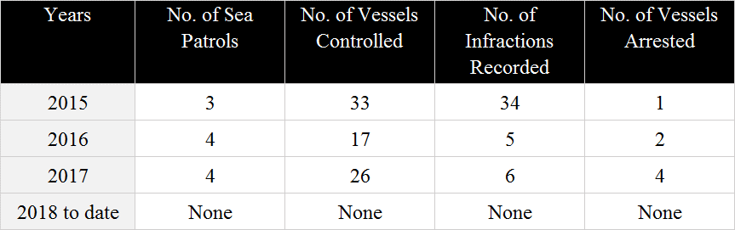

Note: Average sea patrol days 125.

It must be pointed out that the availability of patrol vessels for the SWIOFC region stands at a bare minimum of 3.

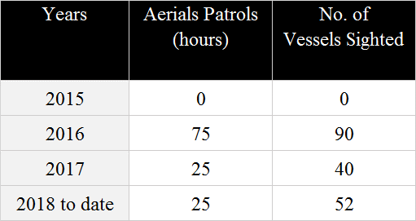

Note: Air patrol did not take place in 2015 due to unavailability of appropriate air craft.

Air surveillance activities have lessened due to unavailability of aircrafts.

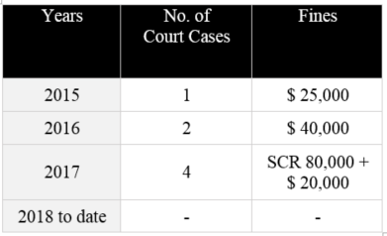

No. of Scientific Observers engaged on board of fishing vessels in the IOC waters and East African Waters

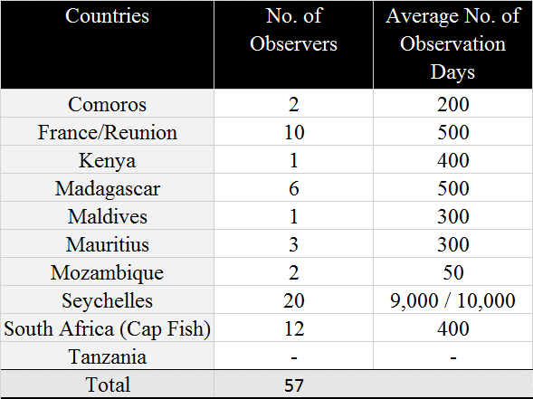

Observer mission have increased significantly since the 2014, mainly due to Seychelles developing their National Observer Programme (NOP) with a considerably large pool of observers deployed on their national vessels and other vessels through private agreements. Mauritius and the Comoros have also made positive contributions after establishing their NOP in 2015. Madagascar and France(Reunion) have been regular in deployment of observers on board their vessels over the last five years.

Meeting for Regional Observer Programme – not implemented

Regional Coordination Unit meeting - Completed

Fisheries Ministerial Conference << South-West Indian Ocean: United for a shared prosperity through the Blue Economy>>, 18 to 21 July 2017, Madagascar _ completed

A regional Fisheries Ministers Conference was convened to take stock of the achievements as well as the prospects and challenges ahead of IOC-PRSP in partnership with the SWIOFish1 in their crusade to combat IUU fishing in all its forms in the industrial tuna fisheries of the SWIO.
SWIOFIsh1 World Bank funded Project termed as “ First South West Indian Ocean Fisheries Governance and shared Growth Project” in the SWIO region highlighted on the avenues of cooperation with the EU IOC Smart fish in the joint Monitoring, Control and Surveillance activities underway in the IOC and East African Region. The facet of Regional Cooperation mechanism including SADC along with other RFMOs, and RECs also received due recognition under the umbrella of SWIOFish1 project.
The landed value of the total catch is estimated at US$ 1 Billion and approximately US$ 3 Billion at the consumer markets. The financial and economic impact of the industrial tune fisheries in the SWIO on the IOC member-states is roughly $ 500 million per year.
A Ministerial Declaration, renewed the mandate for the IOC-PRSP and the strengthening of trust/bond between the participating countries, including the three East African Countries of SWIOFC, to combat IUU fishing in the industrial tuna fisheries in the SWIO region.

Legal workshop for information exchange protocol in the SWIO region – not implemented
Meeting on Standard Operating Procedures – not implemented

Support initiative for increasing synergies on MCS within the region - nearing completion in Early September 2018.

Workshop for Eastern Africa, Southern Africa and Indian Ocean (EA-SA-IO) -SADC

Preparation of common policy positions for engagement with RECs, with regional RFMOs and in global for the region
A consultative workshop for the East Africa, Southern Africa and Indian Ocean (EA-SA-IO) was organized in collaboration with AU-IBAR and the Southern African Development Commission (SADC) Secretariat back-to-back with the 4th meeting of the SADC task force on Illegal, Unreported and Unregulated fishing. Among the key outcomes of the meeting, a roadmap/framework for regional cooperation on MCS for the EA-SA-IO region was agreed upon and priority areas for regional cooperation on MCS were developed It will eventually ensure a greater coherence between the various initiatives in the region and ultimately result in the merging of several processes (e.g., the SADC MCS center in Maputo and the PRSP achievement for the creation of Regional MCS center.
SWIOFish1 is already supporting the regional coordination mechanism approved by the SWIO countries, SWIOFC. At the request of its members, SWIOFC has been acting as a stable regional platform for any fisheries matters in SWIO region over the last 10 + years, involving SWIOFish, SADC, WWF, IOC and other important partners. The main role of the SWIOFC through the SWIOFish1 project in this aspect is precisely that of ensuring a continued coordination among multiple initiatives being carried out or planned for the region, promoting synergies and avoiding waste of resources and overlap.
SWIOFC should continue to be the main regional coordination platform for projects and other fisheries-related initiatives for SWIO area including SWIOFish1, since the project is set out to support members of the Commission and its work.
SWIOFC should contemplate to have an agreement with IOC/ SWIOFish1 to administer and implement at least some of its activities.

Special Assistance to Somalia on Legal and Institutional Development – not implemented . Still Awaiting response from Somalian Authorities.

  - Sustainable regional coordination

SWIOFC Session including RSC meetings (Annually)

Working Party on Collaboration and Cooperation on Tuna Fisheries – held twice a year but to be reduced to one due to budget limitation.

SWIOFC Scientific Committee Meeting - annually.

Working Group on Fisheries Data and Statistics - Completed

Meeting on SWIOFC Working Group on Demersal Fish Stock Assessment - being held once every two years.

Consultancy for the Preparation of the Guideline for Evaluation of Fisheries - not yet implemented.

Meeting on SWIOFC Working Group on Pelagic Fish Stock Assessment - being held once every two years.

Training Course on the use of R system in fish stock assessment – not implemented

Consultancy Scientic/Technical Editor - not implemented)

Inter-session SWIOFC bureau meetings - at least once a year

Establishment and Equipping of SWIOFC Maputo’s Office - 90% completed / Awaiting Video Conference equipment.

Operational costs- SWIOFC office Maputo (lumpsum for telephone, internet etc.) – Annual

Translation Costs – ongoing

Consultancy for the Development of a Program for collaboration with Nairobi Convention – not implemented

Preparation of modalities for the transition of SWIOFC to a fisheries management body – not implemented.

Preparation of a consolidated annual SWIOFC/SWIOfish work program -Annual.

Support Coordination, awareness and sensitization through National Focal Points- not implemented.

Development of an effective regional financing mechanism for the SWIOFC. Preparation of options and Modalities for Management of regional funds- not implemented.

Establishment of mechanism( financing agreements, accounts, Operations)- Not implemented

Consultancy for the Development of a Program for collaboration with Nairobi Convention –not implemented

Technical and Scientific services incl dashboard and coordination for joint research cruises –not implemented

Training -Fudiciary and other project management skills, incl for Focal points –not implemented

Participation of key officers in key regional meetings (IOTC/ Commission & Quota meetings & SIOFA Commission meeting ) – ongoing

4.0.0 Effective Project Management/ Management of the regional component

4.1.0. Regional Management Unit (RMU) operations and financial management

The component supports regional project implementation, coordination, management, monitoring and evaluation.
Overall IOC continues to maintain adequate financial management arrangements for administering SWIOFish1 project.

Project Coordinator - in place.

Administrative & Financial Management - in place.

Assistant Procurement Officer - in place.

Account/Administrative assistant - in place.

The recruitment of an Account /Administrative assistant and an Assistant Procurement Officer have reinforced the human resources capacity thereby diminishing the work overload in the administrative, financial and procurement domains. IOC took advantage of training opportunities in Madagascar for its fiduciary personnel and promoted exchange with fiduciary teams from the SWIOFish projects in Comoros, Mozambique, Tanzania, Madagascar and Seychelles.

Travel (Project Coordinator, Assistant, IOC Coordinators or Deputy) - ongoing

Note :attending International meetings/ workshops/conferences and regular working visits at the SWIOFC secretariat in Maputo besides the participation of other key IOC SWIOFish1 personel in specific international meetings and the WB PIU meeting in Kenya.

Office Equipment (RMU) - 90 % completed

Training (Fiduciary, M&E…) – completed

IOC overhead costs (lumpsum for electricty, internet etc.) – annual

Project Implementation Manual - completed

Monitoring and evaluations – (quarterly and Annual)

The principal monitoring reports used in the SWIOFish project are:
- Quarterly interim financial report
- Quarterly activity report
- Annual Audits
- Annual Progress reports
The above reports are submitted to the World Bank. It must be highlighted that all critical issues and recommendations are highlighted in the World Bank Aide Memoire following supervisory missions effected as at date.

M&E package (Short term expertise, training) (not implemented to date) Short term expertise to be recruited under SWIOFish2
External Financial Audit - Being carried annually
Evaluations - mid-term and final - Mid Term Evaluation underway

Communication - Project Visibility - Ongoing

Communication - Establish a website for the SWIOFC /Visibility/ Prestations Services

Both IOC/SWIOFC have an important Web portal for stakeholders in the region to be acquainted with the activities being carried out throughout the project.

Project Implementation Unit (PIU)
SWIOFish’s regional implementation arrangements comprise a Regional Steering Committee (RSC) and a Regional Implementation Unit (RIU). The RIU includes a Finance and Procurement Unit (FPU).
Regional Implementation Unit (RIU) is responsible for regional component implementation and coordination, operating under the oversight of the established SWIOFish Regional Project Steering Committee (RSC). Besides, a Finance and Procurement unit (FPU) housed in the Indian Ocean Commission (IOC) is responsible for the administration of the regional project funds, financial management and procurement, M&E and auditing and related fiduciary aspects.
The RSC is the Project’s overall policy-setting and decision-making body. It is embedded in the SWIOFC. RSC membership are opened to all SWIOFC countries, represented at the level of Permanent Secretary of the ministry responsible for fisheries including representatives of relevant regional organizations. observers and NGOs.
The RIU supports the RSC, as its executive arm, and is responsible for the regional component implementation and coordination. It is headed by a Regional Project Coordinator (RPC), hosted at the Indian Ocean Commission (IOC).
In addition to guidance from the RSC and directions from the RIU, implementation of the SWIOFish regional component is based on a set of manuals and plans, such as a Regional Project Implementation Manual, specifying administrative and financial procedures and rules, a Regional Project Implementation Plan and a Regional Project Expenditure Plan. All manuals and plans are approved by the Bank by Project effectiveness.
Intermediate Regional Steering Committee.
In addition to the annual meetings of the RSC, optional intermediary meetings have been held with the participation of a small group of members of the RSC (e.g. the members of the SWIOFC Bureau) to address pressing issues.
Virtual consultations.
In situations where an urgent agreement from the RSC would be required, the RIU requests a virtual consultation by sending an email to the SWIOFC Secretariat, with copy to the Bank, for circulation to the RSC members. In absence of objection from the RSC members after a period of 14 calendar days the agreement is considered granted. Changes in activities, budget and procurement agreed during any Intermediate RSC will be submitted to virtual review. The IOC formalizes this virtual consultation process and the intermediate RSCs in the Project Implementation Manual (PIM). This has been the practise so far in case of exceptional needs to move the project forward.

Multilateral meetings ( NIU & RIU)
Synergies between National Implementation Units (NIUs) and the Regional Implementation Unit (RIU) under the SWIOFish program have been encouraged and took place at the WB Hq in Kenya in April 2018. This meeting served as an opportunity to discuss national practices (on procurement, financial management, administrative work, and technical services e.g. Vessel Monitoring Systems) and extract lessons from each other for efficient project implementation. It was also agreed that further discussions on this would take place during the next SWIOFC session / Regional Project Steering Committee (RPSC) meeting. As the project progresses, meetings that support greater collaboration and effective project implementation are recommended between Comoros, Mozambique, Tanzania, Madagascar (SWIOFish2), Seychelles (SWIOFish3),Maldives (SWIOFish4) SWIOFC, IOC and other relevant stakeholders.

- PROJECT PERFORMANCE & ACHIEVEMENT

Note: Please refer to Achievement No. 1 above

New Projects ( Yr4 to Yr6) – Annex 5 -Budget code

- Consultancy on a regional investment strategy to increase the wealth of the portion of tuna resources that is captured in the SWIO EEZ for the benefit of the region and the distribution of wealth within the region.
- Development of a regional fisheries program and consolidate the governance of the tuna resources so that they are exploited on an environmentally sustainable basis and remain economically profitable. May be the introduction of a catch quota through the development of an appropriate quota allocation criteria
- Consultancy on emerging trade issues:
- Access to raw material
- SPS
- Traceability
- Sustainability
- Market access
- ROO
- Subsidies
- Ecolabelling
- Consultancy on the development of a code of conduct for responsible tuna fisheries in the SWIOFC area
- Use of expertise of existing Centre of Excellence in the region for the benefit of SWIOFC countries in fisheries and aquaculture
- Fisheries Industry transparency initiatives in the SWIOFC region:
- Publication of licenses and fees
- Publication of violation, contravention and processes

  - Project Indicators

Results Framework and Monitoring

First South West Indian Ocean Fisheries Governance and Shared Growth Project-SWIOFish1(P132123/P132029)

Project Development Objective/ Global Environmental Objective (PDO/GEO):

To improve the management effectiveness of selected priority fisheries at regional, national and community level.

PDO Level Results Indicators | Unit of Measure
1 a.(Regional Level)
Number of new SWIOFC member country signatures to bilateral and/or multilateral agreements on fisheries | Appendix 1
1 b. Number of SWIOFC members country endorsing Framework Agreement) | in pipeline/Consultancy under way
1 c. Number of Direct project beneficiaries (of whom % are females)
1.1 Minimum Terms & Conditions (MTC) for access to tuna fishery agreed at technical regional level /MTC guidelines No of SWIOFC members Stake endorsing Guidelines | ALL SWIOFC Members endorsed MTC Guidelines at the last Commission meeting except France(Reunion)
1.2 SWIOFC sustainable regional financing mechanism agreed | in pipeline (Yr4/Yr5)
1.3 Number of stakeholders in SWIOFC member country adhering to the code of conduct for the promotion of the responsible Tuna Industry Association. | in pipeline(Yr4/Yr5)
1.4 Number of centers of expertise in Fisheries and Aquaculture identified for the benefits of SWIOFC member country | In pipeline(Yr4/Yr5)
1.5 Number of SWIOFC member country adopting the Fisheries Industries Transparency initiatives. | in pipeline (YR4/Yr5)
1.6 Regional Patrols – (East African and IOC EEZs ) | 11
1.7 No of National observers replace | 57

Notes:

There is likelihood that some of indicators may be improved considerably by the end of 2018.
There is need to incorporate a new Indicator, namely the No of Fisheries Management Plans in place in each SWIOFC Member State.
There is no need to amend existing indicators as once the other activities are being implemented, then the indicators would be filled in accordingly.
The project is on track and the deliverables are mostly likely to be tangible by the end of the project.
Appendix 1
No of Bilateral / Multilateral Agreements and MoU( since the coming into operation of SWIOFish1 to date).

Comoros | 1-Fishing Agreement (EU, and private licences with OPAGAG and ANABAC). Agreement frozen as Comoros is on the Red Card of the EU.
France (Reunion) | All French vessels operate in the EU FPA in the IOC states.
Kenya | None
Madagascar | 1- EU-FPA  2 -Fishing Agreement with Japan
Maldives | No fishing Agreement. 2 MoUs in place with Tanzania and South Africa respectively.
Mauritius | 1- EU-FPA  2-Mauritius –Seychelles Fisheries Agreement  3- Agreement with Japan  Fishing licences issued to Taiwan  MoU with Pakistan, China, Japan
Mozambique | Fishing Agreement with Namibia  Fishing Agreement with Malawi  Fishing Agreement with Japan  Note : Still negotiating an FPA with EU
Seychelles | 1- EU-FPA  2-Mauritius –Seychelles Fisheries Agreement  3- Agreement with Taiwan  4- Agreement with China  5-Agreement with japan  6-Agreement with South Korea
Somalia | None but fishing licences are issued to Chinese Vessels
South Africa | No Fishing Agreement in place but entered into an MoU with Maldives where South Africa is to co-operate and co-ordinate in the development and implementation of the CMMs and improving compliance to IOTC and SWIOFC  However Japan operates in fishing joint ventures with operators in South Africa.
Tanzania | MOU with Maldives on collaboration in sustaining Tuna Fishery Resources and training of artisanal fishers on pole and line fishing method .
Yemen | No information available.

  - Overview of the SWIOFish1 Implementation Progress

3.3.1. Graphic summary of implementation status
Figure 1: Status of implementation of SWIOFish 1 activities

3.3.2. Tabulated summary of implementation status
Table 1. Status of implementation of SWIOFish1 activities by sub-sub-component
Status of implementation of activities by sub-sub-component -SWIOFish1 (8th May 2015 to 30th April 2018)
Sub-sub-component | Total No. of activities | No. activities | No. activities | No. activities | No. activities
Sub-sub-component | Total No. of activities | completed | <50% completed | > 50% <100 % completed | Not completed
Enhanced RegionalCollaboration | 17 | 5 | 1 | 2 | 9
Support Enhanced and Cost Effective MCS Capacity | 9 | 4 | 1 | 0 | 4
Suastainable Regional Coordination and Collaboration | 24 | 2 | 2 | 10 | 10
Effective Project Management | 13 | 6 | 3 | 3 | 1
Total | 63 | 17 | 7 | 15 | 24

- Conclusions and Recommendations

The SWIOFish1 project has been relevant to the region. The project is coherent with national, regional and international policy and strategy. If implemented successfully this project is bound to ensure that the objectives set are realistic and achievable besides serving the needs of the SWIOFC Members through regional integration around fisheries management, while at the same time strengthening sector governance and promoting shared growth through harnessing the value of coastal and marine fisheries to regional economies.
Implementation to date has been more or less satisfactory in terms of results/outcomes and objectives in spite of the difficulties enumerated above.
The access to at least some level of stable funding is essential for the achievement of the SWIOFC mandate.
The presence of the SWIOFish1 project has allowed SWIOFC to strongly increase its services to the member countries, and also the participation of the latter in the SWIOFC regional activities.
Direct support to countries, to allow them to carry out the national-level fisheries management and research activities, is essential for the good functioning of the SWIOFC. Concentrating the funding only on meetings at SWIOFC level will lead to inefficient work, since countries have no work to share or report at meetings.

Annex 1. SWIOFish EXPANDED Results framework
Please refer to § 3.2.

ANNEX 2. IMPLEMENTATION Progress
Please attach updated electronic version of annual plan (Excel file) with progress values (columns F & G) updated to end of reporting period. CAPTURE ALL RESULTS FROM BEGINNING OF PROJECT UNTIL YEAR 3, UPDATED TO APRIL 30, 2018
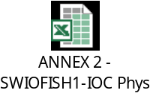

ANNEX 3: Procurement status
Please attach updated electronic versions in Excel format, of: (UPDATED TO APRIL 30, 2018)
- ToRs progress table (worksheet 1)
- Procurement progress table (worksheet 2)
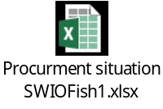
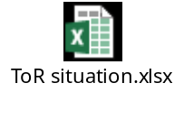
ANNEX 4: FINANCIAL status - SUMMARY
Please attach updated electronic versions in Excel format of SUMMARY financial status table as per Annex 4 format - UPDATED TO APRIL 30, 2018


ANNEX 5: FINANCIAL status - DETAILED
Please attach updated electronic versions in Excel format of DETAILED financial status table with breakdown as per individually coded activities in workplan. INCLUDE ALL COSTS AND EXPENDITURES FROM THE BEGINNING OF THE PROJECT UNTIL YEAR 3, UPDATED TO APRIL 30, 2018



