

European Union

GRANTS
RESILIENCE BUILDING AND DISASTER RESPONSE MANAGEMENT IN THE INDIAN OCEAN (RDRM)

RSO/FED/042-521/ RDRM-IO

TENDER DOSSIER
(Local open tender)

COI/ RDRM /AO/2024/007

SUPPLY, DELIVERY, INSTALLATION, COMMISSIONING AND AFTER-SALES SERVICE OF EQUIPMENT TO STRENGTHEN EARLY WARNING SYSTEMS IN SEYCHELLES

Location: Seychelles

INVITATION LETTER

Ébène, 18 April 2025

Our ref: COI/RDRM/AO/2024/007
Object: INVITATION TO TENDER FOR: Supply, delivery, installation, commissioning and after-sales service of equipment to strengthen early warning systems in Seychelles

Dear Madam/Sir

I am pleased to inform you that you are invited to take part in the local open procedure for the above supply contract. The complete tender dossier includes:

- Instructions to tenderers and contract notice
- Draft contract and special conditions, including annexes:
- Draft contract
- Special conditions
- Annex I : general conditions
- Annex II + III : technical specifications + technical offer (to be tailored to the specific project)
- Annex IV : Budget breakdown (model financial offer)
- Annex V : Forms
- Further information:
- Administrative compliance grid
- Evaluation grid
- Tender form for a supply contract and Declaration of honour on exclusion and selection criteria (annex A14a)

For full information about procurement procedures please consult the practical guide and its annexes, which can be downloaded from the following web page: https://wikis.ec.europa.eu/display/ExactExternalWiki/ePRAG
We look forward to receiving your tender which has to be submitted no later than the submission deadline mentioned in the Contract Notice.
By submitting a tender, you accept to receive notification of the outcome of the procedure by electronic means. Such notification shall be deemed to have been received by you on the date upon which the contracting authority sends it to the electronic address you referred to in your offer.
Yours sincerely,

Name and signature

PART A

Instructions to Tenderers and Contract Notice

INSTRUCTIONS TO TENDERERS
PUBLICATION REFERENCE: COI/ RDRM /AO/2024/007
By submitting a tender, tenderers fully and unreservedly accept the special and general conditions governing the contract as the sole basis of this tendering procedure, whatever their own conditions of sale may be, which they hereby waive. Tenderers are expected to examine carefully and comply with all instructions, forms, contract provisions and specifications contained in this tender dossier. Failure to submit a tender containing all the required information and documentation within the deadline specified will lead to the rejection of the tender. No account can be taken of any remarks in the tender relating to the tender dossier; remarks may result in the immediate rejection of the tender without further evaluation.
These instructions set out the rules for the submission, selection and implementation of contracts financed under this call for tenders, in conformity with the practical guide (available on the internet at: https://wikis.ec.europa.eu/display/ExactExternalWiki/ePRAG).

1. Supplies to be provided

1.1 The subject of the contract is: the supply, delivery, installation, commissioning and after-sales service of the following supplies divided into 2 lots:
- Lot 1: COMMUNICATION EQUIPMENT

REPEATER EQUIPMENT

Three (03) Repeater Unit
Three (03) Antenna Colinear
One (01) Compact combiner
Four (04) Microwave Link
Five (05) POE Unit
One (01) Ethernet Connector RJ45
One (01) Tough Cable UTP Outdoor
Seven (07) Heliax Connector N Type Male
Five (05) Ethernet Switch Manager
Two (02) UPS Unit
Eight (08) battery 12V 110Ah
Ten (10) Tyraps Outdoor
Three (03) Amalgamating tape - Sealing Kit
One (01) Antenna Installation Set
Two (02) Cable Double Shielded
One (01) Rack Cabinet
Two (02) Power distribution Unit

BASE STATION

Fifteen (15) VHF Radio base station configuration inc power cable
Fifteen (15) Desktop microphone
Seventeen (17) Power supply
Fifteen (15) Yagi antenna
One (01) Coaxial Cable Roll
Thirty five (35) Coaxial Connectors N Type Male LMR400
Twenty five ( 25) Coaxial Cable Roll
Fifteen (15) Coaxial Connectors N Type Female LMR240
Fifteen (15) Coaxial Connectors BNC Male LMR240

MOBILE RADIOS

Fifteen (15) Mobile VHF Radio inc power cable and microphone

PORTABLE RADIOS

Twenty (20) Mobile antenna VHF with magnetic mount
Twenty (20) Magnetic Mount GPS Active Antenna
Seventy nine (79) Handheld radio + battery + charger + belt clip
Five (05) Multi charger
Fifty (50) Spare Battery for above radio
Thirty (30) Speaker microphone for portable radio
Fifteen (15) Earpiece with PTT for Item 34 with spares

SOFTWARE UPGRADE

One (01) TRBONet Enterprise from V5.2
One (01) Trbonet Watch Software
One (01) Trbonet Watch Licences for 4 networks
One (01) Radio Licences for Trbonet

SOLAR POWER UPGRADE LA DIGUE (UPGRADE TO 10KW FOR 4 REPEATER SYSTEM)

Two (02) Blue Solar Controller
Eight (08) Batteries 12V 110Ah
Eight (08) Solar Panels
Four (04) Inverter unit (DC to DC converter 48V-12V)
One (01) set Accessories, cabling, connectors for above

OTHERS

One (01) Programming Cable DM4401e
One (01) Programming Cable DP3441e
One (01) Programming Cable SLR 5500

- Lot 2: IT EQUIPMENT AND ASSOCIATED ITEMS

VIDEO MONITORS AND CAMERA

One ( 01) Video Monitors for Workstation
Two (02) Go Pro Camera

LAPTOP, PRINTERS, ROUTER

Two (02) Laptops
One (01) Router
Four (04) Printer

TABLETS
Twenty-eight (28) tablets

To be delivered and implemented to the Disaster Risk Management Division of Seychelles, Global Village Suite No. 3, Mont Fleuri, Victoria, Mahe, Seychelles, Incoterms for prices are DDP, the implementation period is maximum NINETY (90) days

1.2 The supplies must comply fully with the technical specifications set out in the tender dossier (technical annex) and conform in all respects with the drawings, quantities, models, samples, measurements and other instructions

1.3 Tenderers are not authorised to tender for a variant solution in addition to the present tender.

2. Timetable
 | DATE | TIME*
Clarification meeting / site visit (if any) | Not applicable | Not applicable
Deadline for requesting clarifications from the contracting authority | 28/04/2025 | 04h30pm
Last date on which clarifications are issued by the contracting authority | 09/05/2025 | -
Deadline for submission of tenders | 19/05/2025 | 12h00
Tender opening session | 19/05/2025 | 02h45pm
Notification of award to the successful tenderer | 03/06/2025 ** | -
Signature of the contract | 13/06/2025 ** | -

* All times correspond to the time zone of the country of the contracting authority
** Provisional date

3. Participation

3.1 The eligibility requirements detailed in the Additional information about the contract notice (Annex A5f) or, if applicable, in the Contract Notice (C2), apply to all members of a joint venture/consortium and all subcontractors, as well as to all entities upon whose capacity the tenderer relies for the selection criteria. Every tenderer, member of a joint venture/consortium, every capacity-providing entity, every subcontractor must certify that they meet these conditions. They must prove their eligibility by a document dated less than one year earlier than the deadline for submitting tenders, drawn up in accordance with their national law or practice or by copies of the original documents stating the constitution and/or legal status and the place of registration and/or statutory seat and, if it is different, the place of central administration. The contracting authority may accept other satisfactory evidence that these conditions are met.

3.2 Natural or legal persons are not entitled to participate in this tender procedure or be awarded a contract if they are in any of the situations mentioned in Sections 2.4. (EU restrictive measures), 2.6.10.1. (exclusion criteria) or 2.6.10.1.2. (rejection from a procedure) of the practical guide. Should they do so, their tender will be considered unsuitable or irregular respectively. In the cases listed in Section 2.6.10.1. of the practical guide tenderers may also be excluded from EU financed procedures and be subject to financial penalties up to 10 % of the total value of the contract in accordance with the Financial Regulation in force. This information may be published on the Commission website in accordance with the Financial Regulation in force. Tenderers must provide declarations on honour that they are not in any of these exclusion situations. Such declarations must also be submitted by all the members of a joint venture/consortium, by any sub-contractor and by any capacity providing entities. Tenderers who make false declarations may also incur financial penalties and exclusion in accordance with the Financial Regulation in force. Their tender will be considered irregular.

The exclusion situations referred to above also apply to all members of a joint venture/consortium, all subcontractors and all suppliers to tenderers, as well as to all entities upon whose capacity the tenderer relies for the selection criteria. In cases of doubt over declarations, the contracting authority will request documentary evidence that subcontractors and/or capacity providing entities are not in a situation that excludes them.

3.3. To be eligible to take part in this tender procedure, tenderers must prove to the satisfaction of the contracting authority that they comply with the necessary legal, technical and financial requirements and have the means to carry out the contract effectively.

3.4 Subcontracting is allowed. The tenderer and, where applicable, entities on whose capacities it has relied with regard to criteria relating to the economic and financial capacity shall be jointly liable for the performance of the contract.

When selecting subcontractors, suppliers should give preference to natural persons, companies or firms of ACP States capable of providing the supplies required on similar terms.

4. Origin

4.1 By derogation, all supplies under this contract may originate in any country.

4.2 When submitting tenders, tenderers must state expressly that all the goods meet the requirements concerning origin and must state the countries of origin. They may be asked to provide additional information in this connection.

5. Type of contract

Unit-price

6. Currency

Tenders must be presented in Euro

7. Lots

7.1 The tenderer may submit a tender for one lot, or all of the lots.

7.2 Each lot will form a separate contract, and the quantities indicated for different lots will be indivisible. The tenderer must offer the whole of the quantity or quantities indicated for each lot. Under no circumstances must tenders be considered for part of the quantities required. If the tenderer is awarded more than one lot, a single contract may be concluded covering all those lots.

7.3 A tenderer may include in its tender the overall discount it would grant in the event of some or all of the lots for which it has submitted a tender being awarded. The discount should be clearly indicated for each lot in such a way that it can be announced during the public tender opening session.

7.4 Contracts will be awarded lot by lot, but the contracting authority may select the most favourable overall solution after taking account of any discounts offered.

8. Period of validity

8.1 Tenderers will be bound by their tenders for a period of 90 days from the deadline for the submission of tenders.

8.2 In exceptional cases and prior to the expiry of the original tender validity period, the contracting authority may ask tenderers in writing to extend this period by 40 days. Such requests and the responses to them must be made in writing. Tenderers that agree to do so will not be permitted to modify their tenders and they are bound to extend the validity of their tender guarantees for the revised period of validity of the tender. If they refuse, without forfeiture of their tender guarantees, their participation in the tender procedure will be terminated. In case the contracting authority is required to obtain the recommendation of the panel referred to in Section 2.6.10.1.1. of the practical guide, the contracting authority may, before the validity period expires, request an extension of the validity of the tenders up to the adoption of that recommendation.
8.3 The successful tenderer will be bound by its tender for a further period of 60 days. The further period is added to the validity period of the tender irrespective of the date of notification.

9. Language of tenders

9.1 The tenders, all correspondence and documents related to the tender exchanged by the tenderer and the contracting authority must be written in the language of the procedure, which is English.

If the supporting documents are not written in one of the official languages of the European Union, a translation into the language of the call for tender must be attached. Where the documents are in an official language of the European Union other than English, it is strongly recommended to provide a translation into English, to facilitate evaluation of the documents.

10. Submission of tenders

10.1 Tenders must be sent to the contracting authority before the deadline specified in Contract Notice They must include all the documents specified in point 11 of these Instructions and be sent to the following address
Contracts and Procurement Department
Indian Ocean Commission
Blue Tower, 4th floor
Institute Road, Ebène, Mauritius

If the tenders are hand delivered, they should be delivered to the following address:
Contracts and Procurement Department
Indian Ocean Commission
Blue Tower, 4th floor
Institute Road, Ebène, Mauritius
8h30-16h (from Monday to Friday)

Tenders must comply with the following conditions:

10.2 All tenders must be submitted in one original, marked ‘original’, and one copy signed in the same way as the original and marked ‘copy’.

10.3 The tenders should be submitted:

(a) either by post or by courier service, in which case the evidence shall be constituted by the postmark or the date of the deposit slip

(b) or by hand-delivery to the premises of the contracting authority by the participant in person or by an agent, in which case the evidence shall be constituted by the acknowledgment of receipt.

The contracting authority may, for reasons of administrative efficiency, reject any application or tender submitted on time to the postal service but received, for any reason beyond the contracting authority's control, after the effective date of approval of the short-list report or of the evaluation report, if accepting applications or tenders that were submitted on time but arrived late would considerably delay the evaluation procedure or jeopardise decisions already taken and notified.

10.4 All tenders, including annexes and all supporting documents, must be submitted in a sealed envelope bearing only:

a) the above address;

b) the reference code of this tender procedure, (i.e. COI/ RDRM /AO/2024/007);

c) where applicable, the number of the lot(s) tendered for;

d) the words ‘Not to be opened before the tender opening session’ in the language of the tender dossier.

e) the name of the tenderer.

The technical and financial offers must be placed together in a sealed envelope. The envelope should then be placed in another single sealed envelope/package, unless their volume requires a separate submission for each lot.

11. Content of tenders

Failure to fulfil the below requirements will constitute an irregularity and may result in rejection of the tender. All tenders submitted must comply with the requirements in the tender dossier and comprise :

Part 1: Technical offer:

a detailed description of the supplies tendered in conformity with the technical specifications, including any documentation required, including :
  - a proposal for after-sales service over 1 year;

The technical offer should be presented as per template (Annex II+III*, Contractor’s technical offer) adding separate sheets for details if necessary.

Part 2: Financial offer:

A financial offer calculated on a DDP basis for the supplies tendered, including :
  - financial proposal for after-sales services for 1 year

This financial offer should be presented as per template (Annex IV*, Budget breakdown), adding separate sheets for details if necessary.

In case of doubt about the applicable VAT system, it is the tenderer's responsibility to contact his or her national authorities to clarify the way in which the European Union is exempt from VAT.

Part 3: Documentation:
To be supplied using the templates attached*:
- The "Tender form for a supply contract", together with Annex 1 "Declaration on honour on exclusion criteria and selection criteria", both duly completed, which includes the tenderer’s declaration, point 7 from each member if a consortium, and capacity-providing entities or subcontractors (if any). Signed originals of the Declaration on honour shall be submitted.
- The details of the bank account into which payments should be made (financial identification form – document c4o1_fif_en) (tenderers that have already signed another contract with the European Commission, may provide their financial identification form number instead of the financial identification form, or a copy of the financial identification form provided on that occasion, if no change has occurred in the meantime.)
- The legal entity file (document c4o2_lefind_en) and the supporting documents (tenderers that have already signed another contract with the European Commission, may provide their legal entity number instead of the legal entity sheet and supporting documents, or a copy of the legal entity sheet provided on that occasion, if no change in legal status has occurred in the meantime).
To be supplied in free-text format:
- A description of the warranty conditions, which must be in accordance with the conditions laid down in Article 32 of the general conditions.
- A description of the organisation of the commercial warranty tendered in accordance with the conditions laid down in Article 32 of the special conditions
- Duly authorised signature: an official document (statutes, power of attorney, notary statement, etc.) proving that the person who signs on behalf of the company, joint venture or consortium is duly authorised to do so.

Remarks:
Tenderers are requested to follow this order of presentation.
Annex* refers to templates attached to the tender dossier. These templates are also available on: https://wikis.ec.europa.eu/display/ExactExternalWiki/Annexes#Annexes-AnnexesC(Ch.4):Supplies

12. Taxes and other charges

The applicable tax and customs arrangements are the following:

General provisions regarding tax and customs arrangements are attached to the tender dossier.

13. Additional information before the deadline for submission of tenders
The tender dossier should be clear enough so that tenderers do not need to request additional information during the procedure. If the contracting authority, on its own initiative or in response to a request from a prospective tenderer, provides additional information on the tender dossier, it must send such information in writing to all other prospective tenderers at the same time.

Tenderers may submit questions in writing to the following address up to 21 days before the deadline for submission of tenders, specifying the publication reference and the contract title:

Contracts and Procurement Department
Indian Ocean Commission
Blue Tower, 4th floor
Institute Road, Ebène, Mauritius
Email : smc@coi-ioc.org ;
Any clarification of the tender dossier will be communicated simultaneously in writing to all tenderers at the latest 8 days before the deadline for submitting tenders.

Any prospective tenderers seeking to arrange individual meetings with either the contracting authority and/or the European Commission during the tender period may be excluded from the tender procedure.

14. Clarification meeting / site visit

14.1 No clarification meeting / no site visit planned. Visits by individual prospective tenderers during the tender period cannot be organized.

15. Alteration or withdrawal of tenders

15.1 Tenderers may alter or withdraw their tenders by written notification prior to the deadline for submission of tenders. No tender may be altered after this deadline. Withdrawals must be unconditional and will end all participation in the tender procedure.

Any such notification of alteration or withdrawal must be prepared and submitted in accordance with Section 10. The outer envelope must be marked ‘Alteration’ or ‘Withdrawal’ as appropriate.

15.2 No tender may be withdrawn in the interval between the deadline for submission of tenders and the expiry of the tender validity period. Withdrawal of a tender during this interval may result in forfeiture of the tender guarantee.

16. Costs of preparing tenders
No costs incurred by the tenderer in preparing and submitting the tender are reimbursable. All such costs will be borne by the tenderer.

17. Ownership of tenders
The contracting authority retains ownership of all tenders received under this tender procedure. Consequently, tenderers have no right to have their tenders returned to them.

18. Joint venture or consortium

18.1 If a tenderer is a joint venture or consortium of two or more persons, the tender must be a single one with the object of securing a single contract, each person must sign the tender and will be jointly and severally liable for the tender and any contract. Those persons must designate one of their members to act as leader with authority to bind the joint venture or consortium. The composition of the joint venture or consortium must not be altered without the prior written consent of the contracting authority.

18.2 The tender may be signed by the representative of the joint venture or consortium only if it has been expressly so authorised in writing by the members of the joint venture or consortium, and the authorising contract, notarial act or deed must be submitted to the contracting authority in accordance with point 11 of these instructions to tenderers. All signatures to the authorising instrument must be certified in accordance with the national laws and regulations of each party comprising the joint venture or consortium together with the powers of attorney establishing, in writing, that the signatories to the tender are empowered to enter into commitments on behalf of the members of the joint venture or consortium. Each member of such joint venture or consortium must provide the proof required under Article 3.5 as if it, itself, were the tenderer.

19. Opening of tenders

19.1 The purpose of the opening session is to check whether the tenders have been submitted in accordance with the submission requirements of the call for tenders.

19.2 The date and venue of the tender opening session is on 19th May 2025 at 02h45pm at the following address:
Indian Ocean Commission
Blue Tower, 4th floor
Institute Road, Ebène, Mauritius

The committee will draw up minutes of the meeting, which will be available on request.
In the case that at the date of the opening session some tenders have not been delivered to the contracting authority but their representatives can show evidence that it has been sent on time, the contracting authority will allow them to participate in the first opening session and inform all representatives of the tenderers that a second opening session will be organised.

19.3 At the tender opening, the tenderers’ names, the tender prices, any discount offered, written notifications of alteration and withdrawal, the presence of the requisite tender guarantee (if required) and such other information as the contracting authority may consider appropriate may be announced.

19.4 After the public opening of the tenders, no information relating to the examination, clarification, evaluation of tenders, or recommendations concerning the award of the contract can be disclosed until after the contract has been awarded.

19.5 Any attempt by tenderers to influence the evaluation committee in the process of examination, clarification, evaluation and comparison of tenders, to obtain information on how the procedure is progressing or to influence the contracting authority in its decision concerning the award of the contract will result in the immediate rejection of their tenders.

19.6 All tenders received after the deadline for submission specified in the contract notice or these instructions will be kept by the contracting authority. The associated guarantees will be returned to the tenderers. No liability can be accepted for late delivery of tenders. Late tenders will be rejected and will not be evaluated.

20. Evaluation of tenders

20.1 Examination of the administrative conformity of tenders

The aim at this stage is to check that tenders comply with the essential requirements of the tender dossier. A tender is deemed to comply if it satisfies all the conditions, procedures and specifications in the tender dossier without substantially departing from or attaching restrictions to them.

Substantial departures or restrictions are those which affect the scope, quality or execution of the contract, differ widely from the terms of the tender dossier, limit the rights of the contracting authority or the tenderer’s obligations under the contract or distort competition for tenderers whose tenders do comply. Decisions to the effect that a tender is not administratively compliant must be duly justified in the evaluation minutes.

If a tender does not comply with the tender dossier, it will be rejected immediately and may not subsequently be made to comply by correcting it or withdrawing the departure or restriction.

20.2 Technical evaluation

After analysing the tenders deemed to comply in administrative terms, the evaluation committee will rule on the technical admissibility of each tender, classifying it as technically compliant or non-compliant.

The minimum qualifications required (see selection criteria in the additional information about the contract notice are to be evaluated at the start of this stage.

Where contracts include after-sales service and/or training, the technical quality of such services will also be evaluated by using yes/no criteria as specified in the tender dossier.

20.3 In the interests of transparency and equal treatment and to facilitate the examination and evaluation of tenders, the evaluation committee may ask each tenderer individually for clarification of its tender including breakdowns of prices, within a reasonable time limit to be fixed by the evaluation committee. The request for clarification and the response must be in writing, but no change in the price or substance of the tender may be sought, offered or permitted except as required to confirm the correction of arithmetical errors discovered during the evaluation of tenders pursuant to Article 20.4. Any such request for clarification must not distort competition. Decisions to the effect that a tender is not technically compliant must be duly justified in the evaluation minutes.

20.4 Financial evaluation
a) Tenders found to be technically compliant will be checked for any arithmetical errors in computation and summation. Errors will be corrected by the evaluation committee as follows:

- where there is a discrepancy between amounts in figures and in words, the amount in words will be the amount taken into account;

- except for lump-sum contracts, where there is a discrepancy between a unit price and the total amount derived from the multiplication of the unit price and the quantity, the unit price as quoted will be the price taken into account.
b) Amounts corrected in this way will be binding on the tenderer. If the tenderer does not accept them, its tender will be rejected.
c) Unless specified otherwise, the purpose of the financial evaluation process is to identify the tenderer offering the lowest price. Where specified in the technical specifications, the evaluation of tenders may take into account not only the acquisition costs but, to the extent relevant, costs borne over the life cycle of the supplies (such as for instance maintenance costs and operating costs), in line with the technical specifications. In such case, the contracting authority will examine in detail all the information supplied by the tenderers and will formulate its judgment on the basis of the lowest total cost, including additional costs.

20.5 Variant solutions
Variant solutions will not be taken into consideration.

20.6 Award criteria
The sole award criterion will be the price. The contract will be awarded to the lowest compliant tender.

Where tenders are of equivalent economic and technical quality, preference will be given to those with the widest participation of ACP States. See further Section 2.6.9. of the practical guide.

  - Documentary evidence for exclusion and selection criteria

At any time during the procurement procedure and before the award of the contract, the contracting authority may request documentary evidence on compliance with the exclusion criteria and selection criteria (financial, economic, technical and professional capacity) set out in these instructions. Please note that a request for evidence in no way implies that the tenderer has been successful. All tenderers are invited to prepare in advance the documents related to the evidence, since they may be requested to provide such evidence within a short deadline. In any event, the tenderer proposed by the evaluation committee for the award of the contract, will be requested to provide such evidence at short notice.

When requested, regarding the exclusion criteria, the tenderers should be able to provide the documentary proof or statements required under the law of the country in which the company (or, for consortia, each of the companies) is established, to show that it does not fall into any of the exclusion situations listed in Section 2.6.10.1. of the practical guide.

This evidence, documents or statements must be dated, no more than one year before the date of submission of the tender.

The above-mentioned documents must be submitted for every member of a joint venture/consortium, all subcontractors and every capacity providing entity.

The contracting authority may waive the obligation of any tenderer to submit the documentary evidence referred to above if such evidence has already been submitted for the purposes of another procurement procedure, provided that the issue date of the documents does not exceed one year and that they are still valid. In this case, the tenderer must declare on his/her honour that the documentary evidence has already been provided in a previous procurement procedure and confirm that his/her situation has not changed.

Where the documentary evidence submitted is in an official language of the European Union other than the one of the procedure, it is strongly recommended to provide a translation into the language of the procedure, in order to facilitate the evaluation of the documents.

Failure to provide valid documentary evidence at the request and within the deadline set by the Contracting Authority shall lead to the rejection of the tender for the award of the contract, unless the tenderer can justify the failure on the grounds of material impossibility.

If the successful tenderer fails to provide this documentary proof or statement or if the successful tenderer is found to have provided false information, the award will be considered null and void. In this case, the contracting authority may award the tender to the next lowest tenderer or cancel the tender procedure.]

21. Notification of award
By submitting a tender, each tenderer accepts to receive notification of the outcome of the procedure by electronic means. Such notification shall be deemed to have been received on the date upon which the contracting authority sends it to the electronic address referred to in the offer.

The contracting authority will inform all tenderers simultaneously and individually of the award decision. The tender guarantees of the unsuccessful tenderers will be released once the contract is signed. The successful tenderer will be informed in writing that its tender has been accepted (notification of award).

22. Signature of the contract and performance guarantee

22.1 The contracting authority reserves the right to vary quantities specified in the tender by +/- 100 % at the time of contracting and during the validity of the contract. The total value of the supplies may not, as a result of the variation rise or fall by more than 25 % of the original financial offer in the tender. The unit prices quoted in the tender shall be used.

22.2 Within 30 days of receipt of the contract signed by the contracting authority, the selected tenderer must sign and date the contract and return it, with the performance guarantee (if applicable), to the contracting authority. On signing the contract, the successful tenderer will become the contractor and the contract will enter into force.

22.3 If it fails to sign and return the contract and any financial guarantee required within 30 days after receipt of notification, the contracting authority may consider the acceptance of the tender to be cancelled without prejudice to the contracting authority’s right to seize the guarantee, claim compensation or pursue any other remedy in respect of such failure, and the successful tenderer will have no claim whatsoever on the contracting authority.

22.4 The performance guarantee referred to in the general conditions is set at 5% of the amount of the contract. The performance guarantee must be presented in the form specified in the annex to the tender dossier. It will be released within 60 days of the issue of the final acceptance certificate by the contracting authority, except for the proportion assigned to after-sales service. For contracts of EUR 150 000 or below, on the basis of objective criteria such as the type and value of the contract, the contracting authority may decide not to require such a guarantee.

23. Tender guarantee

No tender guarantee is required

24. Ethics clauses and code of conduct

24.1 Absence of conflict of interest
The tenderer must not be affected by any conflict of interest and must have no equivalent relation in that respect with other tenderers or parties involved in the project. Any attempt by a tenderer to obtain confidential information, enter into unlawful agreements with competitors or influence the evaluation committee or the contracting authority during the process of examining, clarifying, evaluating and comparing tenders will lead to the rejection of its tender and may result in administrative penalties according to the Financial Regulation in force.

24.2 Respect for human rights as well as environmental legislation and core labour standards
The tenderer and its personnel must comply with human rights and applicable data protection rules. In particular and in accordance with the applicable basic act, tenderers and applicants who have been awarded contracts must comply with the environmental legislation including multilateral environmental agreements, and with the core labour standards as applicable and as defined in the relevant International Labour Organisation conventions (such as the conventions on freedom of association and collective bargaining; elimination of forced and compulsory labour; abolition of child labour).

Zero tolerance for sexual exploitation, abuse and harassment:
The European Commission applies a policy of 'zero tolerance' in relation to all wrongful conduct which has an impact on the professional credibility of the tenderer.
Physical abuse or punishment, or threats of physical abuse, sexual abuse or exploitation, harassment and verbal abuse, as well as other forms of intimidation shall be prohibited.

24.3 Anti-corruption and anti-bribery
The tenderer shall comply with all applicable laws and regulations and codes relating to anti-bribery and anti-corruption. The European Commission reserves the right to suspend or cancel project financing if corrupt practices of any kind are discovered at any stage of the award process or during the execution of a contract and if the contracting authority fails to take all appropriate measures to remedy the situation. For the purposes of this provision, ‘corrupt practices’ are the offer of a bribe, gift, gratuity or commission to any person as an inducement or reward for performing or refraining from any act relating to the award of a contract or execution of a contract already concluded with the contracting authority.

24.4 Unusual commercial expenses
Tenders will be rejected or contracts terminated if it emerges that the award or execution of a contract has given rise to unusual commercial expenses. Such unusual commercial expenses are commissions not mentioned in the main contract or not stemming from a properly concluded contract referring to the main contract, commissions not paid in return for any actual and legitimate service, commissions remitted to a tax haven, commissions paid to a payee who is not clearly identified or commissions paid to a company which has every appearance of being a front company.
Contractors found to have paid unusual commercial expenses on projects funded by the European Union are liable, depending on the seriousness of the facts observed, to have their contracts terminated or to be permanently excluded from receiving EU funds.

24.5 Breach of obligations, irregularities or fraud
The contracting authority reserves the right to suspend or cancel the procedure, where the award procedure proves to have been subject to breach of obligations, irregularities or fraud. If breach of obligations, irregularities or fraud are discovered after the award of the contract, the contracting authority may refrain from concluding the contract.

25. Cancellation of the tender procedure
If a tender procedure is cancelled, tenderers will be notified by the contracting authority.
If the tender procedure is cancelled before the tender opening session the sealed envelopes will be returned, unopened, to the tenderers.
Cancellation may occur, for example, if:
- the tender procedure has been unsuccessful, namely where no suitable, qualitatively or financially acceptable tender has been received or there has been no valid response at all;
- the economic or technical parameters of the project have changed fundamentally;
- exceptional circumstances or force majeure render normal implementation of the project impossible;
- all technically acceptable tenders exceed the financial resources available;
- there have been breach of obligations, irregularities or frauds in the procedure, in particular where these have prevented fair competition;
- the award is not in compliance with sound financial management, i.e. does not respect the principles of economy, efficiency and effectiveness (e.g. the price proposed by the tenderer to whom the contract is to be awarded is objectively disproportionate with regard to the price of the market.
In no event will the contracting authority be liable for any damages whatsoever including, without limitation, damages for loss of profits, in any way connected with the cancellation of a tender procedure even if the contracting authority has been advised of the possibility of damages. The publication of a contract notice does not commit the contracting authority to implement the programme or project announced.

26. Appeals
Tenderers believing that they have been harmed by an error or irregularity during the award process may file a complaint. See Section 2.12. of the practical guide.

27. Data Protection
Processing of personal data related to this tender procedure by the contracting authority takes place in accordance with the national legislation of the state of the contracting authority and with the provisions of the respective financing agreement.

The tender procedure and the contract relate to an external action funded by the EU, represented by the European Commission. If processing your reply to the invitation to tender involves transfer of personal data (such as names, contact details and CVs) to the European Commission, they will be processed solely for the purposes of the monitoring of the procurement procedure and of the implementation of the contract by the Commission, for the latter to comply with its obligations under the applicable legislative framework and under the financing agreement concluded between the EU and the Partner Country without prejudice to possible transmission to the bodies in charge of monitoring or inspection tasks in application of EU law. For the part of the data transferred by the contracting authority to the European Commission, the controller for the processing of personal data carried out within the Commission is: the head of legal affairs unit of DG International Partnerships.

Details concerning processing of your personal data by the Commission are available on the privacy statement at: https://wikis.ec.europa.eu/display/ExactExternalWiki/Annexes#Annexes-AnnexesA(Ch.2):General.

In cases where you are processing personal data in the context of participation to a tender (e.g. CVs of both key and technical experts) and/or implementation of a contract (e.g. replacement of experts) you shall accordingly inform the data subjects of the possible transmission of their data to EU institutions and bodies and communicate the above mentioned privacy statement to them.

28. Early detection and exclusion system
The tenderers and, if they are legal entities, persons who have powers of representation, decision-making or control over them, are informed that, should they be in one of the situations of early detection or exclusion, their personal details (name, given name if natural person, address, legal form and name and given name of the persons with powers of representation, decision-making or control, if legal person) may be registered in the early detection and exclusion system, and communicated to the persons and entities listed in the above-mentioned decision, in relation to the award or the execution of a procurement contract.

CONTRACT NOTICE
CALL FOR TENDER: GENERAL INFORMATION
I.1) Name and address Contracting Authority

Official name: Indian Ocean Commission (IOC)

Postal address: Blue Tower, 3rd floor
Town: Ebène
Postal Code: 72202
E-mail: smc@coi-ioc.org
Internet address: https://www.commissionoceanindien.org
II.1.1) Title:
Supply, delivery, installation, commissioning and after-sales service of equipment to strengthen early warning systems in Seychelles

II.1.2) Main CPV code

Not applicable

II.1.3) Type of contract
Supplies

II.1.4) Short description of the contract
Acquisition of IT equipment (- Lot 1: COMMUNICATION EQUIPMENT: repeater equipment, base station, mobile radios, portable radios, software upgrade,solar power upgrade la digue (upgrade to 10kw for 4 repeater system); - Lot 2: IT EQUIPMENT AND ASSOCIATED ITEMS: video monitors and camera, laptop, printers, router, tablets )

IV.1.1.) Type of Procedure

Open

Notice number in the OJ S Non applicable

II.1.6) Information about lots

This contract is divided into lots.

Tenders may be submitted for:
- all lots
- one lot only

CALL FOR TENDER: INFORMATION PER LOT

II.2) Description
II.2.1)
Lot no.: 1
Title: COMMUNICATION EQUIPMENT

Lot no.: 2
Title: IT EQUIPMENT AND ASSOCIATED ITEMS

II.2.2) Additional CPV code(s)

Main CPV code :Not applicable

II.2.3) Place of performance

Geographical zone benefitting from the action: SEYCHELLES

II.2.5) Award Criteria

Price

II.2.14) Additional information

Repetition of similar services/works

Provided they are in conformity with the basic project, new services or works consisting in the repetition of similar services or works, may be entrusted up to 25% of the initial contract to the initial contractor by negotiated procedure without prior publication of a contract notice.

IV.2.2) Time limit for submission of tenders or requests to participate

Date: 19/05/2025
Local Time : 12h00

IV.2.6) Minimum time frame during which the tenderer must maintain the tender

Duration in months: Three (03) months (from the date stated for receipt of tender)

IV.2.7) Conditions for opening of tenders

Date: 19/05/2025
Local time :02h45 pm
Place: Office of IOC at Blue Tower, 4th floor, Ebène

Additional information about the Contract Notice

SUPPLY, DELIVERY, INSTALLATION, COMMISSIONING AND AFTER-SALES SERVICE OF EQUIPMENT TO STRENGTHEN EARLY WARNING SYSTEMS IN SEYCHELLES
Location - Seychelles
- Nature of contract
unit price
- Programme title
RESILIENCE BUILDING AND DISASTER RESPONSE MANAGEMENT IN THE INDIAN OCEAN (RDRM-IO)
- Financing
Financing agreement RSO/FED/042-521/ RDRM-IO

- Legal basis, eligibility and rules of origin
The legal basis of this procedure is Annex IV to the Partnership Agreement between the members of the African, Caribbean and Pacific Group of States of the one part, and the European Community and its Member States, of the other part, signed in Cotonou on 23 June 2000 as amended in Luxembourg on 25 June 2005 and in Ouagadougou on 22 June 2010. Reference is made to Annex IV as revised by Decision 1/2014 of the ACP-EU Council of Ministers of 20 June 2014.

Participation in tendering is open on equal terms to all natural and legal persons (participating either individually or in a grouping – consortium – of candidates/tenderers) which are established in one of the Member States of the European Union, ACP States or in a country or territory authorised by the ACP-EC Partnership Agreement under which the contract is financed.
Participation is also open to international organisations.

All supplies under this contract may originate in any country.

For UK candidates or tenderers: Please be aware that following the entry into force of the EU-UK Withdrawal Agreement* on 1 February 2020 and in particular Articles 127(6), 137 and 138, the references to natural or legal persons residing or established in a Member State of the European Union and to goods originating from an eligible country, as defined under Regulation (EU) No 236/2014** and Annex IV of the ACP-EU Partnership Agreement***, are to be understood as including natural or legal persons residing or established in, and to goods originating in, the United Kingdom ****. Those persons and goods are therefore eligible under this call.

* Agreement on the withdrawal of the United Kingdom of Great Britain and Northern Ireland from the European Union and the European Atomic Energy Community.
** Regulation (EU) No 236/2014 of the European Parliament and of the Council of 11 March 2014 laying down common rules and procedures for the implementation of the Union's instruments for financing external action.
*** Annex IV to the ACP-EU Partnership Agreement, as revised by Decision 1/2014 of the ACP-EU Council of Ministers (OJ L196/40, 3.7.2014).
**** Including the Overseas Countries and Territories having special relations with the United Kingdom, as laid down in Part Four and Annex II of the TFEU.

- Candidature
All eligible natural and legal persons (as per item 4 above) or groupings of such persons (consortia) may participate or tender.
A consortium may be a permanent, legally established grouping or a grouping which has been constituted informally for a specific procurement procedure. All partners of a consortium (i.e., the leader and all other partners) are jointly and severally liable to the contracting authority.
The participation or tender of an ineligible natural or legal person will result in the automatic exclusion of that person. In particular, if that ineligible person belongs to a consortium, the whole consortium will be excluded.
- Number of requests to participate or tenders
No more than one request to participate or tender can be submitted by a natural or legal person whatever the form of participation (as an individual legal entity or as leader or partner of a consortium submitting a request to participate or tender). In the event that a natural or legal person submits more than one request to participate or tender, all requests to participate or tenders in which that person has participated will be excluded.
In case of lots, the candidates or tenderers may submit only one request to participate or tender per lot. Contracts will be awarded lot by lot and each lot will form a separate contract.

- Period of implementation of tasks
Ninety (90) days after signature of the contract by the two parties
- Language of the procedure
All written communications for this tender procedure and contract must be in English.
- Additional information
Financial data to be provided by the candidate in the request to participate form or in the tender submission form must be expressed in EUR. If applicable, where a candidate refers to amounts originally expressed in a different currency, the conversion to EUR shall be made in accordance with the InforEuro exchange rate of March 2025, which can be found at the following address: http://ec.europa.eu/budget/graphs/inforeuro.html.

SELECTION CRITERIA

- Selection criteria
Capacity-providing entities
An economic operator (i.e. candidate or tenderer) may, where appropriate and for a particular contract, rely on the capacities of other entities, regardless of the legal nature of the links which it has with them. If the economic operator relies on other entities, it must in that case prove to the contracting authority that it will have at its disposal the resources necessary for the performance of the contract by producing a commitment by those entities to place those resources at its disposal. Such entities, for instance the parent company of the economic operator, must respect the same rules of eligibility and notably that of nationality as the economic operator relying on them and must comply with the selection criteria for which the economic operator relies on them. Furthermore, the data for this third entity for the relevant selection criterion should be included in a separate document. Proof of the capacity will also have to be provided when requested by the contracting authority.
With regard to technical and professional criteria, an economic operator may only rely on the capacities of other entities where the latter will perform the tasks for which these capacities are required.
With regard to economic and financial criteria, the entities upon whose capacity the economic operator relies, become jointly and severally liable for the performance of the contract.
The following selection criteria will be applied to candidates. In the case of requests to participate submitted by a consortium, these selection criteria will be applied to the consortium as a whole if not specified otherwise. The selection criteria will not be applied to natural persons and single-member companies when they are sub-contractors.
The candidate shall not use previous experience which caused breach of contract and termination by a contracting authority as a reference for selection criteria.
- LOT N° 1
The selection criteria for tenderers to Lot n° 1 are as follows:
1) Economic and financial capacity of tenderer (based on item 3 of the tender form). In case of tenderer being a public body, equivalent information should be provided. The reference period which will be taken into account will be the last three financial years for which accounts have been closed.
- The tenderer's average annual turnover must be more than EUR 260,000 over the last 3 years ( 2022, 2023, 2024) .
- Current ratio (current assets/current liabilities) in the last year for which accounts have been closed must be at least 1. In case of a consortium this criterion must be fulfilled by each member.

2) Professional capacity of tenderer (based on items 4 and 5 of the tender form). The reference period which will be taken into account will be the last three years preceding the submission deadline.
- Has a professional certificate appropriate to this contract, such as supply of communication equipment.

3) Technical capacity of tenderer (based on items 5 and 6 of the tender form). The reference period which will be taken into account will be the last three years preceding the submission deadline.
- The tenderer has provided similar supplies under at least 1 contract with a budget of at least EUR 200,000 in fields related to the present contract which was implemented successfully at any moment during the following period: April 2022 to March 2025.

- LOT N° 2
The selection criteria for tenderers to Lot n° 2 are as follows:
1) Economic and financial capacity of tenderer (based on item 3 of the tender form). In case of tenderer being a public body, equivalent information should be provided. The reference period which will be taken into account will be the last three financial years for which accounts have been closed.
- The tenderer's average annual turnover must be more than EUR 22,000 over the last 3 years ( 2022, 2023, 2024).
- Current ratio (current assets/current liabilities) in the last year for which accounts have been closed must be at least 1. In case of a consortium this criterion must be fulfilled by each member.

2) Professional capacity of tenderer (based on items 4 and 5 of the tender form). The reference period which will be taken into account will be the last three years preceding the submission deadline.
Has a professional certificate appropriate to this contract, such as supply of IT equipment.

3) Technical capacity of tenderer (based on items 5 and 6 of the tender form). The reference period which will be taken into account will be the last three years preceding the submission deadline.
- The tenderer has provided similar supplies under at least 1 contract with a budget of at least EUR 15,000 in fields related to the present contract which was implemented successfully at any moment during the following period: April 2022 to March 2025.

In case a tenderer applies simultaneously to lots n° 1 and n° 2 , the tenderer must comply with the following selection criteria:

1) Economic and financial capacity of tenderer (based on item 3 of the tender form). In case of tenderer being a public body, equivalent information should be provided. The reference period which will be taken into account will be the last three financial years for which accounts have been closed
- The tenderer's average annual turnover must be more than EUR 282,000 over the last 3 years (2022, 2023 and 2024).
- Current ratio (current assets/current liabilities) in the last year for which accounts have been closed must be at least 1. In case of a consortium this criterion must be fulfilled by each member

2) Professional capacity of tenderer (based on items 4 and 5 of the tender form). The reference period which will be taken into account will be the last three years preceding the submission deadline.
- Has a professional certificate appropriate to this contract, such as supply of communication equipment and supply of IT equipment.

3) Technical capacity of tenderer (based on items 5 and 6 of the tender form). The reference period which will be taken into account will be the last three years preceding the submission deadline.
- The tenderer has provided similar supplies under at least 1 contract with a budget of at least EUR 215,000 in fields related to the present contract which was implemented successfully at any moment during the following period: April 2022 to March 2025.

PART B

Draft contract and special conditions, including annexes

DRAFT CONTRACT
SUPPLY CONTRACT FOR EUROPEAN
UNION EXTERNAL ACTIONS
N° COI/RDRM/CT/2024/007

financed from the EDF

The Indian Ocean Commission, Blue Tower, 3rd Floor, Rue de l'Institut, Ebène, Republic of Mauritius (‘The contracting authority’),
of the one part,
and
<Full official name of contractor>
[<Legal status/title>]
[<Official registration number>]
<Full official address>
[<VAT number>], (‘the contractor’)
of the other part,

have agreed as follows:

PROJECT:

RESILIENCE BUILDING AND DISASTER RESPONSE MANAGEMENT IN THE INDIAN OCEAN
(RDRM)

RSO/FED/042-521/ RDRM-IO

CONTRACT TITLE:
SUPPLY, DELIVERY, INSTALLATION, COMMISSIONING AND AFTER-SALES SERVICE OF EQUIPMENT TO STRENGTHEN EARLY WARNING SYSTEMS IN SEYCHELLES

Identification number: COI/RDRM/AO/2024/007

Article 1 Subject
1.1 The subject of the contract shall be: the supply, delivery, siting and installation, commissioning and after-sales service of the following supplies divided into 2 lots:
- Lot 1: COMMUNICATION EQUIPMENT

REPEATER EQUIPMENT

Three (03) Repeater Unit
Three(03) Antenna Colinear
One (01) Compact combiner
Four (04) Microwave Link
Five (05) POE Unit
One (01) Ethernet Connector RJ45
One (01) Tough Cable UTP Outdoor
Seven (07) Heliax Connector N Type Male
Five (05) Ethernet Switch Manager
Two (02) UPS Unit
Eight (08) battery 12V 110Ah
Ten (10) Tyraps Outdoor
Three (03) Amalgamating tape - Sealing Kit
One (01) Antenna Installation Set
Two (02) Cable Double Shielded
One (01) Rack Cabinet
Two (02) Power distribution Unit

BASE STATION

Fifteen (15) VHF Radio base station configuration inc power cable
Fifteen (15) Desktop microphone
Seventeen (17) Power supply
Fifteen (15) Yagi antenna
One (01) Coaxial Cable Roll
Thirty five (35) Coaxial Connectors N Type Male LMR400
Twenty five ( 25) Coaxial Cable Roll
Fifteen (15) Coaxial Connectors N Type Female LMR240
Fifteen (15) Coaxial Connectors BNC Male LMR240

MOBILE RADIOS

Fifteen (15) Mobile VHF Radio inc power cable and microphone

PORTABLE RADIOS

Twenty (20) Mobile antenna VHF with magnetic mount
Twenty (20) Magnetic Mount GPS Active Antenna
Seventy nine (79) Handheld radio + battery + charger + belt clip
Five (05) Multi charger
Fifty (50) Spare Battery for above radio
Thirty (30) Speaker microphone for portable radio
Fifteen (15) Earpiece with PTT for Item 34 with spares

SOFTWARE UPGRADE

One (01) TRBONet Enterprise from V5.2
One (01) Trbonet Watch Software
One (01) Trbonet Watch Licences for 4 networks
One (01) Radio Licences for Trbonet

SOLAR POWER UPGRADE LA DIGUE UPGRADE TO 10KW FOR 4 REPEATER SYSTEM)

Two (02) Blue Solar Controller
Eight (08) Batteries 12V 110Ah
Eight (08) Solar Panels
Four (04) Inverter unit (DC to DC converter 48V-12V)
One (01) set Accessories, cabling, connectors for above

OTHERS

One (01) Programming Cable DM4401e
One (01) Programming Cable DP3441e
One (01) Programming Cable SLR 5500

- Lot 2: IT EQUIPMENT AND ASSOCIATED ITEMS

VIDEO MONITORS AND CAMERA

One ( 01) Video Monitors for Workstation
Two (02) Go Pro Camera

LAPTOP, PRINTERS, ROUTER

Two (02) Laptops
One (01) Router
Four (04) Printer

TABLETS
Twenty-eight (28) tablets

The place of acceptance of the supplies shall be Disaster Risk Management Division of Seychelles, Global Village Suite No. 3, Mont Fleuri, Victoria, Mahe, Seychelles, the time limits for delivery shall be <insert date and time> and the Incoterm applicable shall be DDP. The implementation period of tasks shall run from <Specify the date on which implementation of the tasks is to commence> to <date for provisional acceptance>.
1.2 The contractor shall comply strictly with the terms of the special conditions and the technical annex.

Article 2 Origin

The rules of origin of the goods are defined in Article 10 of the special conditions.

When required, a certificate of origin for the goods must be provided by the contractor at the latest when it requests provisional acceptance of the goods. Failure to comply with this condition may result in the termination of the contract and/or suspension of payment.

Article 3 Price
3.1 The price of the supplies shall be that shown on the financial offer (specimen in Annex IV). The total maximum contract price shall be EUR <insert price>
3.2 Payments shall be made in accordance with the general and/or special conditions (Articles 26 to 28).

Article 4 Order of precedence of contract documents
The contract is made up of the following documents, in order of precedence:

- the contract agreement;
- the special conditions;
- the general conditions (Annex I);
- the technical specifications (Annex II [including clarifications before the deadline for submission of tenders]);
- the technical offer (Annex III [including clarifications from the tenderer provided during tender evaluation]);
- the budget breakdown (Annex IV);
- specified forms and other relevant documents (Annex V);

The various documents making up the contract shall be deemed to be mutually explanatory; in cases of ambiguity or divergence, they shall prevail in the order in which they appear above.

Article 5 Other specific conditions applying to the contract

For the purpose of Article 44 of the general conditions, for the part of the data transferred by the contracting authority to the European Commission:

(a) the controller for the processing of personal data carried out within the Commission is the head of legal affairs unit of DG International Partnerships.
(b) the data protection notice is available at https://wikis.ec.europa.eu/display/ExactExternalWiki/Annexes#Annexes-AnnexesA(Ch.2):General

Done in English in two originals, one original being for the contracting authority and one original being for the contractor.

For the contractor For the contracting authority

Name Name:

Title Title:

Signature Signature:

SPECIAL CONDITIONS
These conditions amplify and supplement, if necessary, the general conditions governing the contract. Unless the special conditions provide otherwise, those general conditions remain fully applicable. The numbering of the articles of the special conditions is not consecutive but follows the numbering of the articles of the general conditions. In exceptional cases, and with the authorization of the appropriate Commission departments, other clauses may be added to cover specific situations.
Article 2 Language of the contract

2.1 The language used shall be English.
Article 4 Communications
4.1 Contact persons

Contracting authority:
xxxxxxxxxxxx
Officer in Charge
General Secretariat of the IOC
Blue Tower, 3rd floor, Rue de institute
Ebène, Mauritius
Tél : (230) 402 6100
Email:

Contractor :

…………………………

4.2 An electronic system will be used by the contracting authority and the contractor for all stages of implementation including, inter alia, management of the contract (amendments and administrative orders), reporting (including reporting on results) and payments. The contractor will be required to register in and use the appropriate electronic exchange system to allow for the e-management of the contract.
The electronic management of the contract through the aforementioned system may commence on the date on which implementation of the contract starts, as described in Article 18 below, or at a later date. In the latter case, the contracting authority will inform the contractor in writing that he will be required to use the electronic system for all communications within a maximum period of 3 months.
Article 6 Subcontracting

When selecting subcontractors the contractor must give preference to natural persons or companies from ACP States capable of implementing the tasks required on similar terms.

Article 10 Origin

10.1 By derogation, All goods purchased can originate in any country.
Article 11 Performance guarantee
11.1 The amount of the performance guarantee shall be 5% of the total contract price, including any amounts stipulated in addenda to the contract.

Article 18 Commencement order
18.1 The date of commencement of implementation of the tasks is be the date of signature of the contract by the 2 parties.
Article 19 Period of implementation of the tasks
19.1 The period of implementation of the tasks is for a period of ninety (90) days.
Article 26 General principles of payments
26.1 Payments shall be made in Euro

Pre-financing is not applicable to this contract

Payments shall be authorized and made by the RDRM project finance department.

26.5 In order to obtain payments, the contractor must forward to the authority referred to in paragraph 26.1 above:

a) For the 100 % balance, the invoice(s) in two (2) copies together with the request for provisional acceptance of the supplies.

Article 28 Delayed payments

28.2 By derogation from Article 28.2 of the general conditions, once the deadline laid down in Article 26.3 has expired, the contractor shall, upon demand, be entitled to late-payment interest at the rate and for the period mentioned in the general conditions. The demand must be submitted within two months of receiving late payment

Article 29 Delivery

29.3 The packaging shall become the property of the recipient subject to environmental considerations
Article 31 Provisional acceptance
The certificate of provisional acceptance must be issued using the template in Annex C11.

By derogation from Article 31.2, second paragraph, the contracting authority’s time limit for issuing the certificate of provisional acceptance to the contractor shall not be considered included in the time limit for payments indicated in Article 26.3.

Article 32 Warranty obligations
32.6 . Commercial warranty as granted by the manufacturer must remain valid for minimum two years after final acceptance.

32.7 The warranty must remain valid for two years after final acceptance.

Article 33 After-sales service
33.1 The supplier must provide on-site support services with technical intervention within 5 days of the call received from the client. Support services should be provided during working hours for one year as from the final acceptance of supplies.

The proportion of the performance guarantee linked to the after sale service is 10%

Article 40 Settlement of disputes
40.4 Any dispute arising out of or relating to this contract which cannot be settled otherwise shall:
(a) in the case of a national contract, be settled in accordance with the national legislation of the state of the contracting authority; and
(b) in the case of a transnational contract, be settled either:
(i) if the parties to the contract so agree, in accordance with the national legislation of the state of the contracting authority or its established international practices; or
(ii) by arbitration in accordance with the procedural rules on conciliation and arbitration of contracts financed by the European Development Fund, adopted by Decision 3/90 of the ACP-EEC Council of Ministers of 29 March 1990 (Official Journal No L 382, 31.12.1990, Annex a12 to the practical guide)

Article 44 Data protection

1. Processing of personal data related to the implementation of the contract by the contracting authority takes place in accordance with the national legislation of the state of the contracting authority and with the provisions of the respective financing agreement.

2. To the extent that the contract covers an action financed by the European Union, the Contracting Authority may share communications related to the implementation of the contract, with the European Commission. These exchanges shall be made to the Commission, solely for the purpose of allowing the latter to exercise its rights and obligations under the applicable legislative framework and under the financing agreement with the Partner country – contracting authority. The exchanges may involve transfers of personal data (such as names, contact details, signatures and CVs) of natural persons involved in the implementation of the contract (such as contractors, personnel, experts, trainees, subcontractors, insurers, guarantors, auditors and legal counsel). In cases where the contractor is processing personal data in the context of the implementation of the contract, he/she shall accordingly inform the data subjects of the possible transmission of their data to the Commission. When personal data is transmitted to the Commission, the latter processes them in accordance with Regulation (EU) 2018/1725 of the European Parliament and of the Council of 23 October 2018 on the protection of natural persons with regard to the processing of personal data by the Union institutions, bodies, offices and agencies and on the free movement of such data, and repealing Regulation (EC) No 45/2001 and Decision No 1247/2002/EC and as detailed in the specific privacy statement published at ePRAG. * * *

ANNEX I

GENERAL CONDITIONS

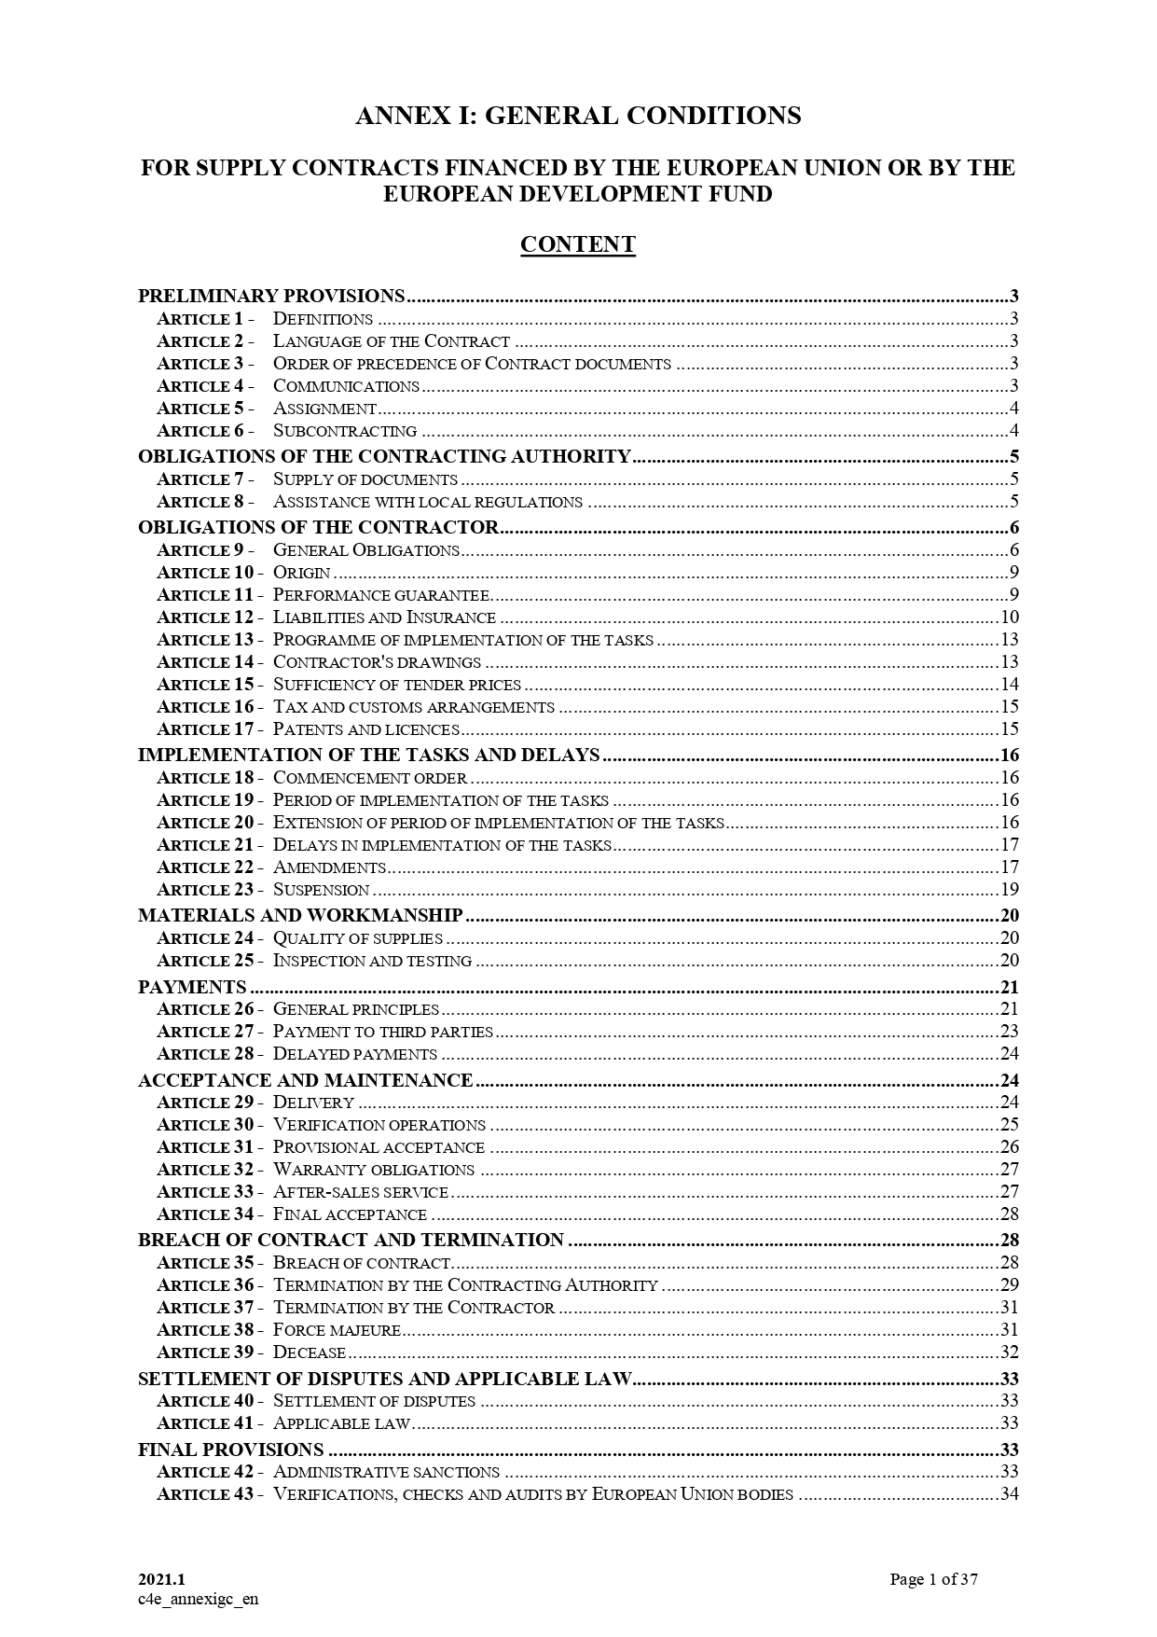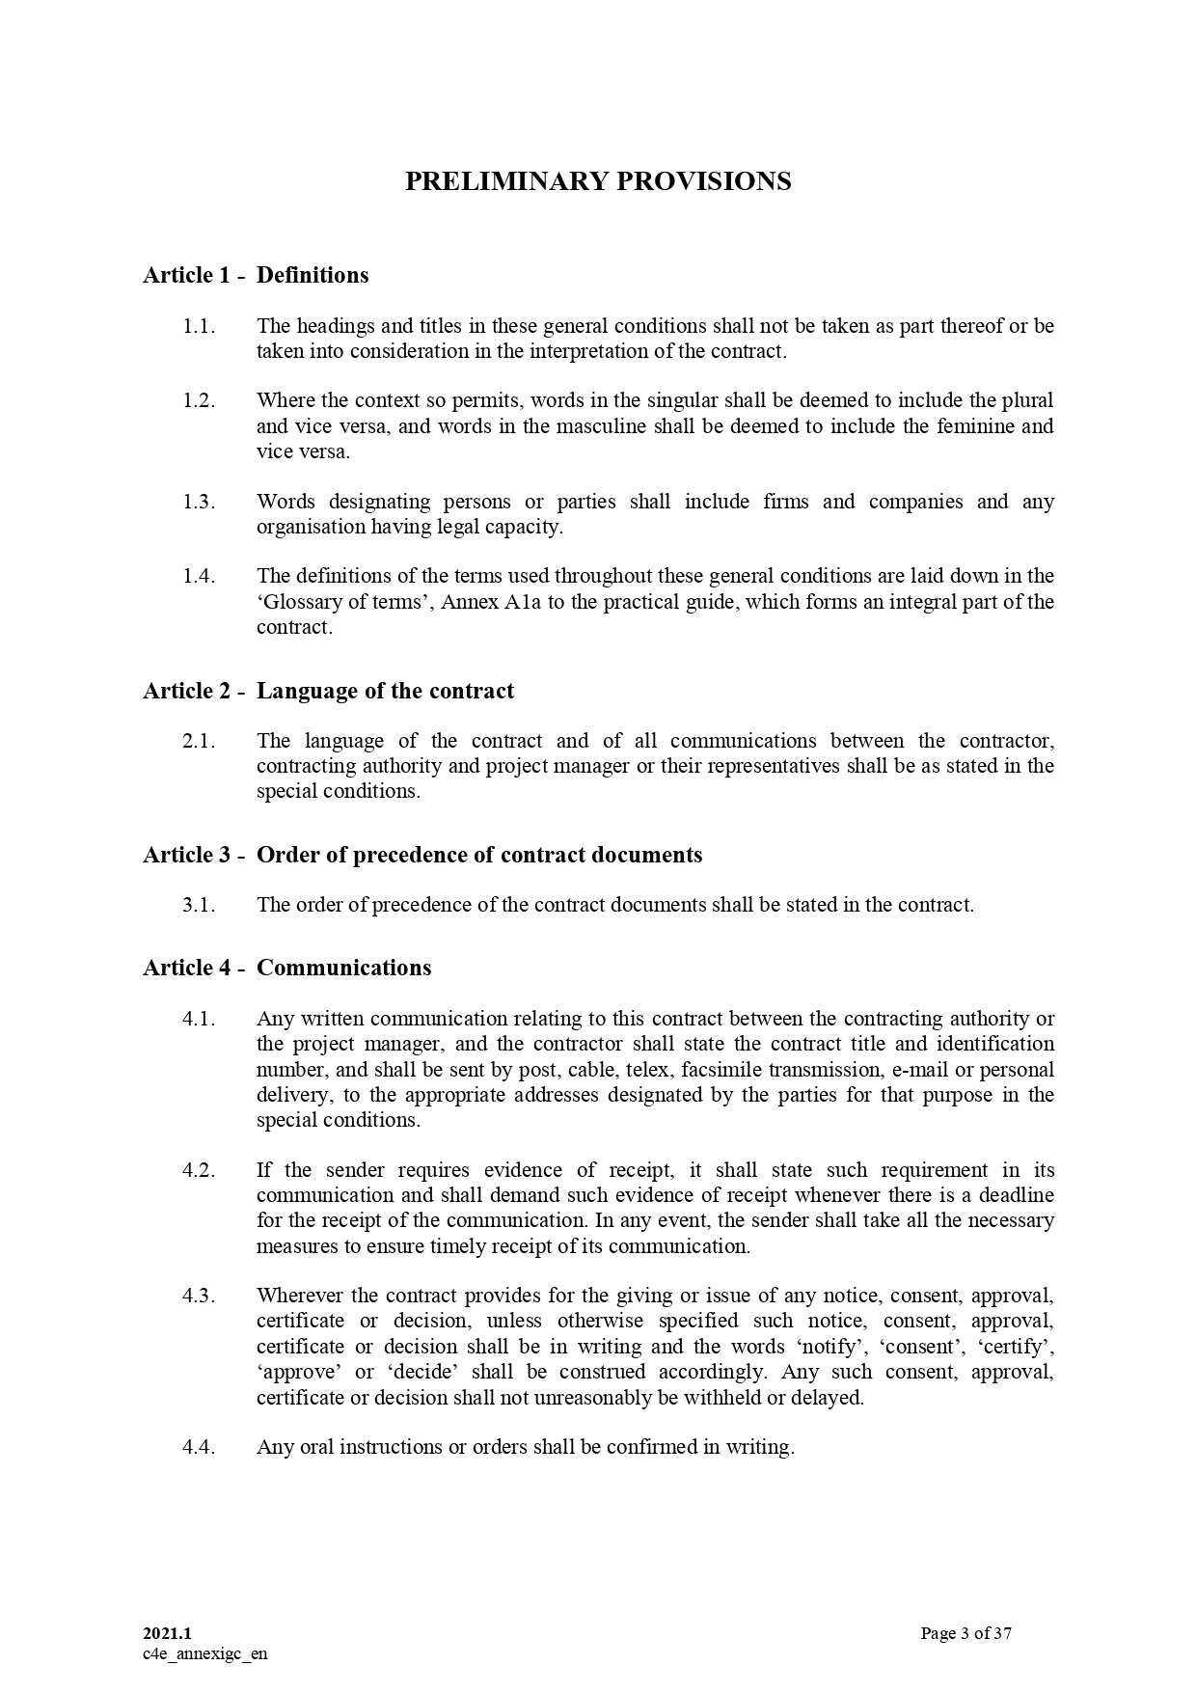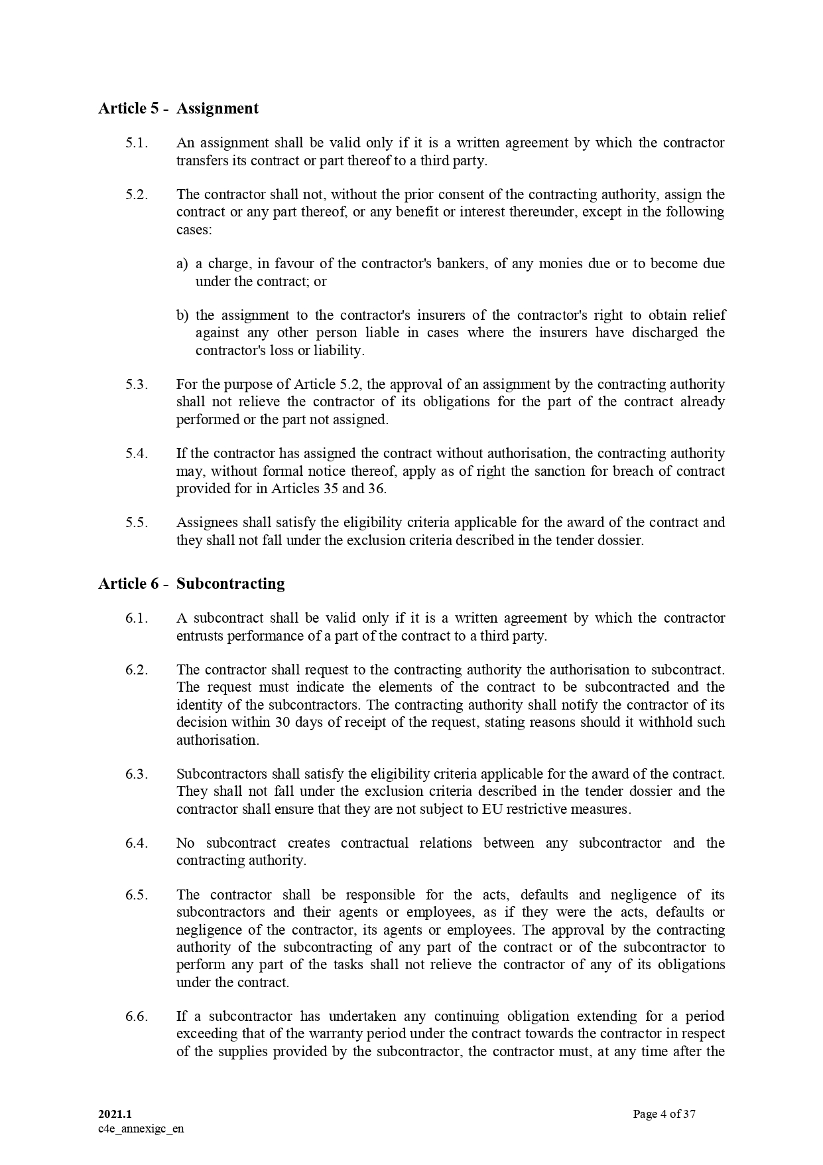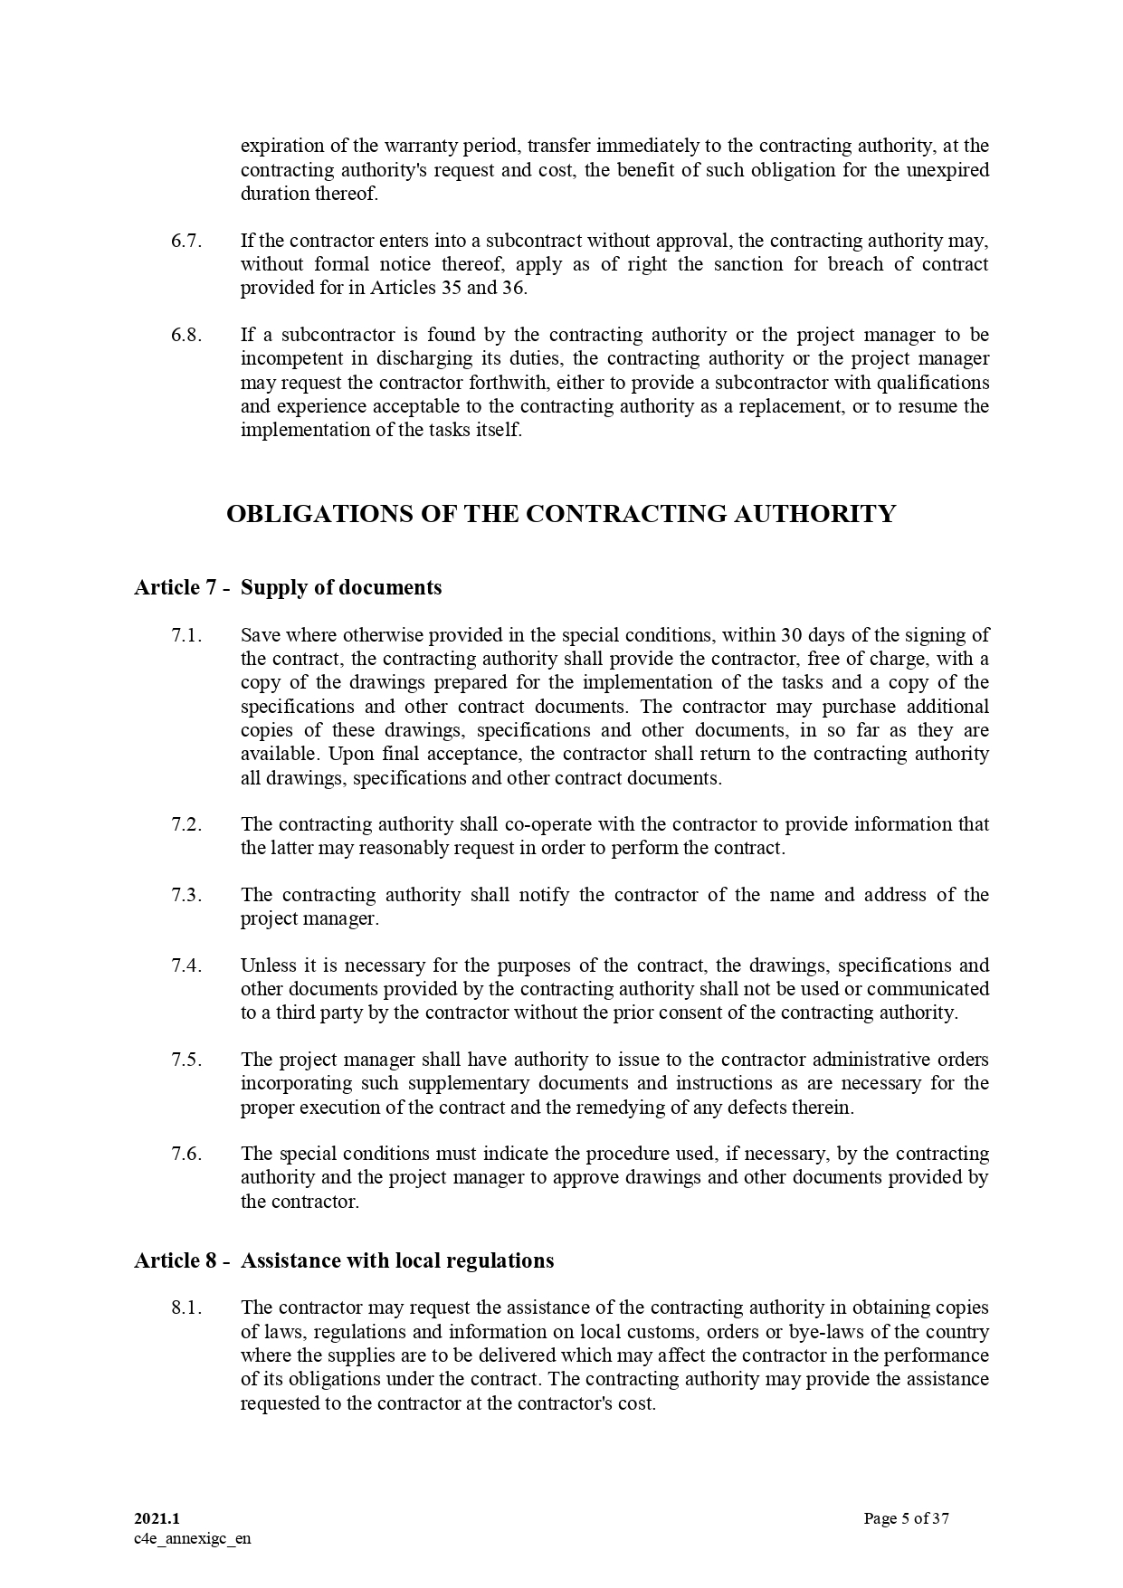

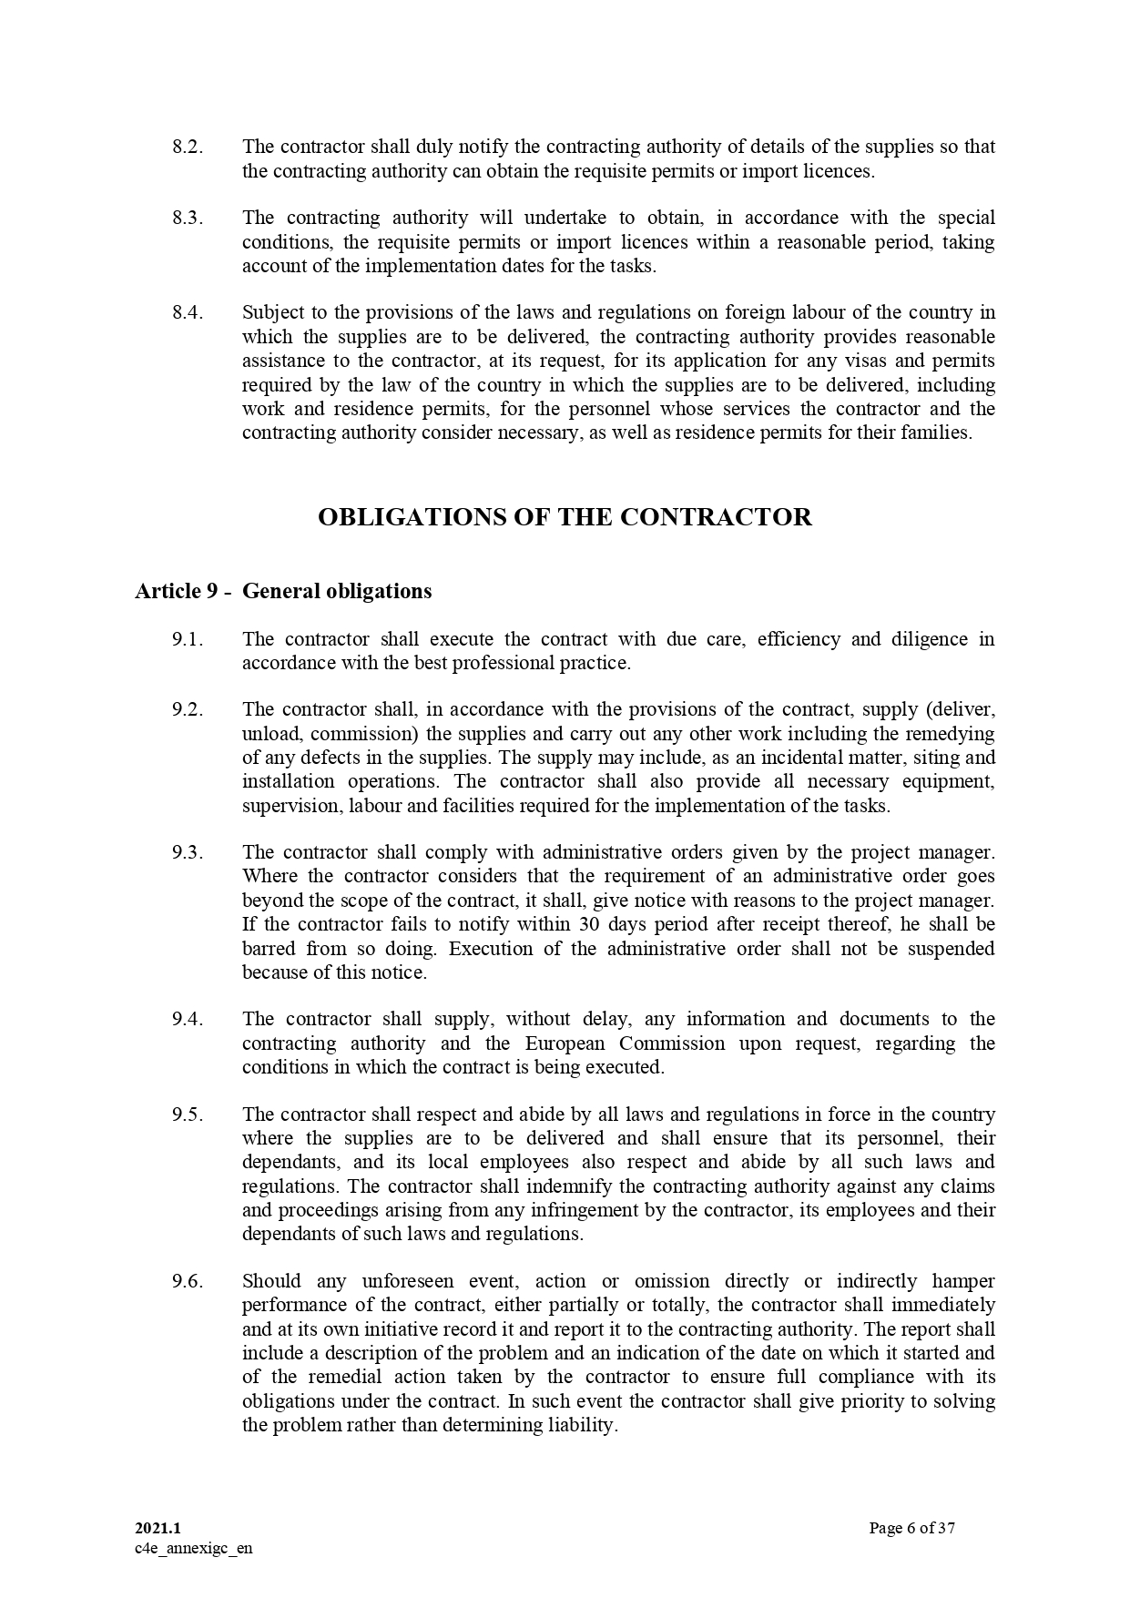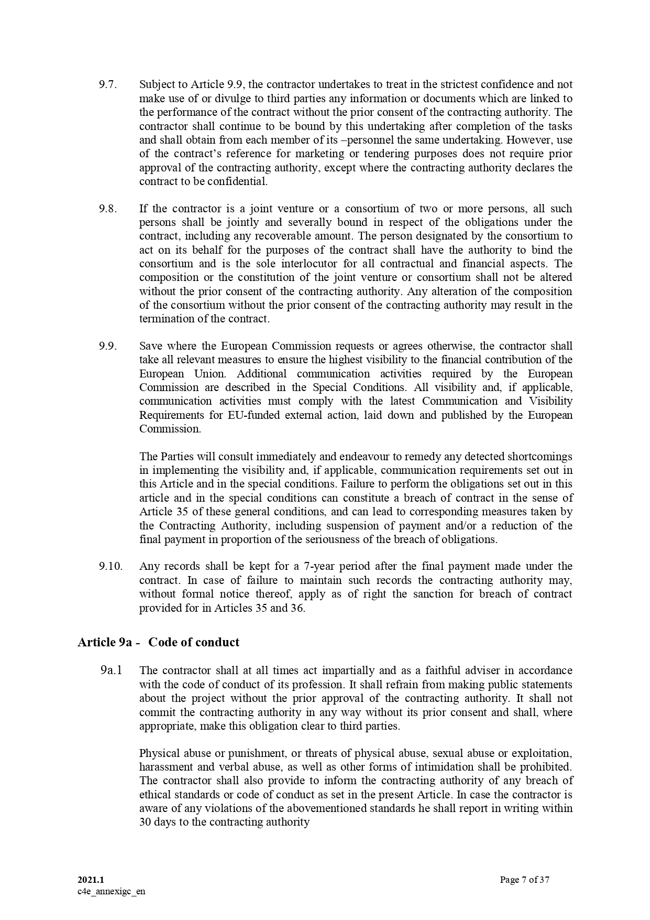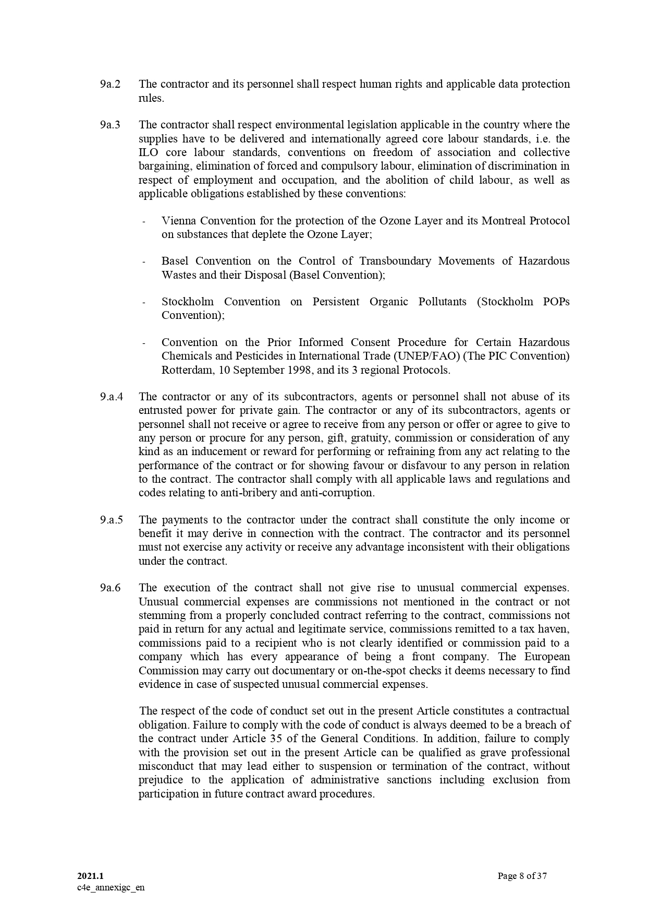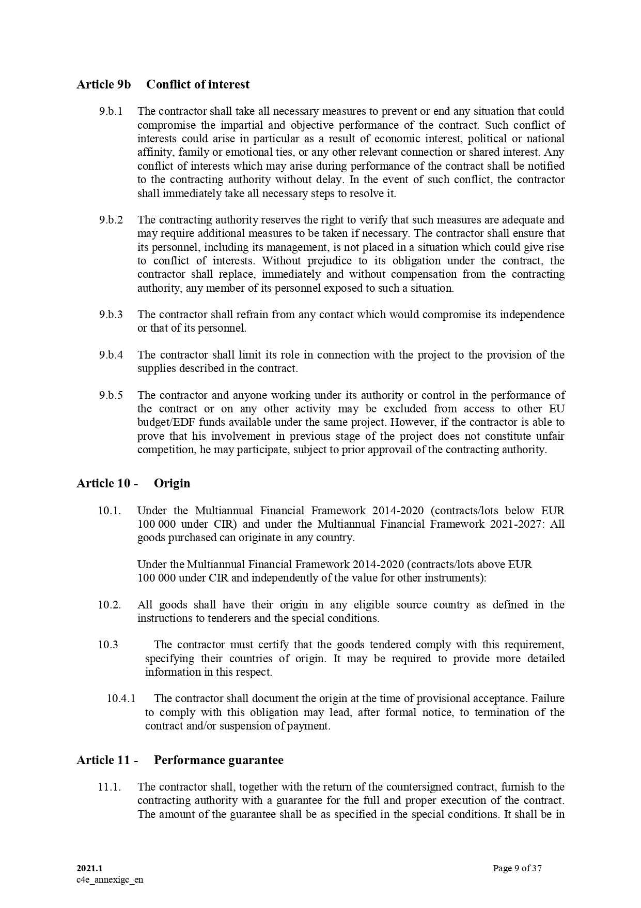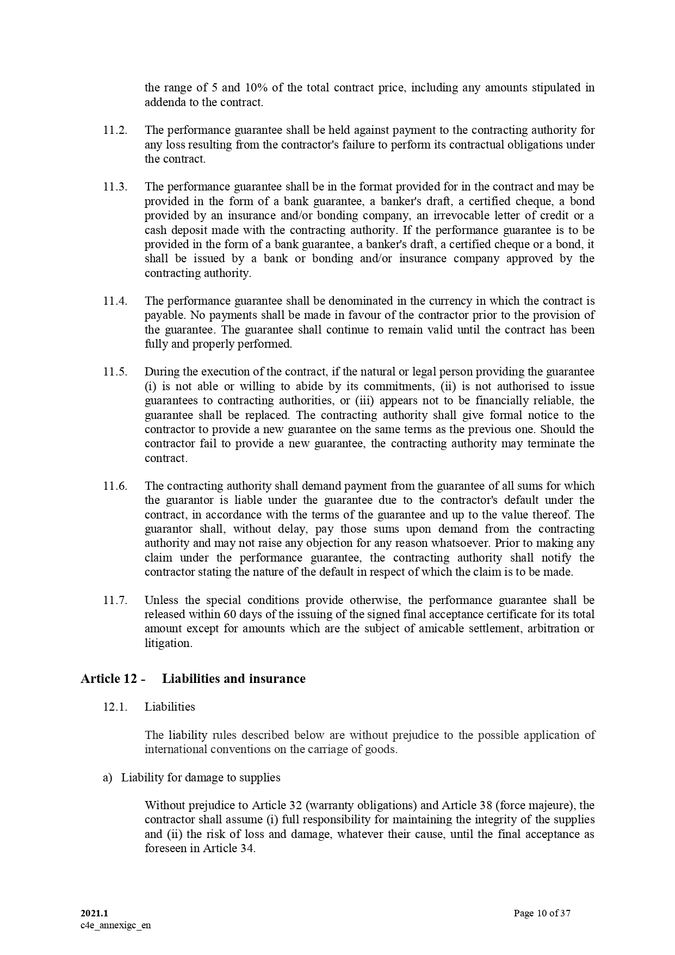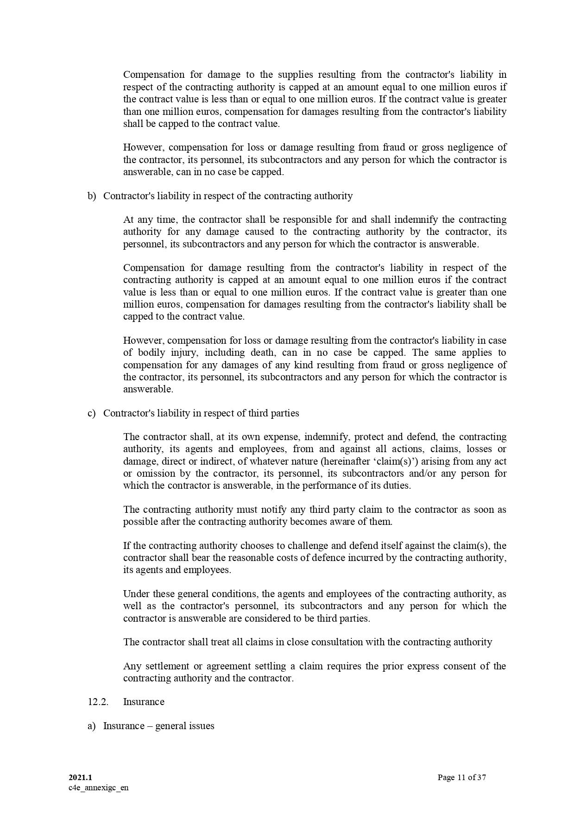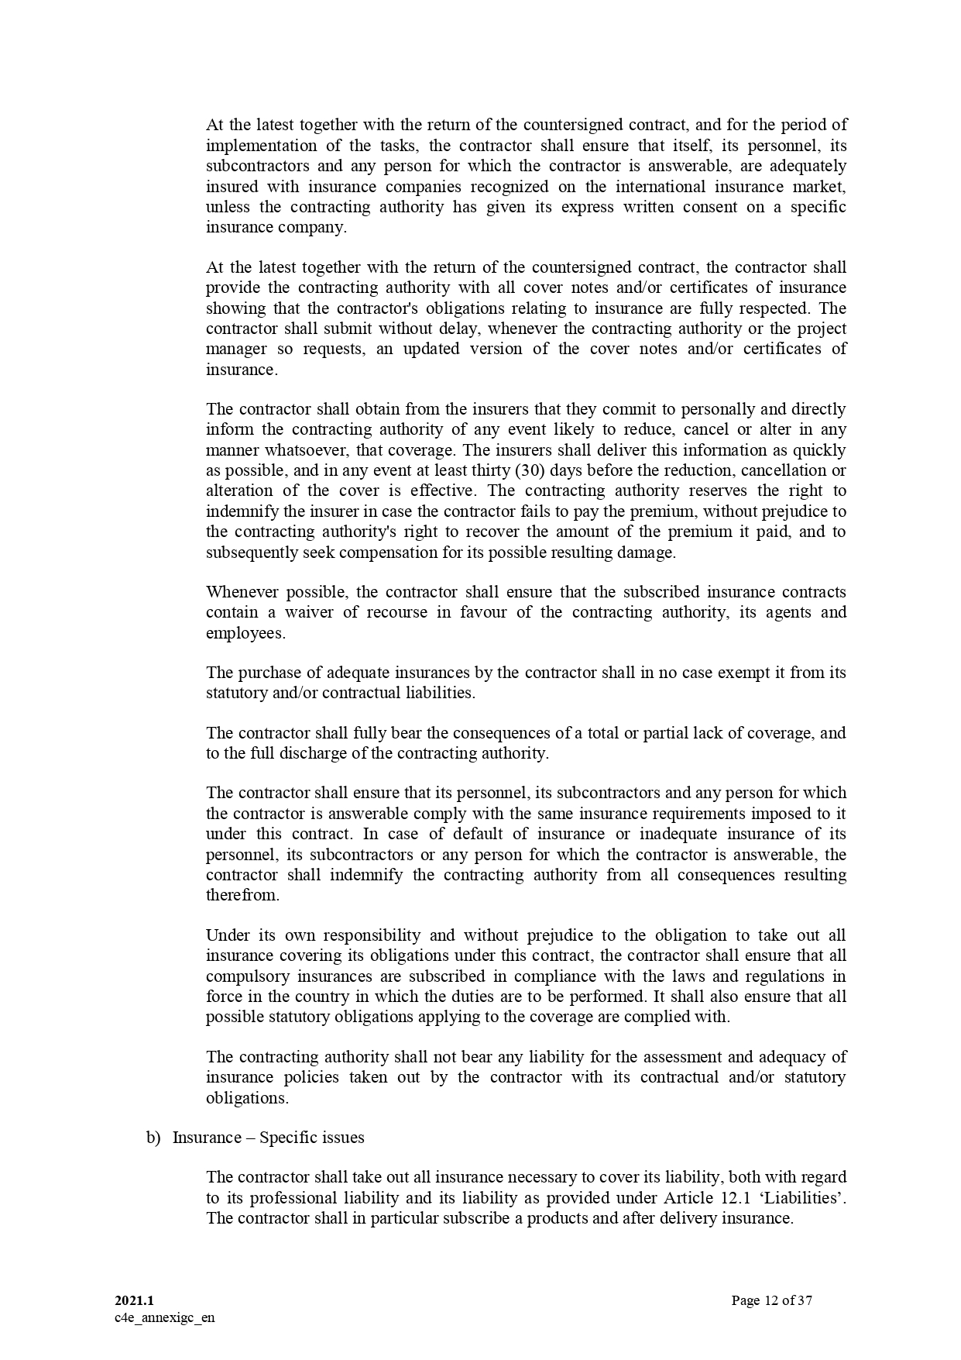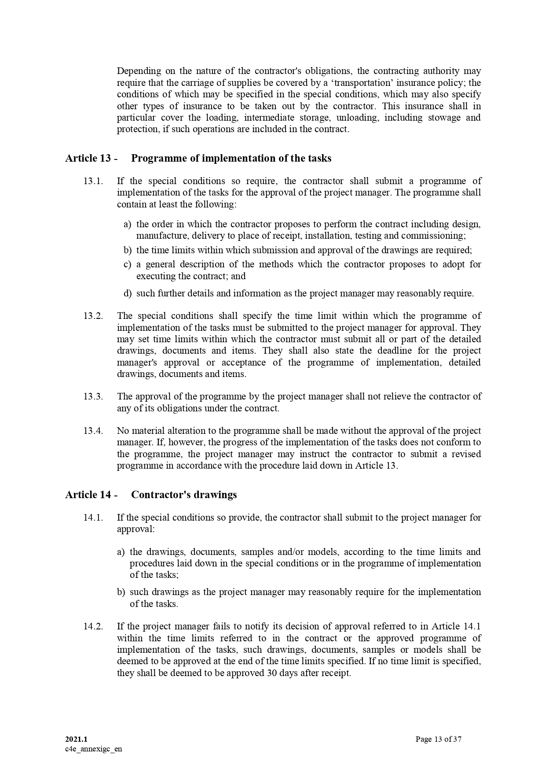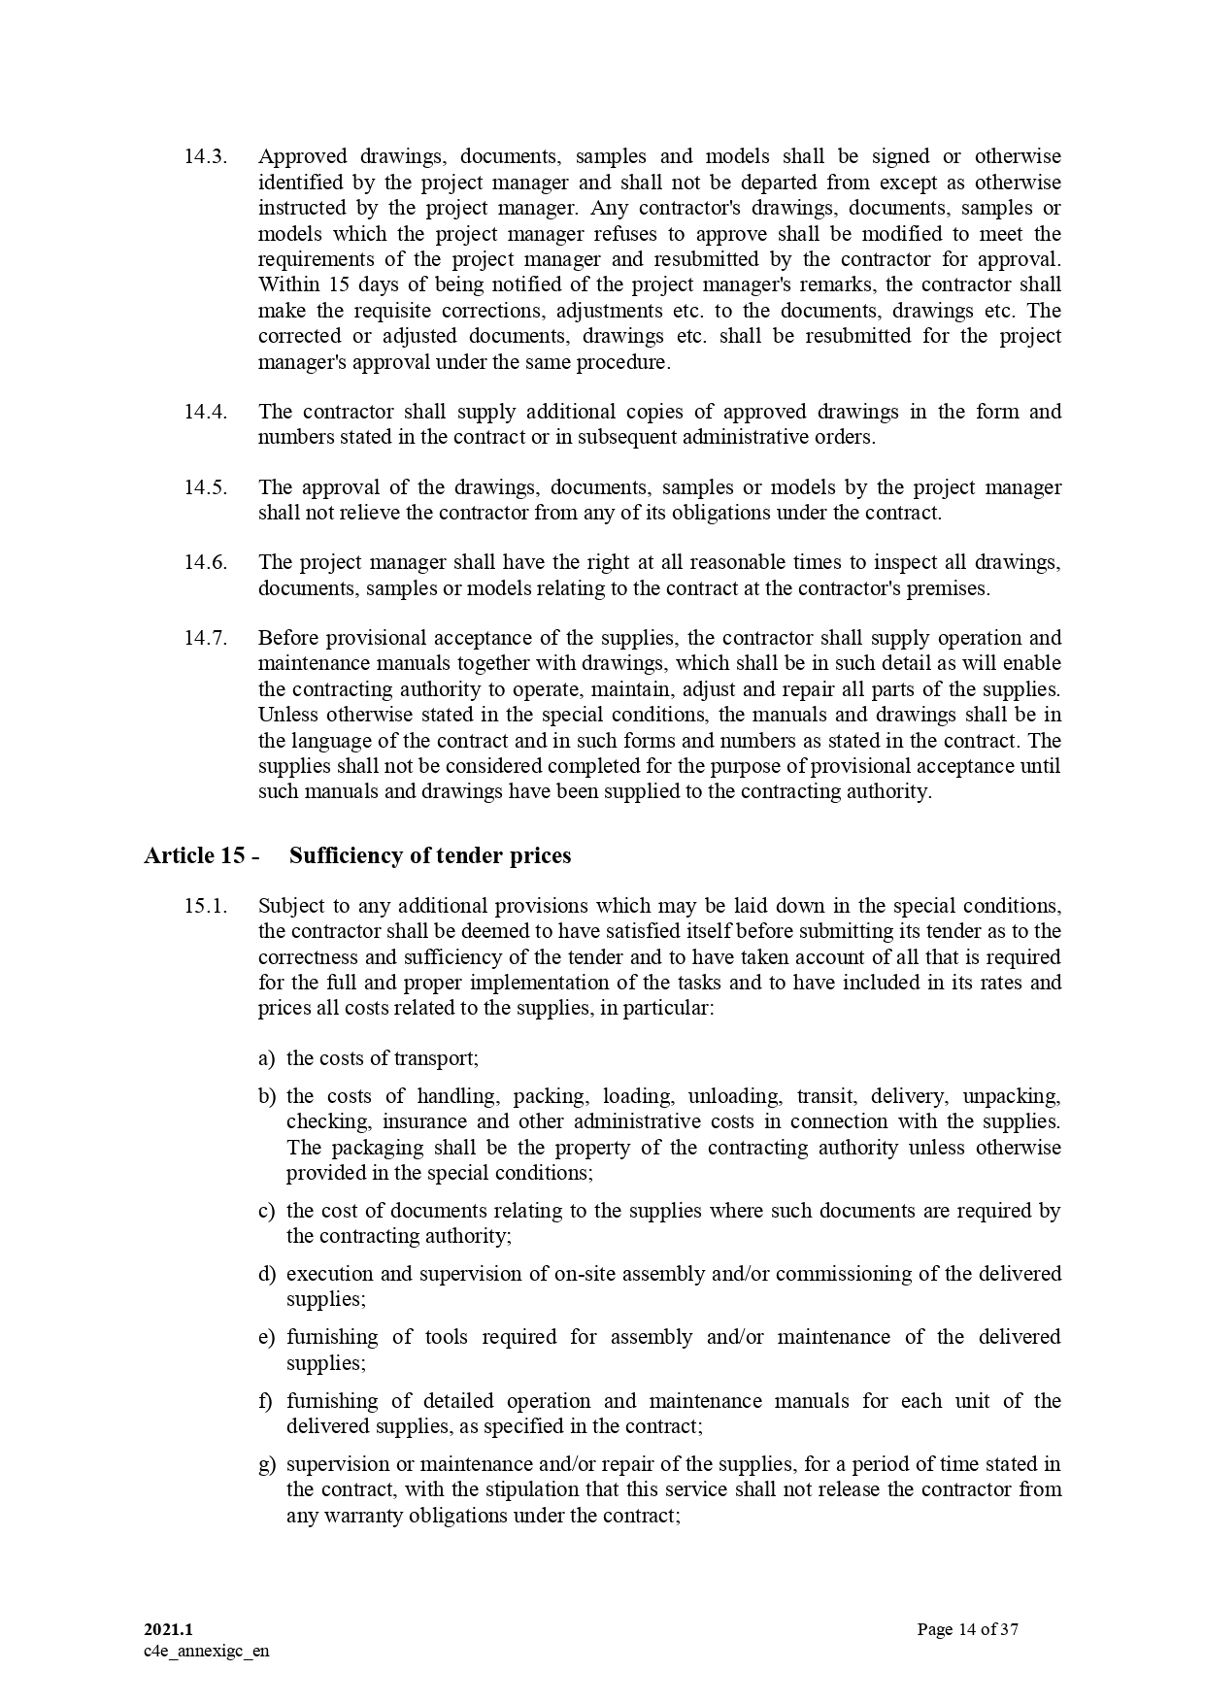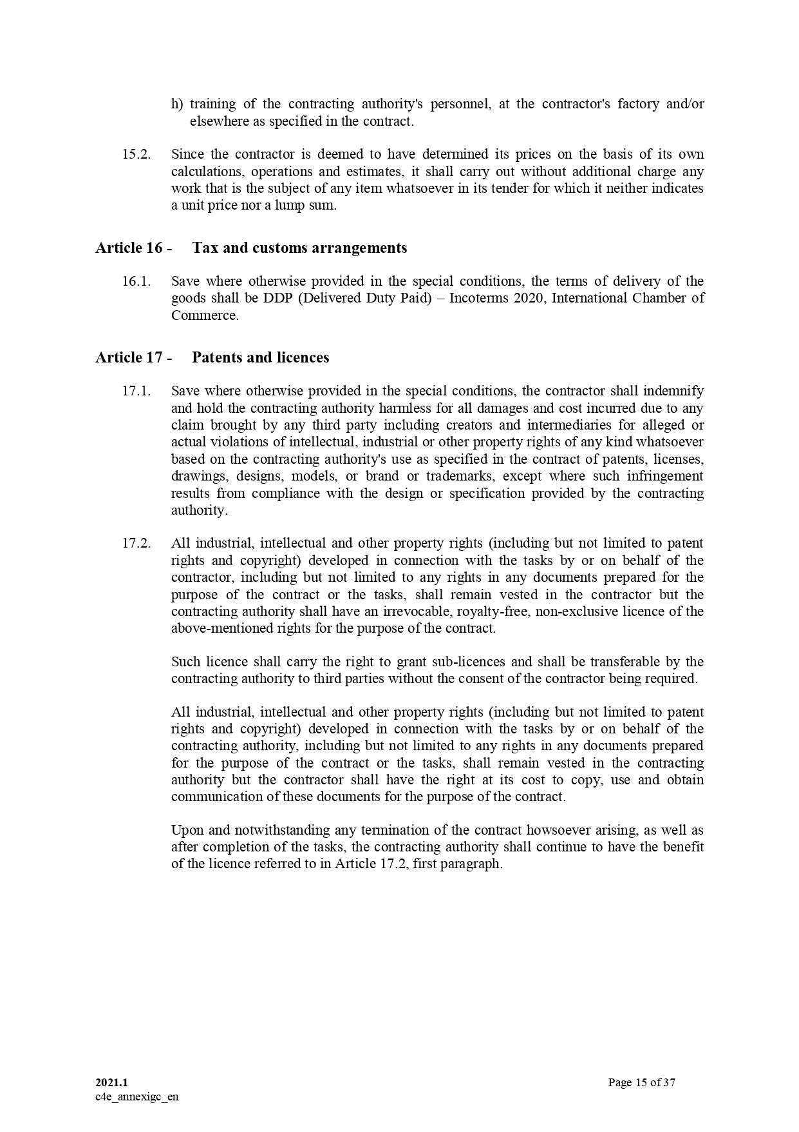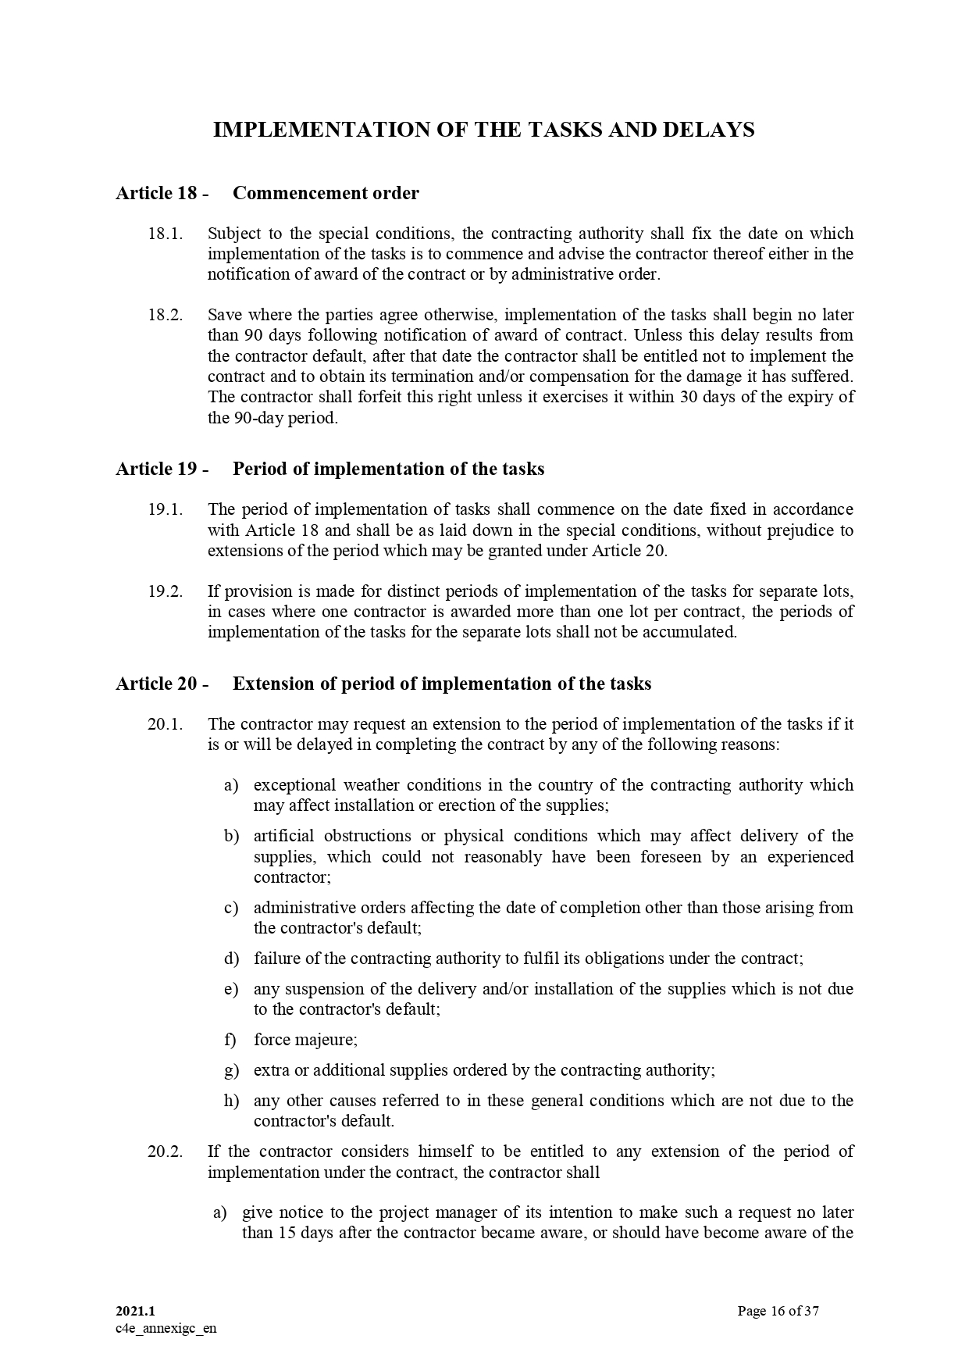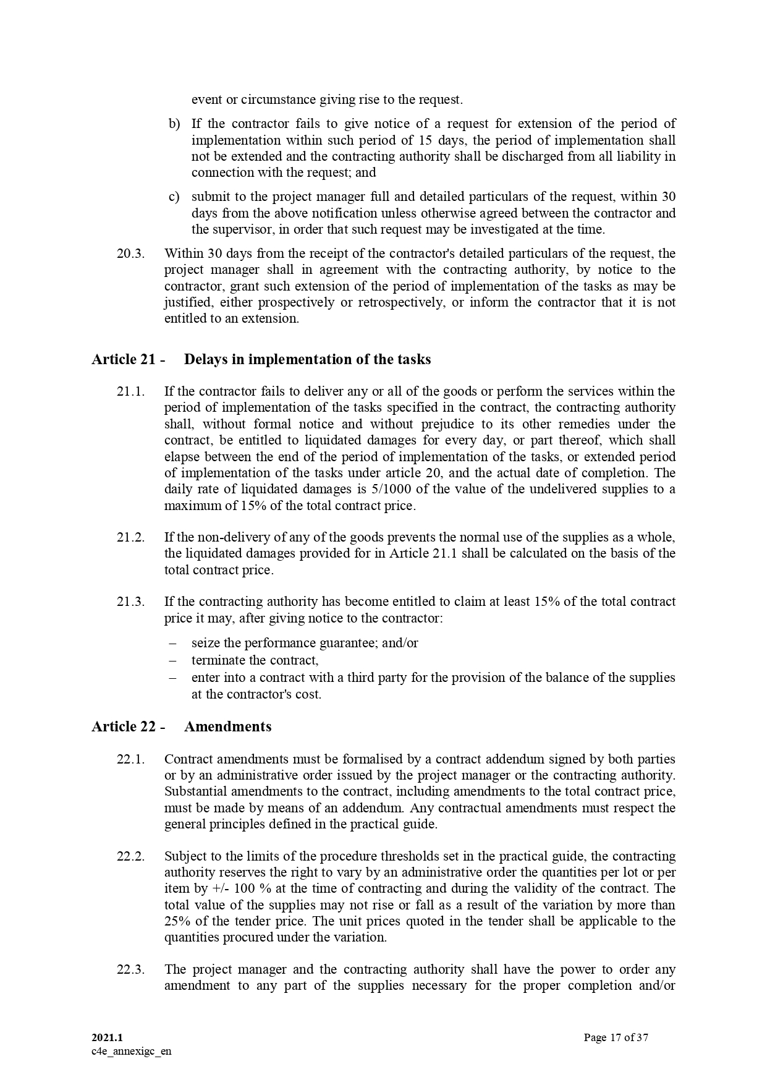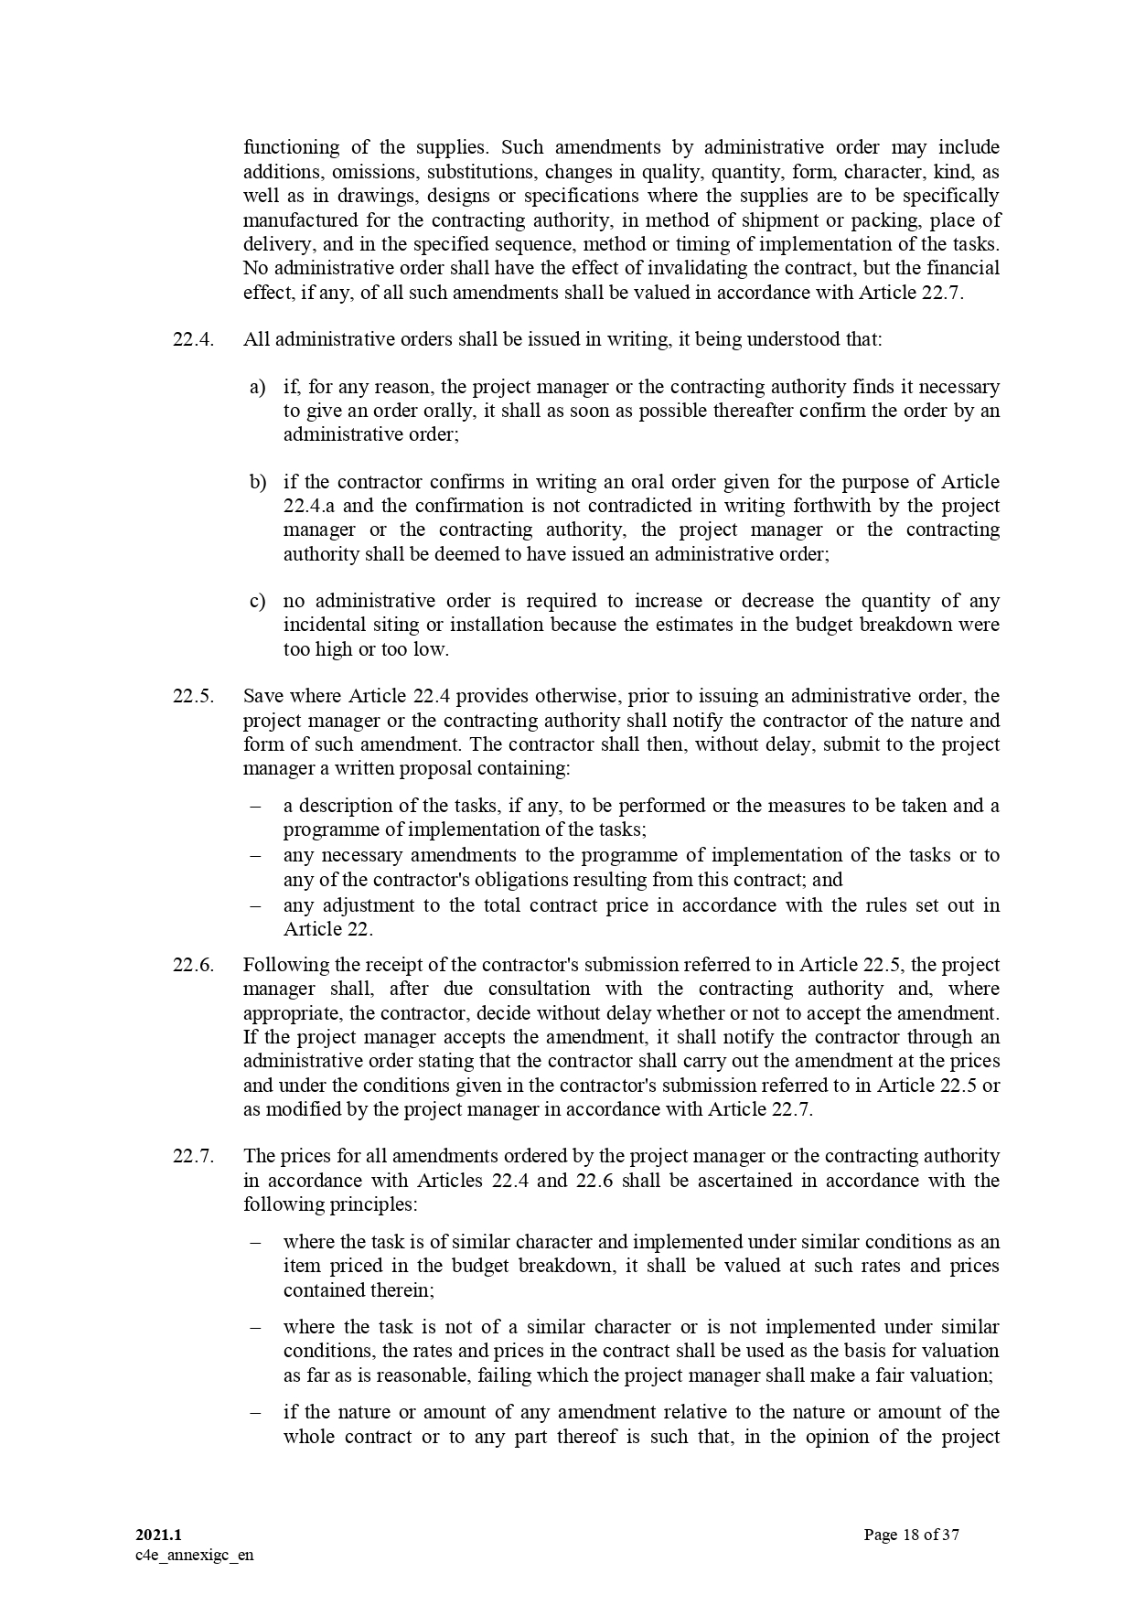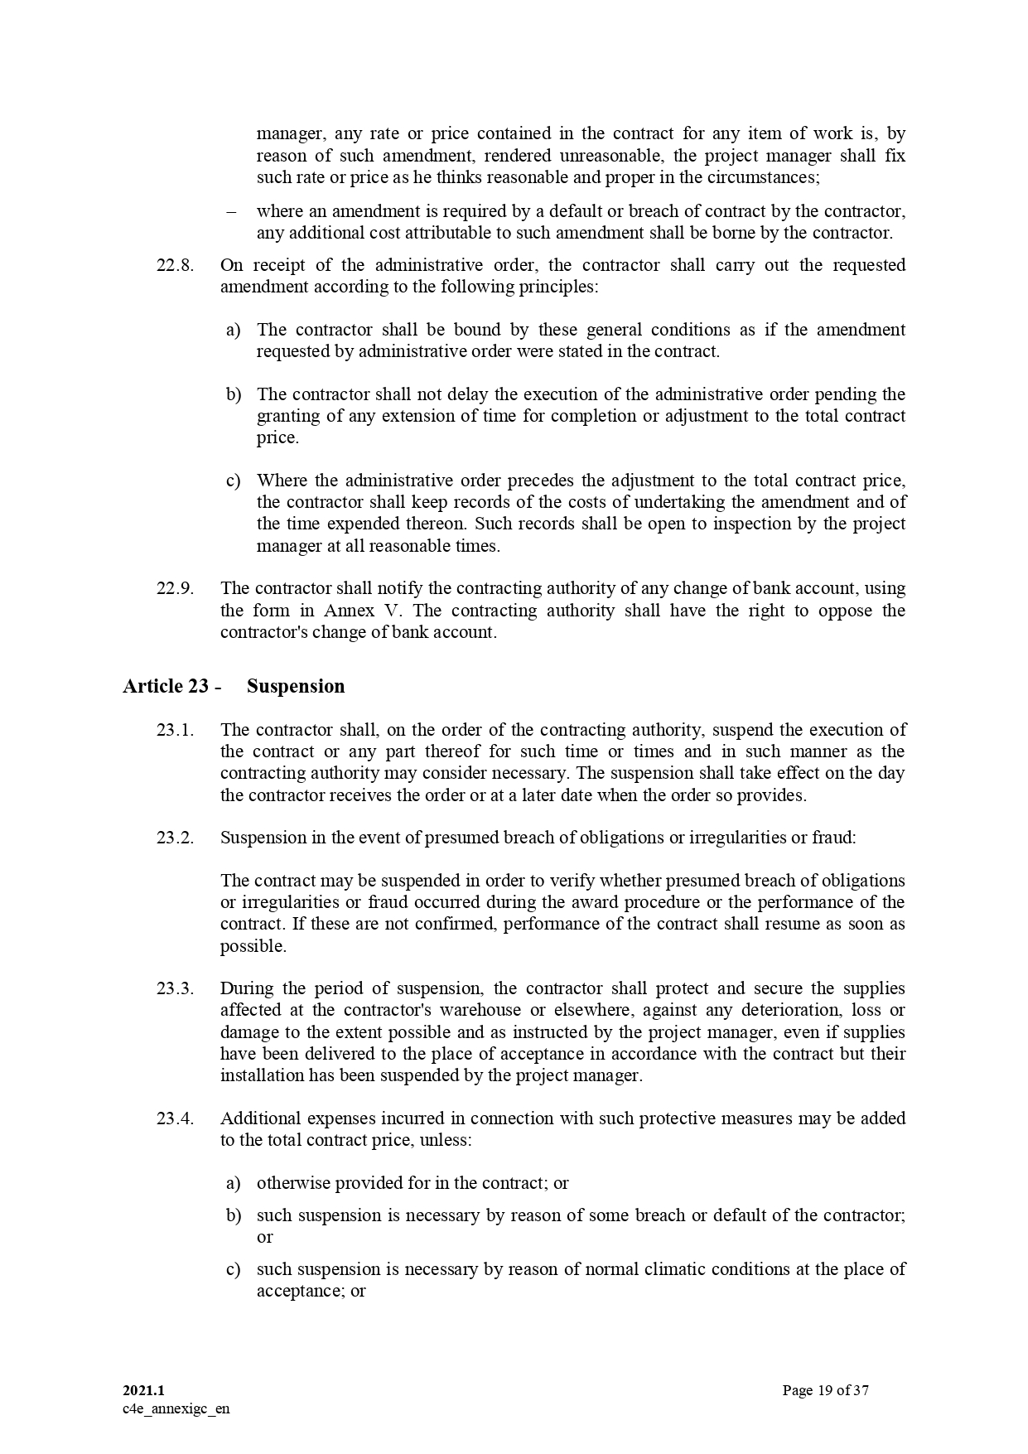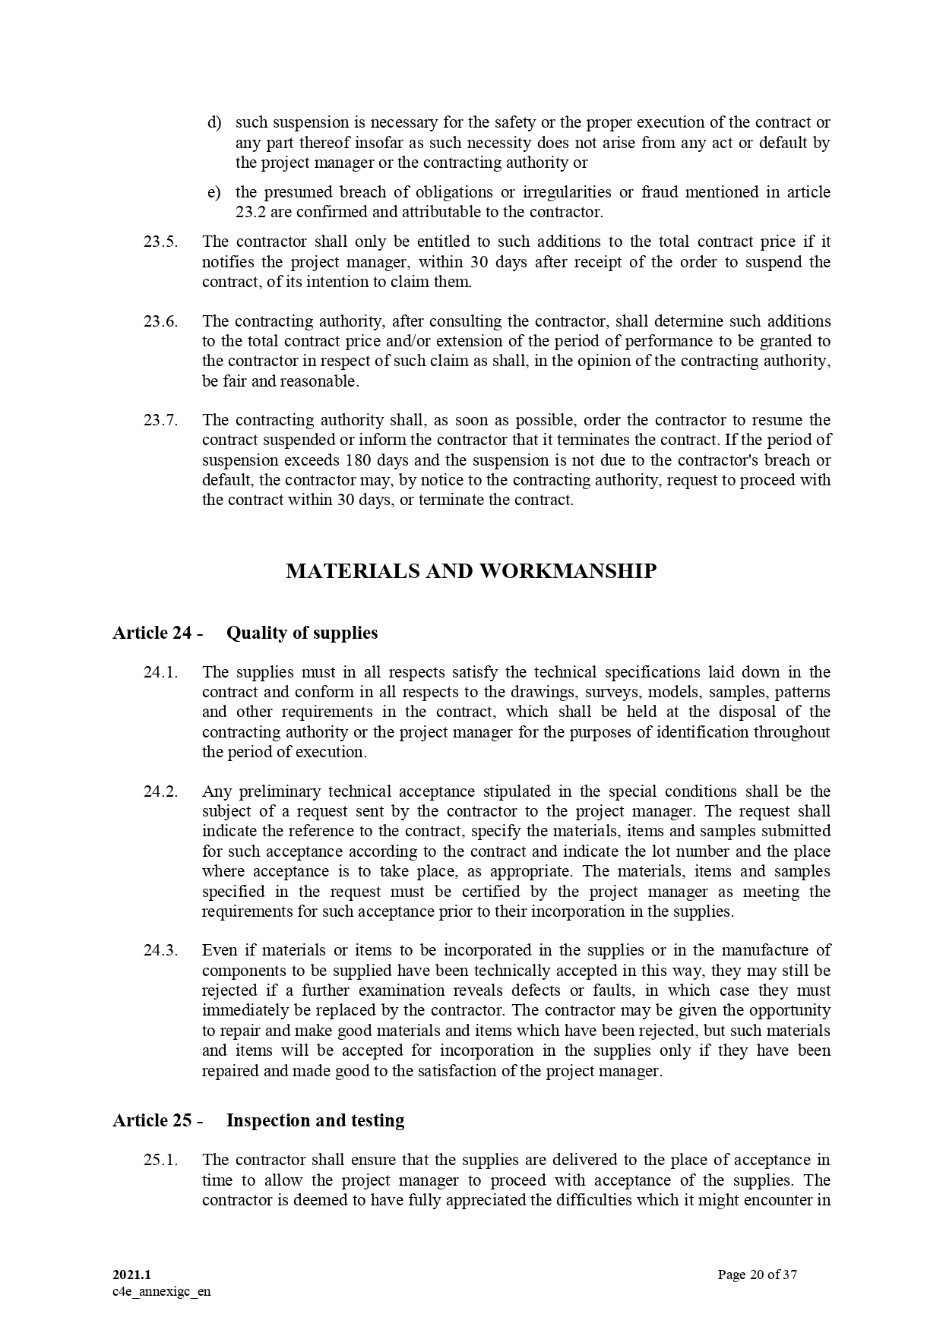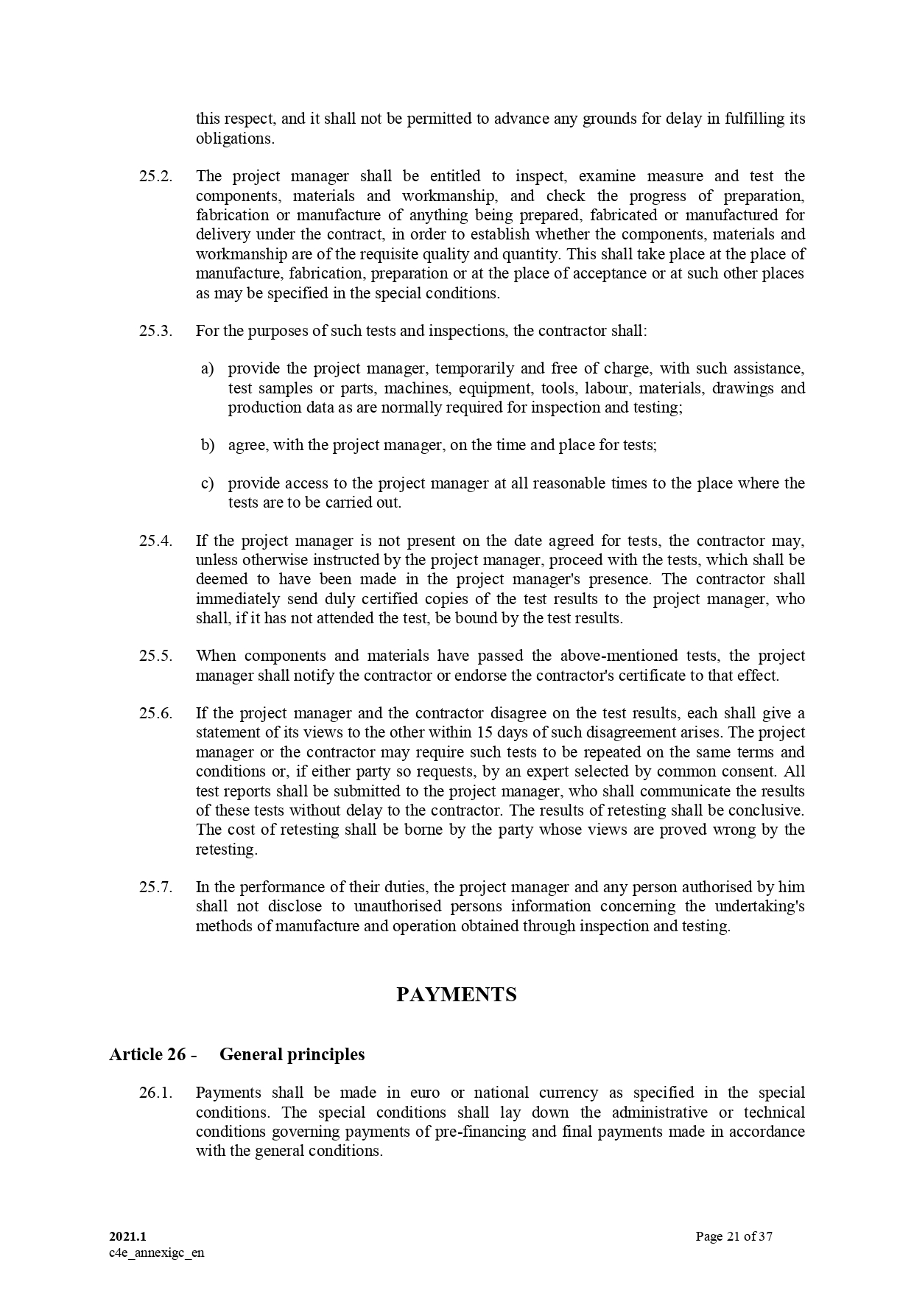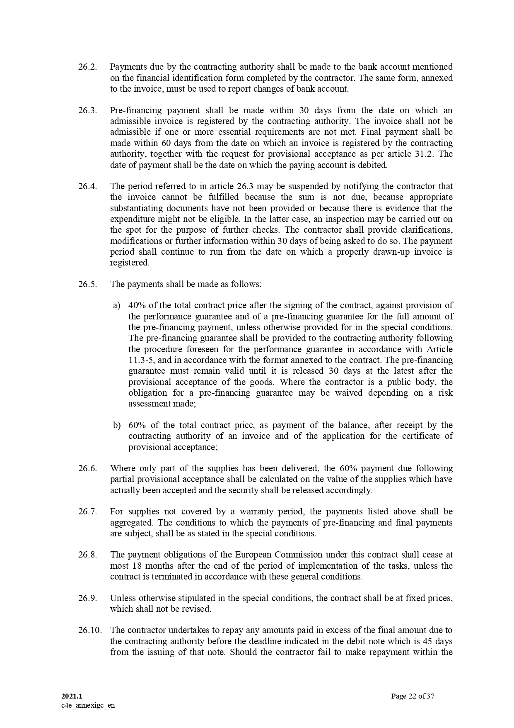

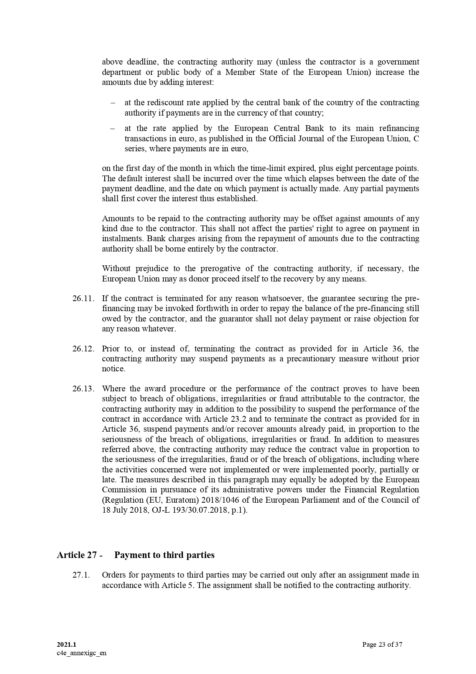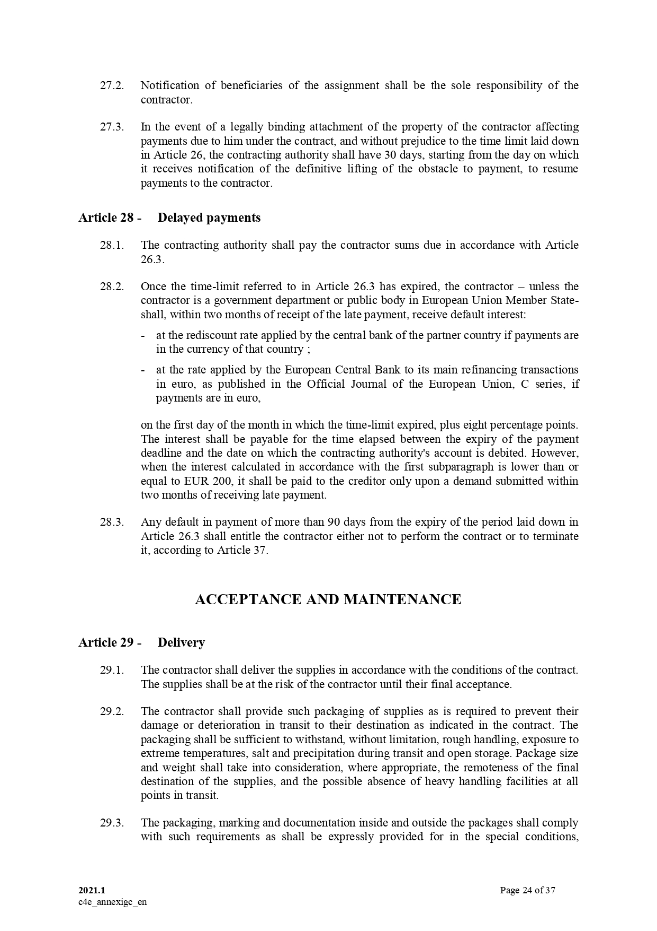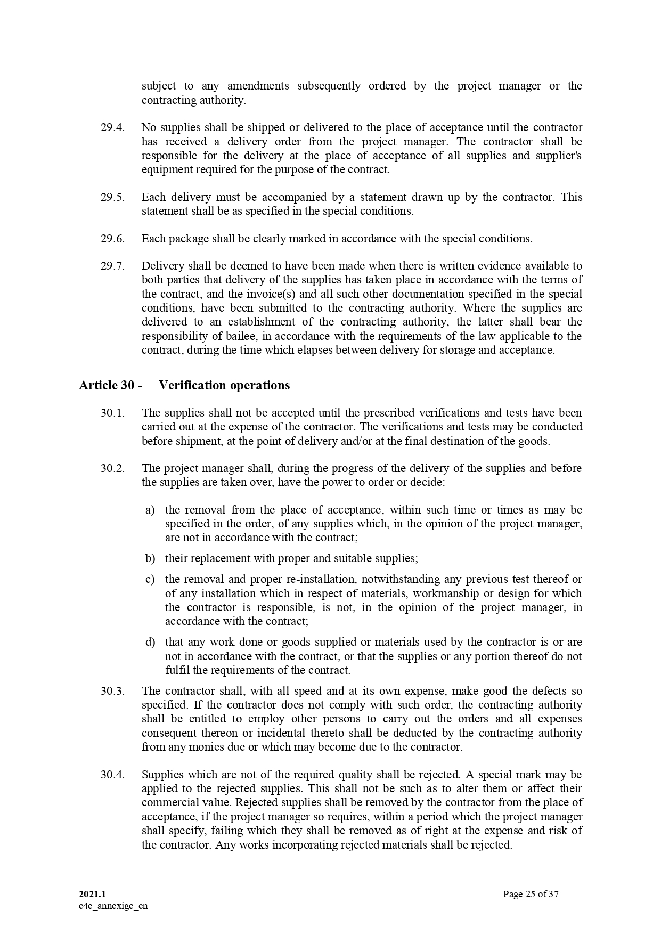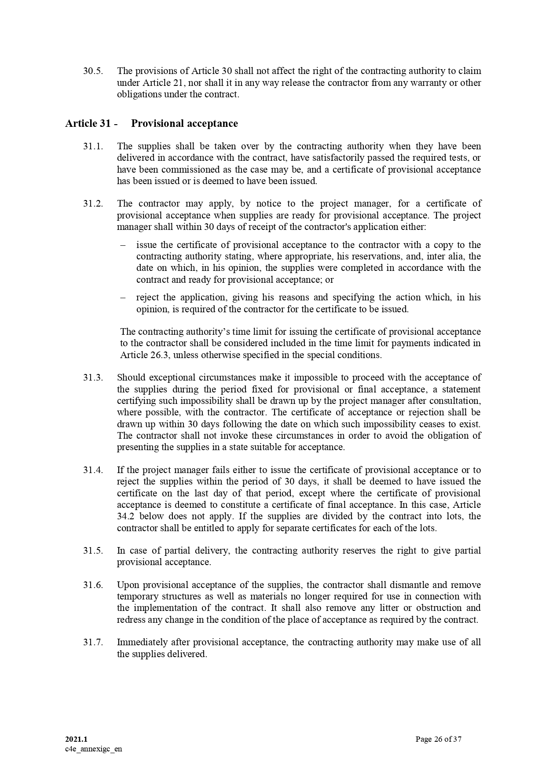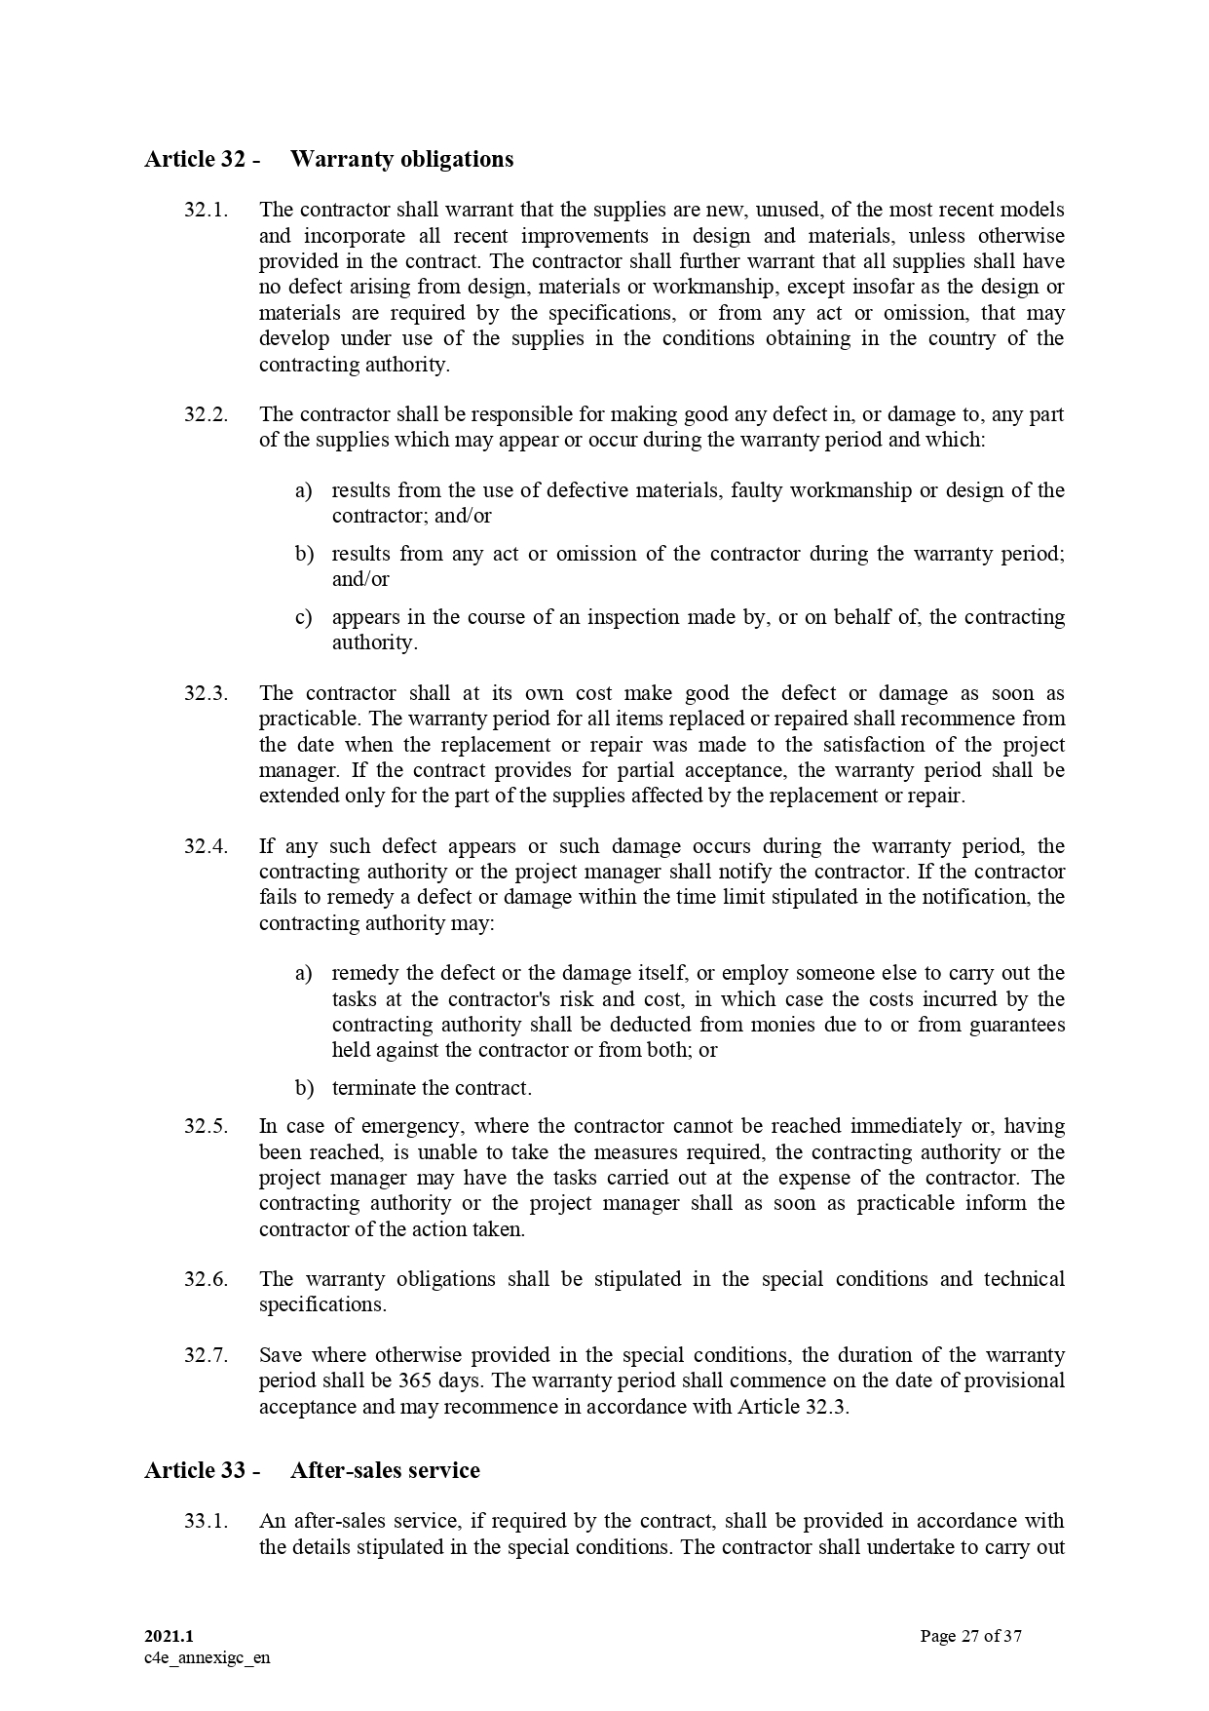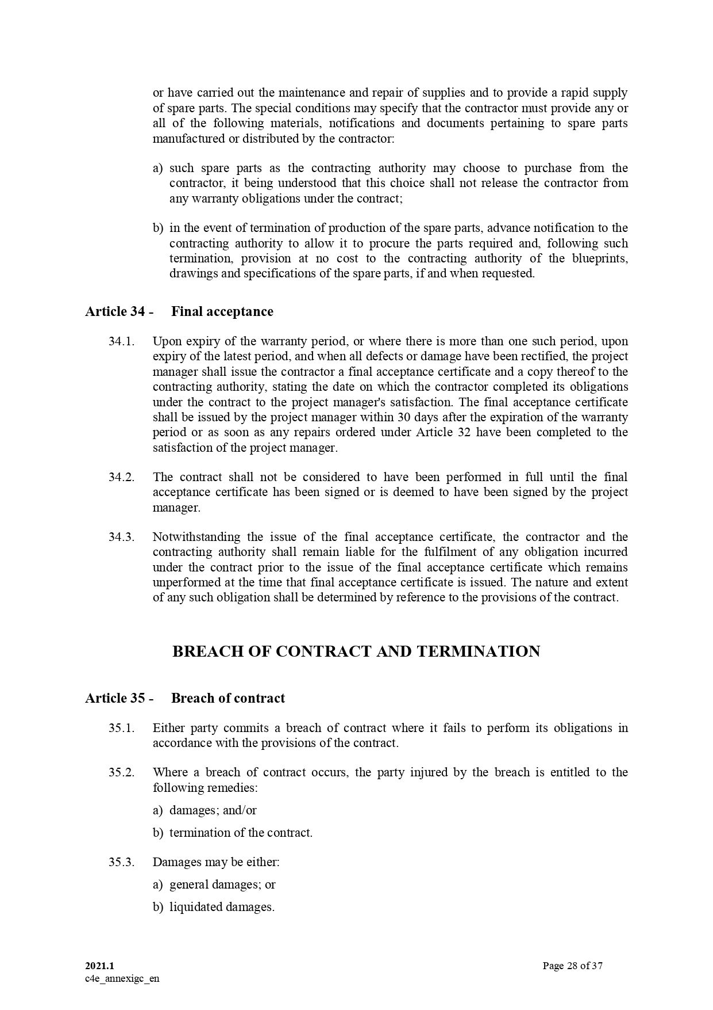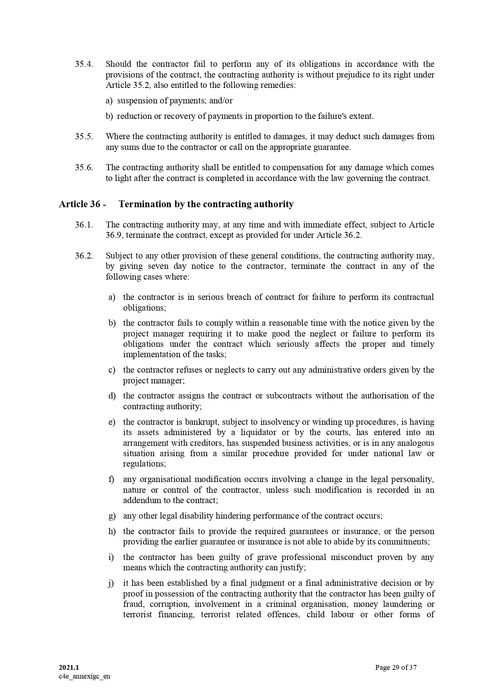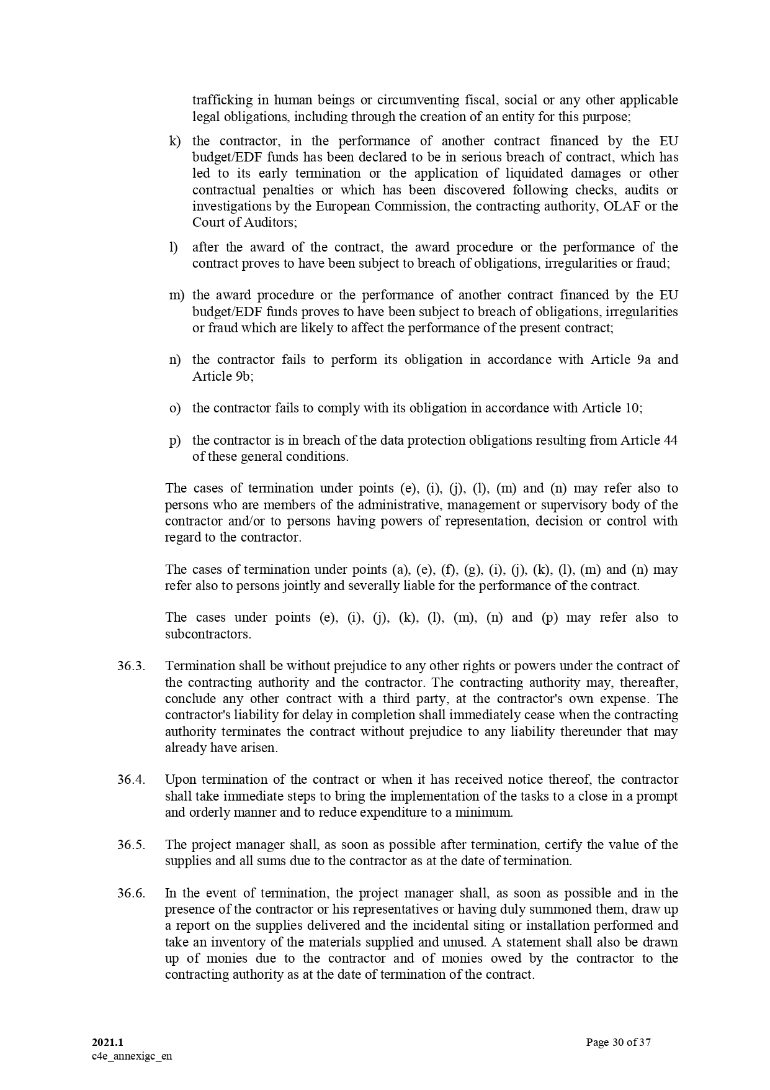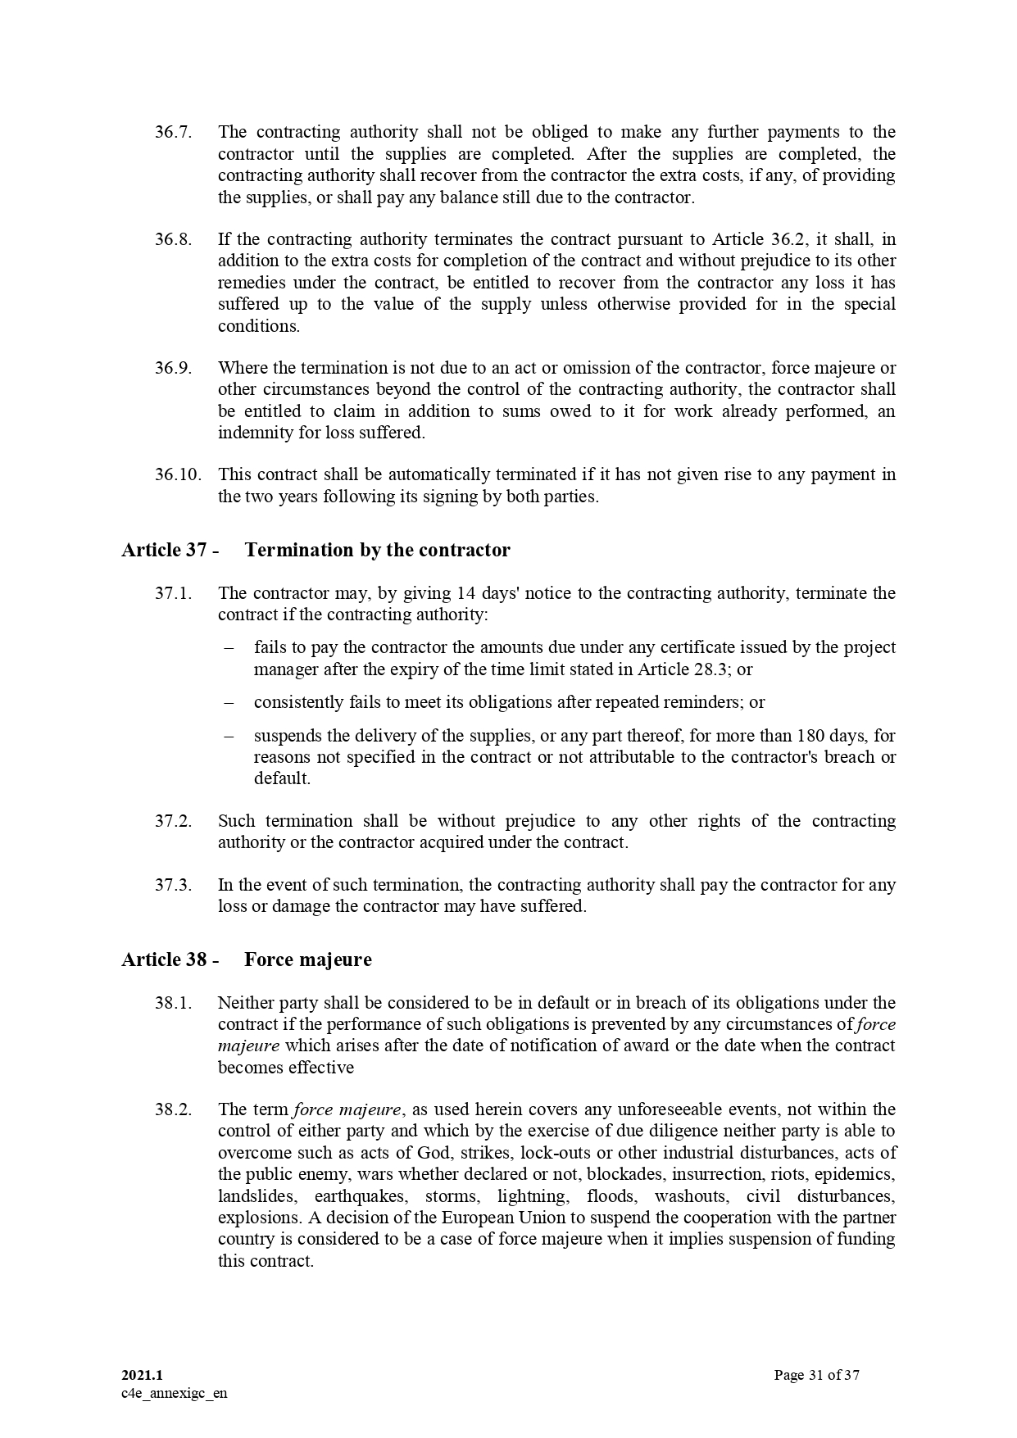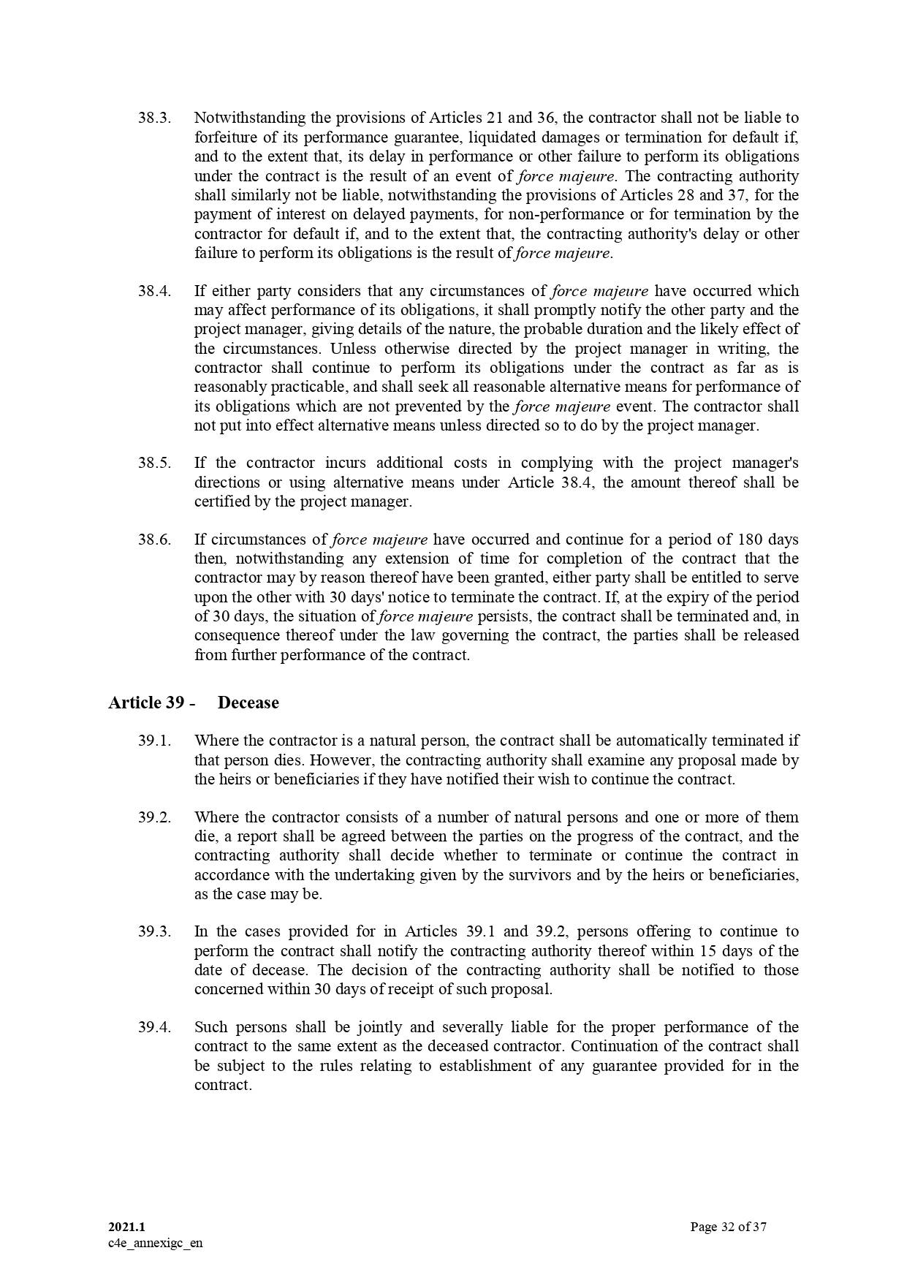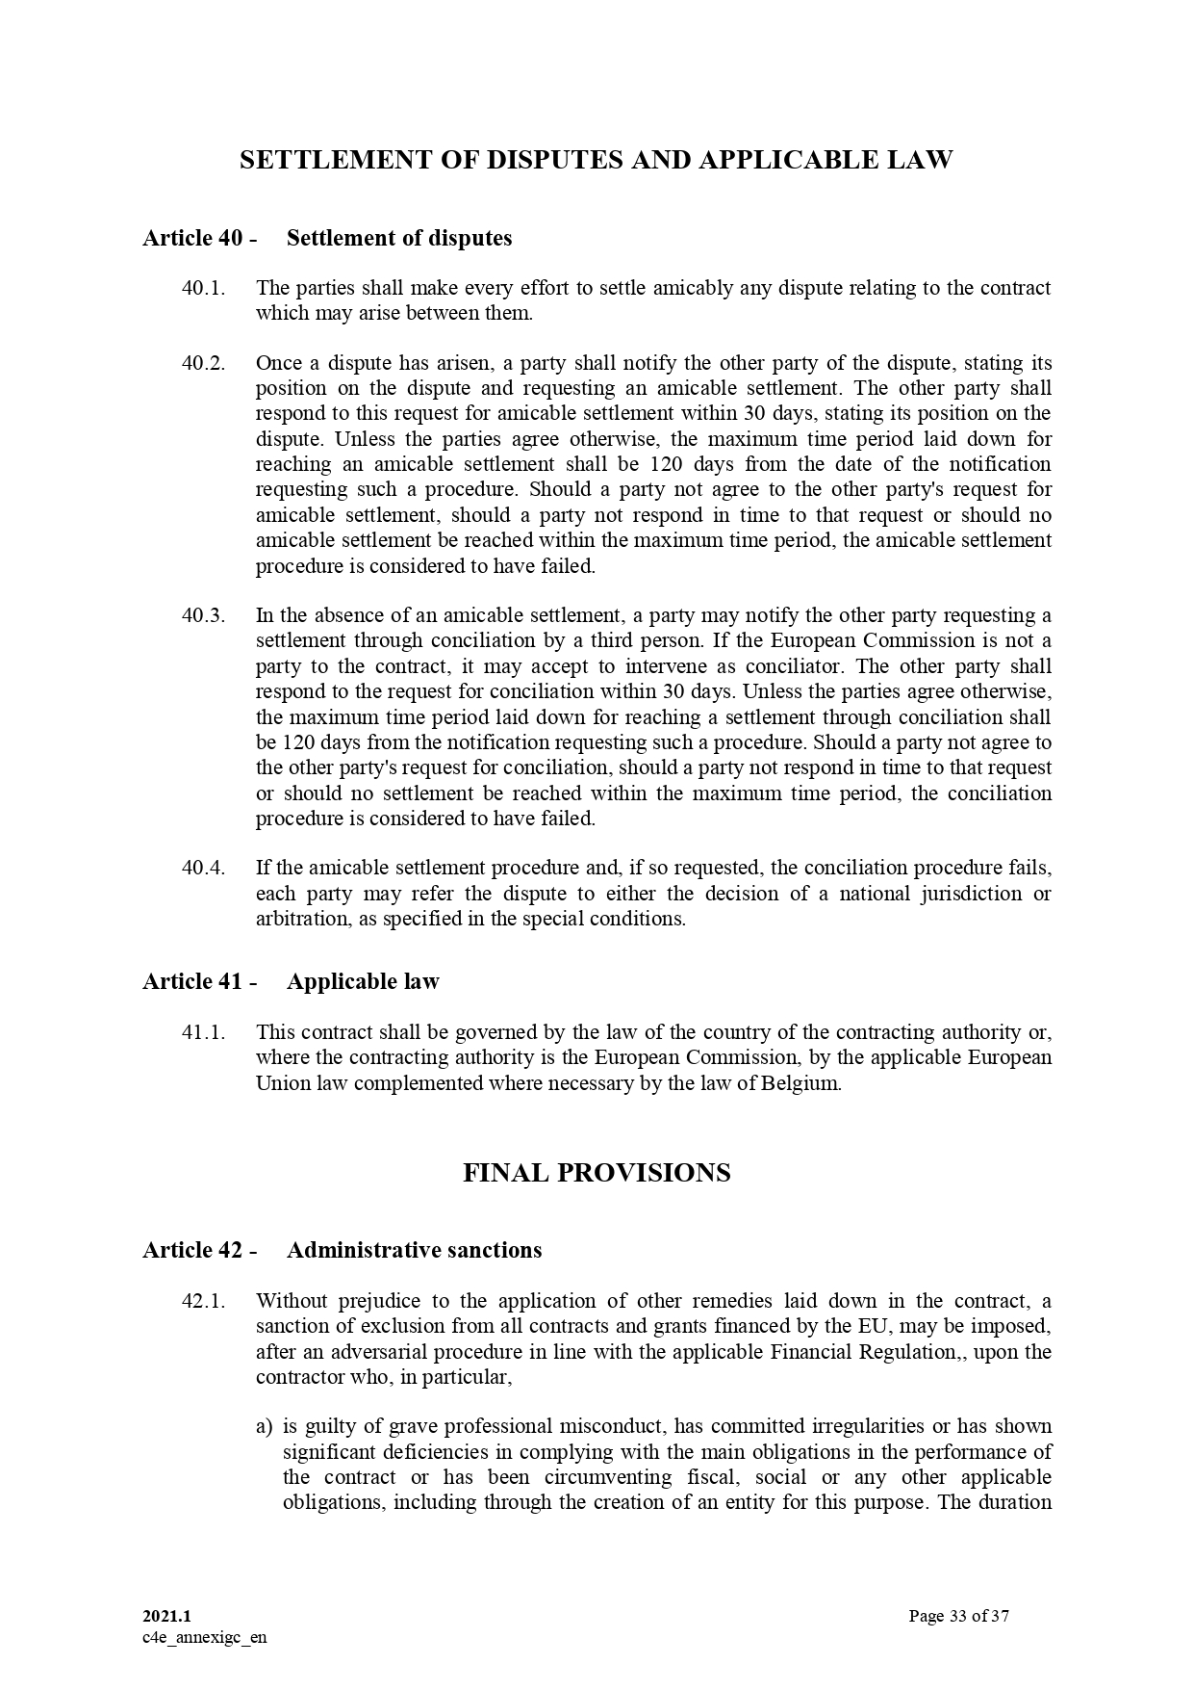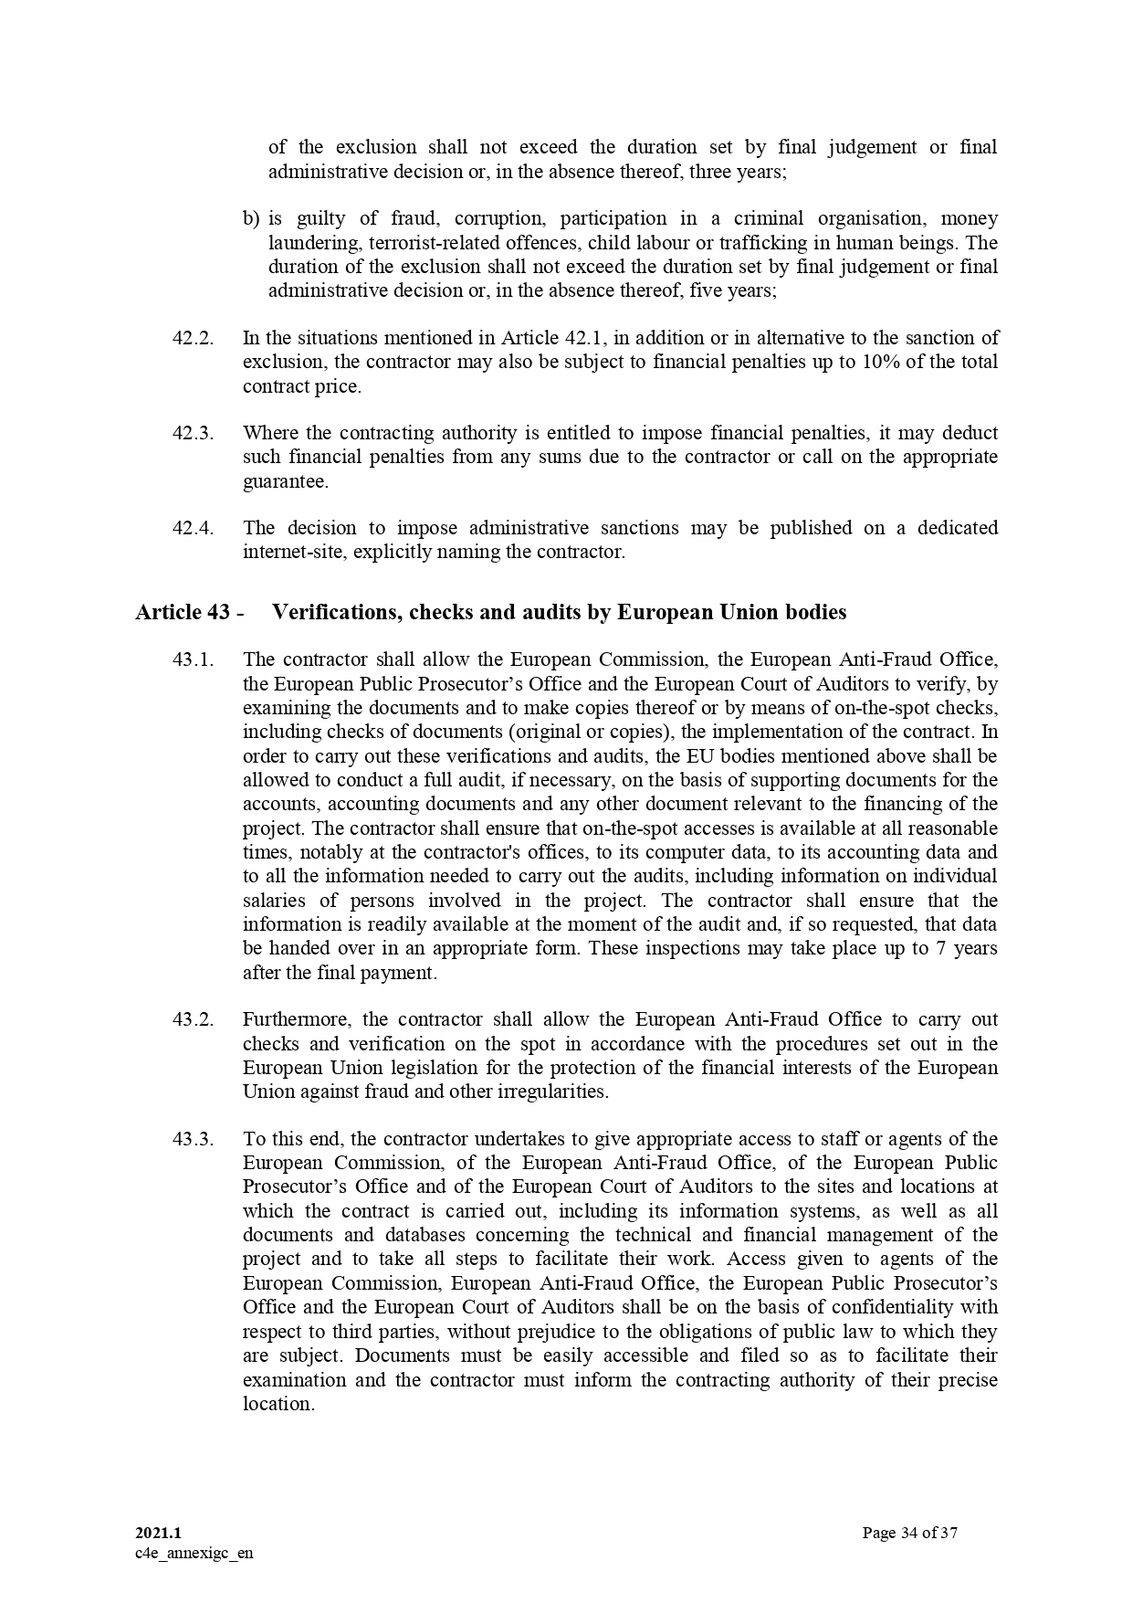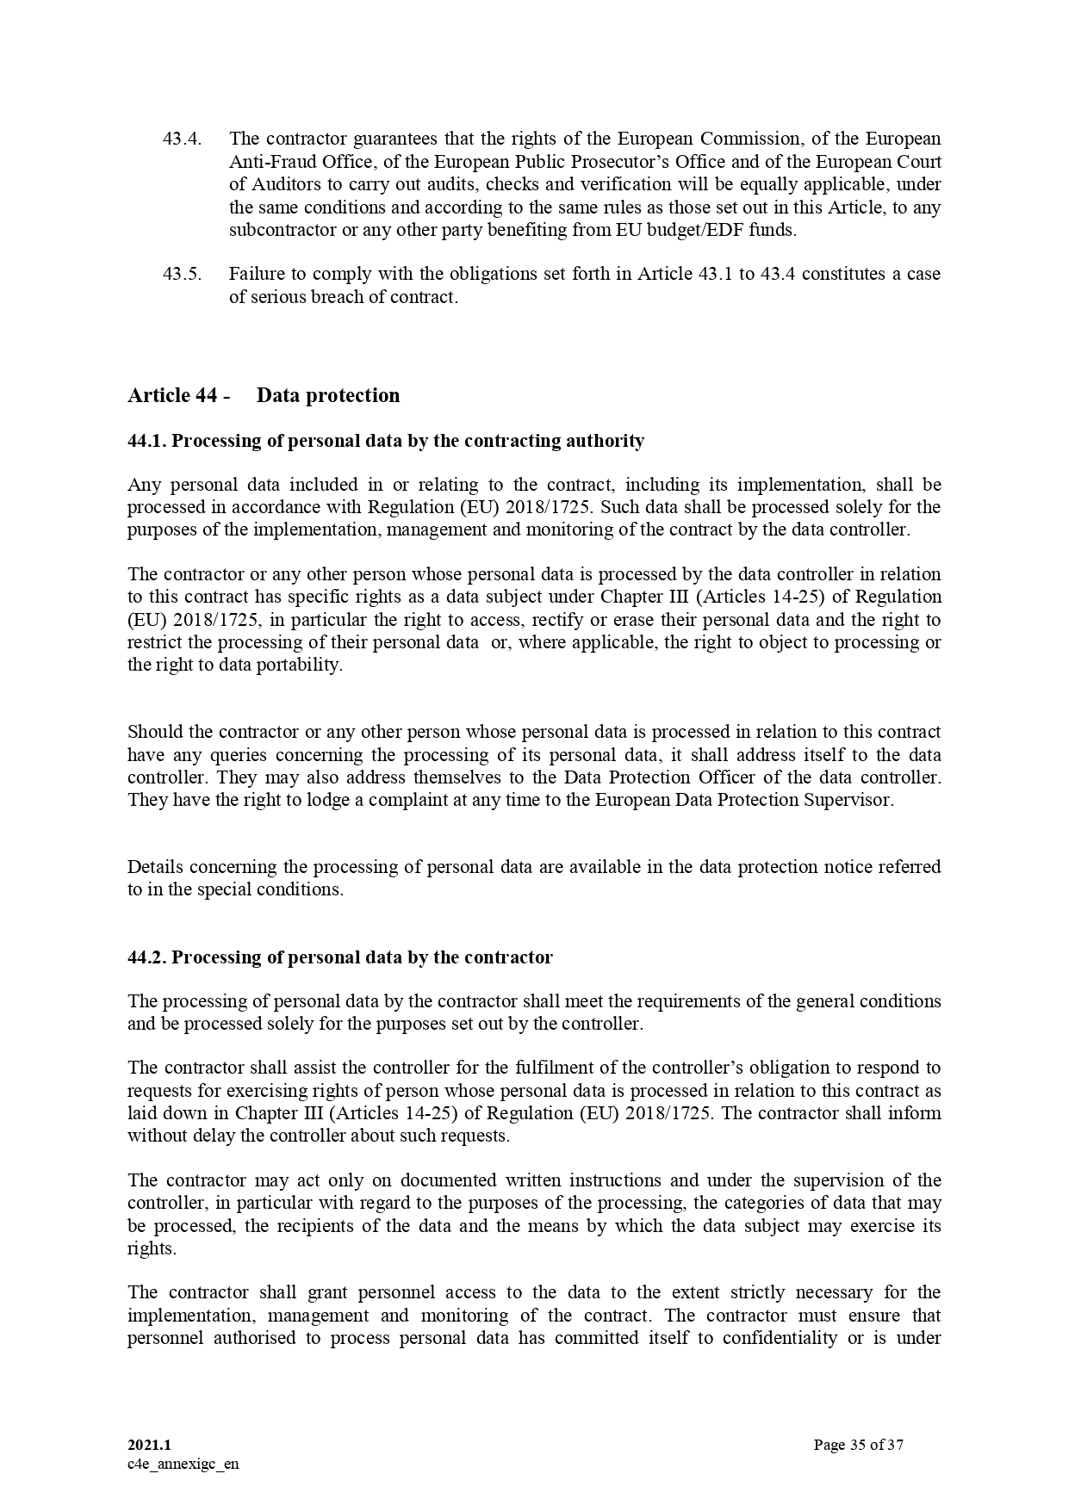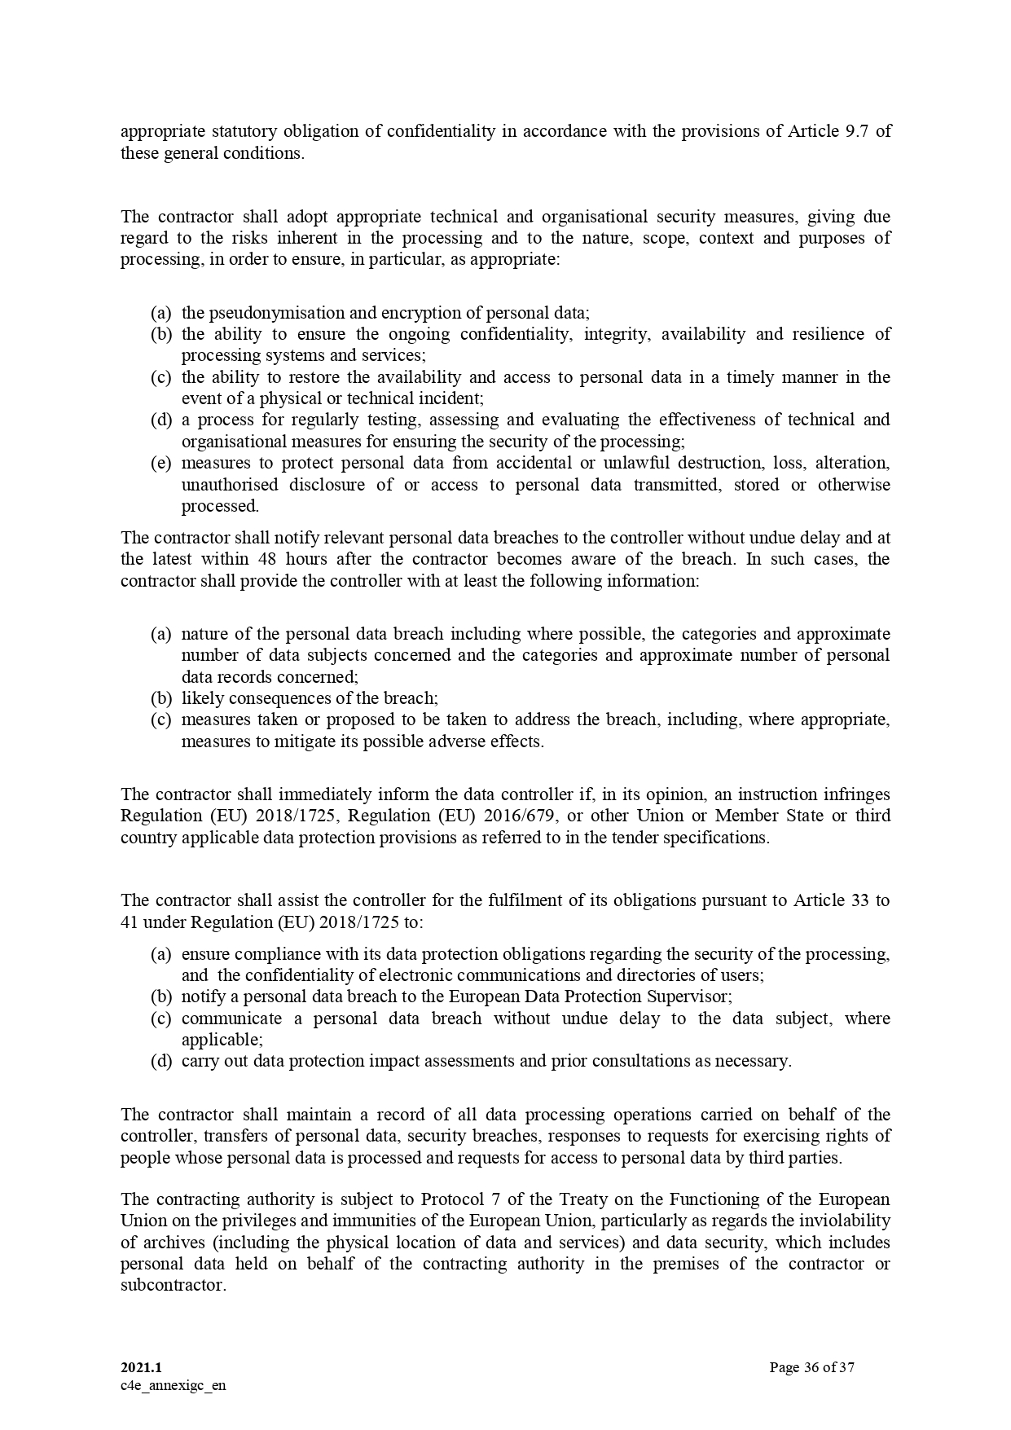



ANNEX II + III: TECHNICAL SPECIFICATIONS + TECHNICAL OFFER

Contract title: SUPPLY, DELIVERY, INSTALLATION, COMMISSIONING AND AFTER-SALES SERVICE OF EQUIPMENT TO STRENGTHEN EARLY WARNING SYSTEMS IN SEYCHELLES

Publication reference: COI/RDRM/AO/2024/007

Columns 1-2 should be completed by the contracting authority
Columns 3-4 should be completed by the tenderer
Column 5 is reserved for the evaluation committee

Tenderers are requested to complete the template on the next pages:
- Column 2 is completed by the Contracting Authority shows the required specifications (not to be modified by the tenderer),
- Column 3 is completed by the Contracting Authority shows the required quantity (not to be modified by the tenderer),
- Column allows the tenderer to make comments on its proposed supply and to make eventual references to the documentation

The eventual documentation supplied should clearly indicate (highlight, mark) the models offered, and the options included, if any, so that the evaluators can see the exact configuration. Offers that do not permit to precisely identify the models and the specifications may be rejected by the evaluation committee.
The offer must be clear enough to allow the evaluators to make an easy comparison between the requested specifications and the offered specifications. Apart from the requested specifications if the tenderer wishes to include additional information concerning an item, its configuration details and any other, then the tender should include it as a separate Annex of their technical proposal document, with the mention “Refer to Annex X (Tenderer’s Annex identification for this item) for more details ....” in column 4.
1.  Item  Number | 2.  Specifications Required | 3.  Specifications Offered | 4.  Notes, remarks,  ref to documentation | 5.  Evaluation Committee’s notes
Lot 1: COMMUNICATION EQUIPMENT

1.1 | Repeater Unit VHF 136-172MHz  Technical specification :  Motorola SLR5500
1.2 | Antenna Colinear Whip 146-155 MHz  Technical specification :  Procom CXL 0dB
1.3 | Compact Combiner Unit (HP) 4 Channel VHF 146-172 MHz  Technical specification :  Sinclair TJ‐2214
1.4 | Microwave Link (LP)  Technical specification :  This includes 4 Microwave Radio UBIQUITI Rocket R5AC-Lite, 4 Dish Antenna UBIQUITI RD-5G30-LW, 4 Radome for Dish UBIQUITI RADOME 5G30
1.5 | POE Unit 24V  Technical specification :  UBIQUITI POE 24
1.6 | Ethernet Connector RJ45 (100pc / 1 pack)  Technical specifications :  UBIQUITI RJ45
1.7 | Tough Cable UTP Outdoor Cat5e 300m  Technical specifications :  UBIQUITI RJ45
1.8 | Heliax Connector N Type Male  Technical specifications :  1/2"-N-PLUG
1.9 | Ethernet Switch Manager  Technical specifications :  Cisco Business CBS220-24T-4G Smart Switch | 24 Port GE | 4x1G SFP
1.10 | UPS Unit  Technical specifications :  FXM FXM-2000, including 19" Kit, Connector Covers, Connectors
1.11 | Battery 12V 110Ah  Technical specifications:  AGM-DEEP-CYCLE
1.12 | Tyraps (100pc / 1 Pack) Outdoor  Technical specifications:  High Quality
1.13 | Amalgamating tape - Sealing Kit (Passus)
1.14 | Antenna Installation Set  Technical specifications :  Antenna Installation Set Including 14 x Cross Section Clamps 120mm x 55mm, 6 x 3m Aluminium Pipes 48.5mm
1.15 | Cable Double Shielded Interconnection Coax  Technical specification  Belden
1.16 | 19" Rack Cabinet 38 - 42U  Technical specification  19" 37U (As Supplied)  Including:  1 Blank Plates Set, 4x Shelf, S/Steel Nuts & Bolts  1 Locks, Roof Extraction Fan, Management Cable Ties, Service Shelf, Earthing Connection Kit, Front Glass Door
1.17 | Power Distribution Unit (6-way extension for mains connections)
1.18 | VHF Radio base station configuration inc power cable  Technical specification  Motorola DM4400e
1.19 | Desktop microphone  Technical specification  Motorola
1.20 | Power Supply 12V 10A
1.21 | Yagi antenna 3 element for above
1.22 | Coaxial Cable Roll (1000m)  Technical specification  LMR400
1.23 | Coaxial Connectors N Type Male LMR400
1.24 | Coaxial Cable Roll (m)  Technical specification  LMR 240
1.25 | Coaxial Connectors N Type Female LMR240
1.26 | Coaxial Connectors BNC Male LMR240
1.27 | Mobile VHF Radio inc power cable and microphone  Technical specification  Motorola DM4401e
1.28 | Mobile antenna VHF with magnetic mount
1.29 | Magnetic Mount GPS Active Antenna  Technical specification :  Motorola PMAN4002
1.30 | Handheld radio + battery + Charger + belt clip  Technical specification :  Motorola DP3441e
1.31 | Multi Charger  Technical specification :  Motorola
1.32 | Spare Battery for above radio  Technical specification :  Motorola
1.33 | Speaker Microphone for portable radio  Technical specification :  Motorola
1.34 | Earpiece with PTT for Item 34 with spares  Technical specification :  Motorola
1.35 | TRBONet Enterprise from V5.2  Technical specification :  Neocoms
1.36 | Trbonet Watch Software  Technical specification:  Neocoms
1.37 | Trbonet Watch Licences for 4 networks
1.38 | Radio Licences for Trbnoet
1.39 | Blue Solar Controller  Technical specification  Nominal battery voltage 12 / 24 / 36 / 48V; Auto Select Rated charge current 70A @ 40°C (104°F) 85A @ 40°C (104°F) ; Maximum solar array input power 1) 12V: 1000W / 24V: 2000W / 36V: 3000W / 48V: 4000W 12V: 1200W / 24V: 2400W / 36V: 3600W / 48V: 4850W; Maximum PV open circuit voltage 150V absolute maximum coldest conditions 145V start-up and operating maximum Minimum PV voltage Battery voltage plus 7 Volt to start Battery voltage plus 2 Volt operating Standby power consumption 12V: 0,55W / 24V: 0,75W / 36V: 0,90W / 48V: 1,00W Efficiency at full load 12V: 95% / 24V: 96,5% / 36V: 97% / 48V: 97,5% Absorption charge 14.4 / 28.8 / 43.2 / 57.6V Float charge 13.7 / 27.4 / 41.1 / 54.8V Equalization charge 15.0 / 30.0 / 45 / 60V; Remote battery temperature sensor
1.40 | Batteries 12V 110Ah  Technical specification  AGM-DEEP-CYCLE  Technology: flat plate  AGMTerminals: copper  Rated capacity: 20 hr. discharge at 25°C  Float design life: 7-10 years at 20°C  Cycle design life: 400 cycles at 80% discharge; 600 cycles at 50% discharge; 1500 cycles at 30% discharge.
1.41 | Solar Panels  Minimum requirements:  305W-20V  Low voltage-temperature coefficient enhances high-temperature operation; Low-light performance and high sensitivity to light across the entire solar spectrum; 5-Year limited warranty on materials and workmanship; Sealed, waterproof, multi-functional junction box gives high level of safety; High performance bypass diodes minimize the power drop caused by shade; Advanced EVA (Ethylene Vinyl Acetate) encapsulation system with triple-layer back sheet; A sturdy, anodized aluminium frame allows modules to be easily roof-mounted with a variety of standard mounting systems; Highest quality, high-transmission tempered glass; High power models with pre-wired quick-connect system with MC4 (PV-ST01) connectors
1.42 | Inverter unit (DC to DC converter 48V-12V)  Technical specification:  Voltage 48/12V; Cont.Output Current 30A ; Protection Category IP43; Efficiency 87%
1.43 | Accessories, cabling, connectors for above
1.44 | Programming Cable DM4401e
1.45 | Programming Cable DP3441e
1.46 | Programming Cable SLR 5500
1.47 | After sale service on all items for one (1) year as from final acceptance
Lot 2: IT EQUIPMENT AND ASSOCIATED ITEMS

2.1 | Video Monitors for Workstation (30 people)  Camera •  Rally Speaker • Rally Mic Pod • Rally Display Hub • Rally Table Hub • COMPATIBILITY Operating Systems • Windows® 7, 8.1 or Windows 10 • macOS®: 10.10 or higher • ChromeOS • Resolutions higher than 1080p • Windows 8.1 or higher or macOS 10.10 or higher • USB 3.0 port • Compatible software
2.2 | Go Pro Camera (Geo-tagged - GoPro Hero Black 11 with GPS features)  Technical specification :  Waterproof camera with GPS features
2.3 | Laptops  2-in-1 Laptop  - Display and Graphics : 14" Touchscreen LED-backlit(1920 x 1200) IPS 250 nits , 45% NTSC, 60Hz, Thin Bezel LCD Display, Intel Iris Xe Graphics Shared, 1080p FHD Camera, Memory and Storage : 32GB DDR4 SDRAM 3200MHz,1TB PCI-E NVMe SSD, high-performance DDR4 memory, faster speed up to 3200 MHz main frequency, game experience, design drawing and other experience  - Processor : Intel Core i7-1255U 10-Core Processor (Up to 4.7 GHz with Intel Turbo Boost Technology,12 MB Intel Smart cache| 10 Cores: 2 Performance Cores + 8 Efficient Cores | 12 Threads),capable of a variety of work computing needs, whether it is high-definition video editing, programming development or interior design  - OS: Windows 11 pro
2.4 | Router  WiFi 6 Router - Multi Gigabit Wireless Internet Router, 1 x 2.5 Gbps Port, Dual Band, VPN Router, OFDMA, MU-MIMO, USB Port, WPA3, Compatible with Alexa
2.5 | Printer (Light Duty)  Multifunction Printer  Copy, print, scan, fax  Access to optional advanced document workflow with Xerox Workflow Central  Mobile Ready: AirPrint, Mopria, Wi-Fi Direct  Comprehensive security features  Fast scanner with single pass DADF and platen
2.6 | Tablets  Minimum requirements:  Memory Storage Capacity 512 GB, 6 GB ram  Screen Size 10.5 Inches,
2.7 | After sale service on all items: for one(1) year as from final acceptance

ANNEXE IV: Budget breakdown (Model financial offer)

Page n° 1 [de…]

PUBLICATION RÉFÉRENCE : COI/ RDRM /AO/2024/007 NAME OF TENDERER: <nom>

 | A |  | C | D | E
 | Item number | Quantity | specifications offered (incl brand/model) | Unit costs with delivery [DDP] [EUR]1  Disaster Risk Management Division, Global Village Suite No. 3, Mont Fleuri, Victoria, Mahe, Seychelles | total  [EUR]
Lot 1
1.1 |  | 03
1.2 |  | 03
1.3 |  | 01
1.4 |  | 4
1.5 |  | 5
1.6 |  | 1
1.7 |  | 1
1.8 |  | 7
1.9 |  | 5
1.10 |  | 2
1.11 |  | 8
1.12 |  | 10
1.13 |  | 3
1.14 |  | 1
1.15 |  | 2
1.16 |  | 1
1.17 |  | 2
1.18 |  | 15
1.19 |  | 15
1.20 |  | 17
1.21 |  | 15
1.22 |  | 1
1.23 |  | 35
1.24 |  | 25
1.25 |  | 15
1.26 |  | 15
1.27 |  | 15
1.28 |  | 20
1.29 |  | 20
1.30 |  | 79
1.31 |  | 5
1.32 |  | 50
1.33 |  | 30
1.34 |  | 15
1.35 |  | 1
1.36 |  | 1
1.37 |  | 1
1.38 |  | 1
1.39 |  | 2
1.40 |  | 8
1.41 |  | 8
1.42 |  | 4
1.43 |  | 1
1.44 |  | 1
1.45 |  | 1
1.46 |  | 1
1.47 (After sale service) |  | fft
Lot 2
2.1 |  | 1
2.2 |  | 2
2.3 |  | 2
2.4 |  | 1
2.5 |  | 4
2.6 |  | 28
2.7 ( After sale service) |  | fft
 |  |  |  | Total

Annex V: Specified forms and other relevant documents

Tax and customs arrangements
Article 31 from Annex IV to the Cotonou Agreement
- The ACP States shall apply to contracts financed by the Community tax and customs arrangements no less favourable than those applied by them to the most favoured States or international development organisations with which they have relations. For the purpose of determining the most-favoured-nation (MFN) treatment, account shall not be taken of arrangements applied by the ACP State concerned to other ACP States, or to other developing countries.
- Subject to the above provisions the following shall apply to contracts financed by the Community:
- the contract shall not be subject in the beneficiary ACP State to stamp or registration duties or to fiscal charges having equivalent effect, whether such charges already exist or are to be instituted in the future; however, such contracts shall be registered in accordance with the laws in force in the ACP State and a fee corresponding to the service rendered may be charged for it;
- profits and/or income arising from the performance of contracts shall be taxable according to the internal fiscal arrangements of the ACP State concerned, provided that the natural or legal persons who realise such profit and/or income have a permanent place of business in that State, or that the performance of the contract takes longer than six months;
- enterprises which must import professional equipment in order to carry out works contracts shall, if they so request, benefit from the system of temporary admission as laid down by the national legislation of the beneficiary ACP State in respect of the said equipment;
- professional equipment necessary for carrying out tasks defined in a service contract shall be temporarily admitted into the beneficiary ACP State or States in accordance with its national legislation free of fiscal, import and customs duties and of other charges having equivalent effect where these duties and charges do not constitute remuneration for services rendered;
- imports under supply contracts shall be admitted into the beneficiary ACP State without customs duties, import duties, taxes or fiscal charges having equivalent effect. The contract for supplies originating in the ACP State concerned shall be concluded on the basis of the ex-works price of the supplies to which may be added such internal fiscal charges as may be applicable to those supplies in the ACP State;
- fuels, lubricants and hydrocarbon binders and, in general, all materials used in the performance of works contracts shall be deemed to have been purchased on the local market and shall be subject to fiscal rules applicable under the national legislation in force in the beneficiary ACP State; and
- personal and household effects imported for use by natural persons, other than those recruited locally, engaged in carrying out tasks defined in a service contract and members of their families, shall be exempt from customs or import duties, taxes and other fiscal charges having equivalent effect, within the limit of the national legislation in force in the beneficiary ACP State.
- Any matter not covered by the above provisions on tax and customs arrangements shall remain subject to the national legislation of the ACP State concerned.

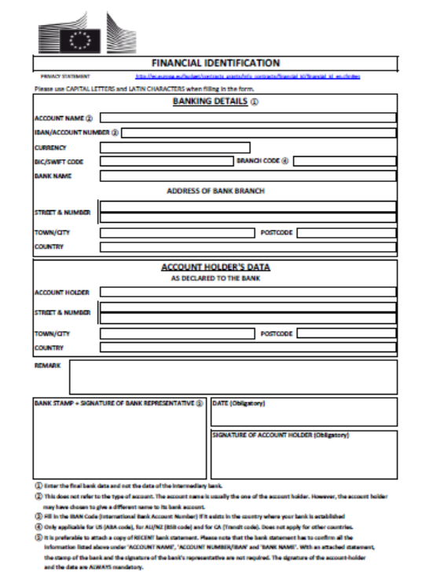

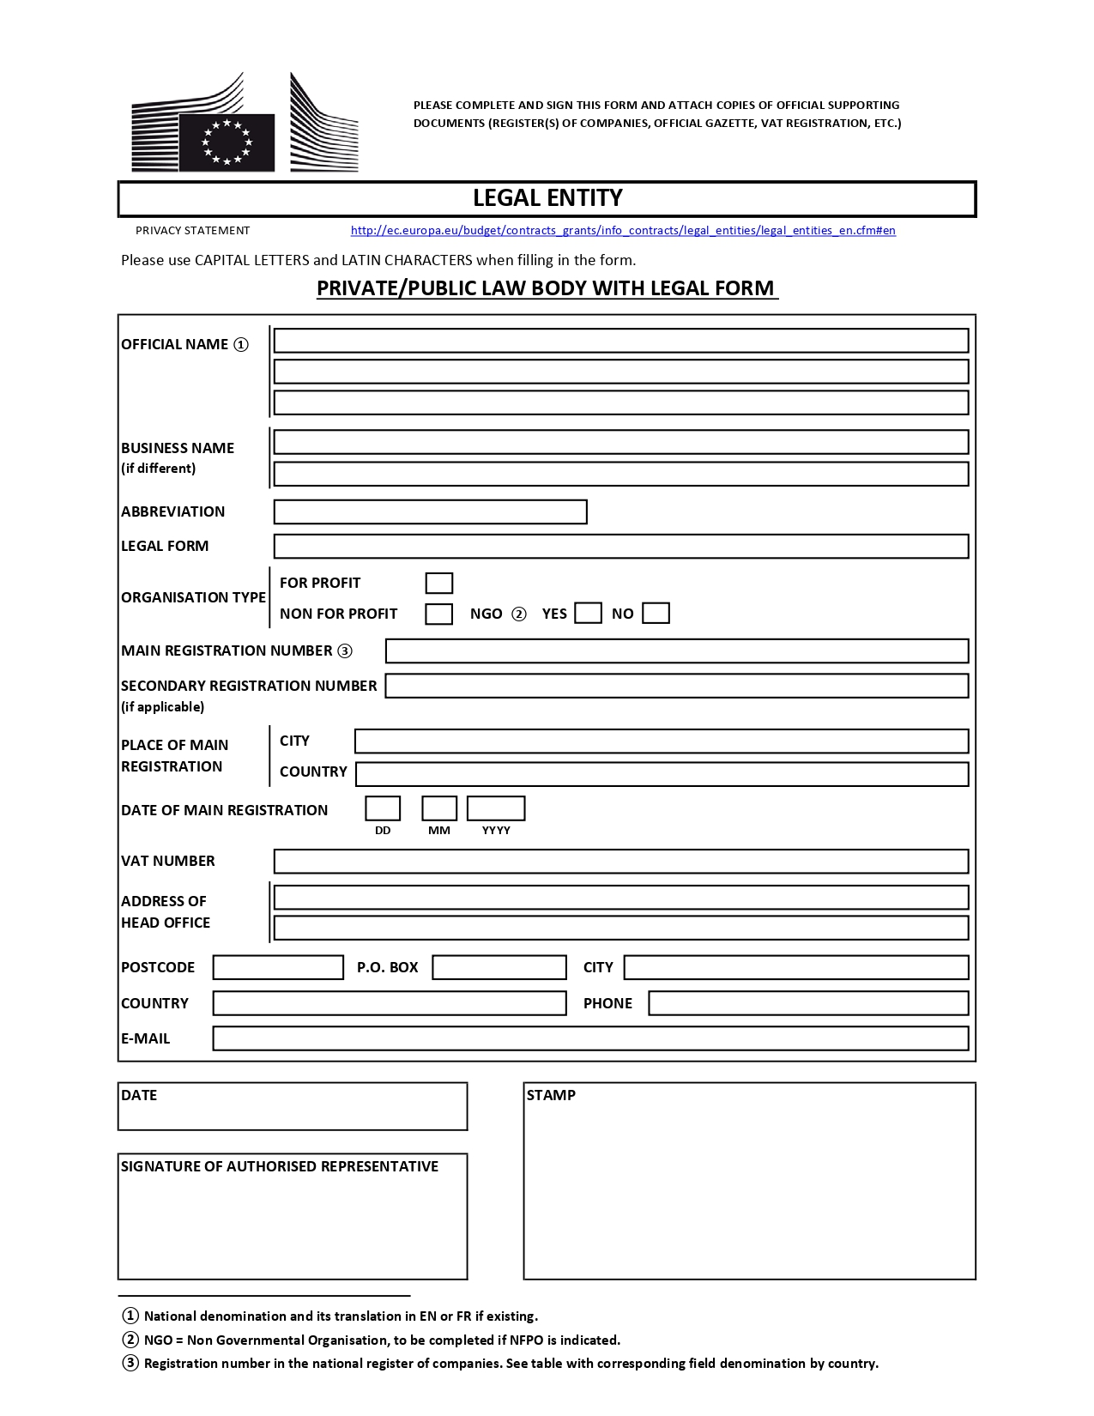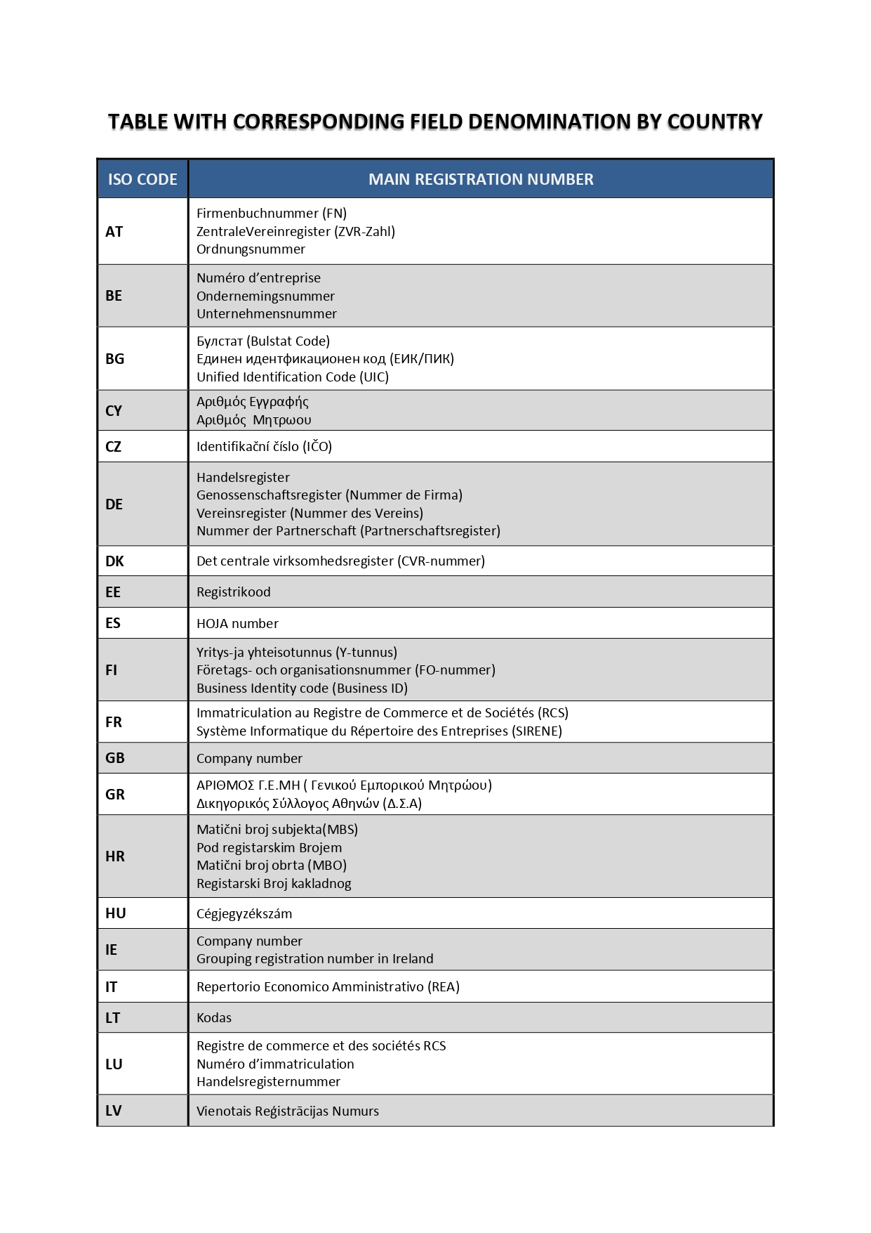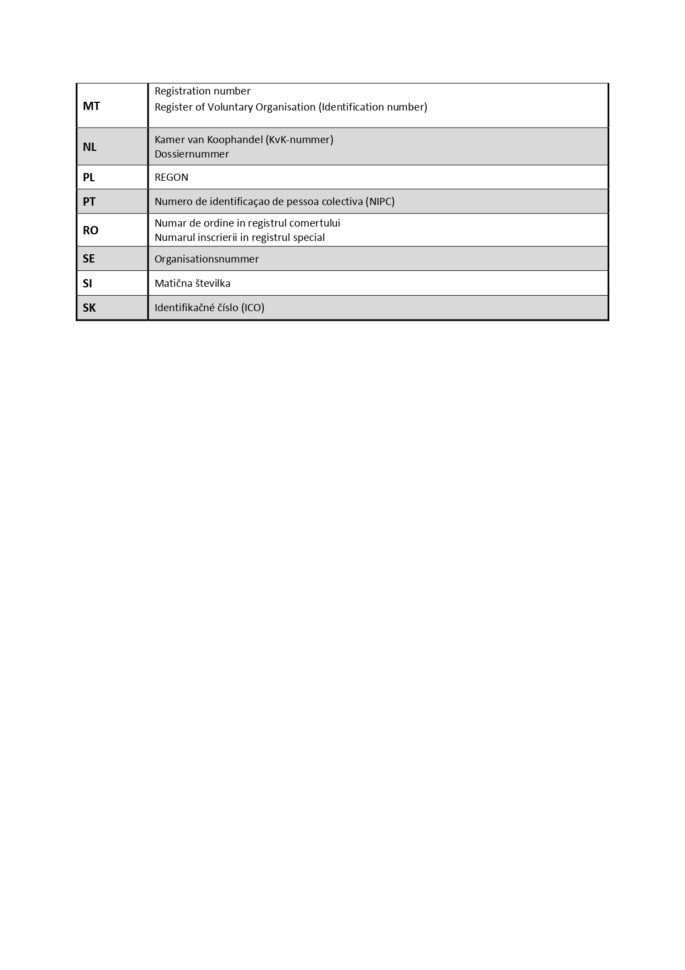

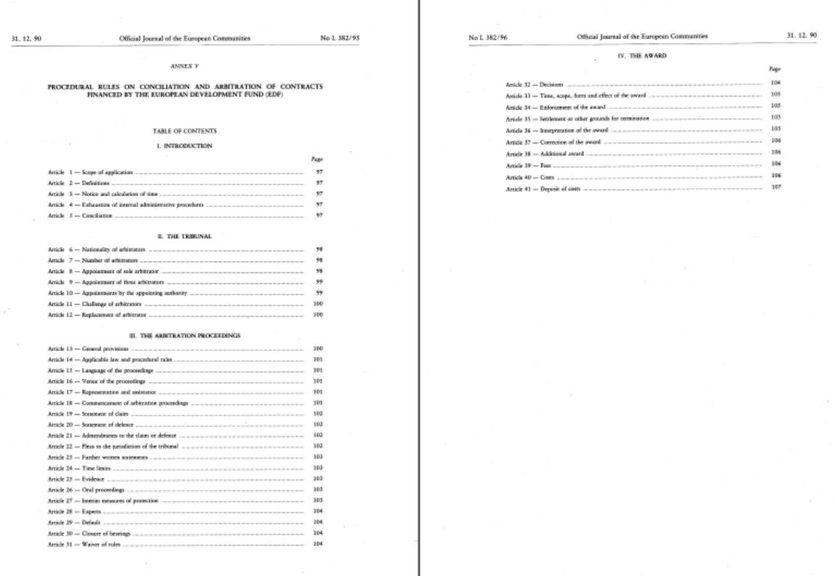

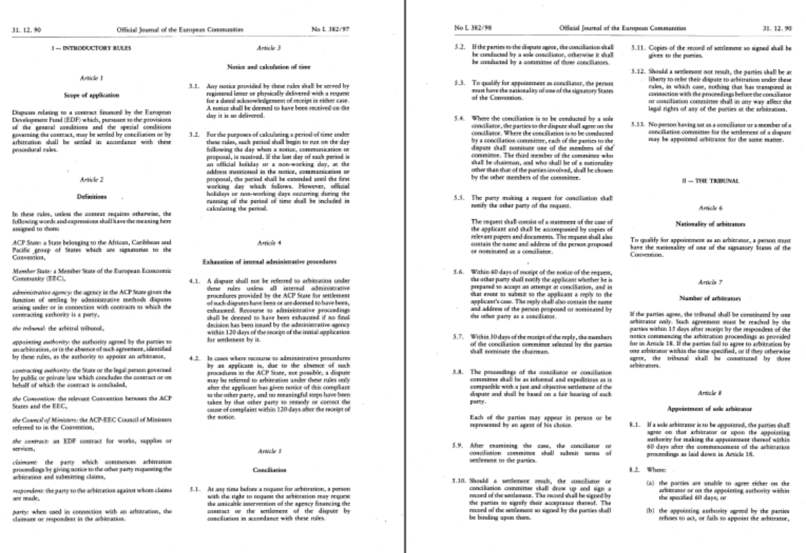

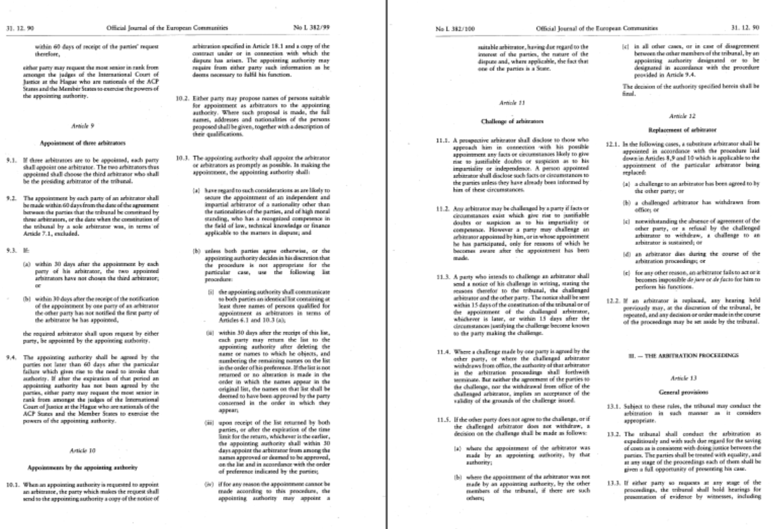

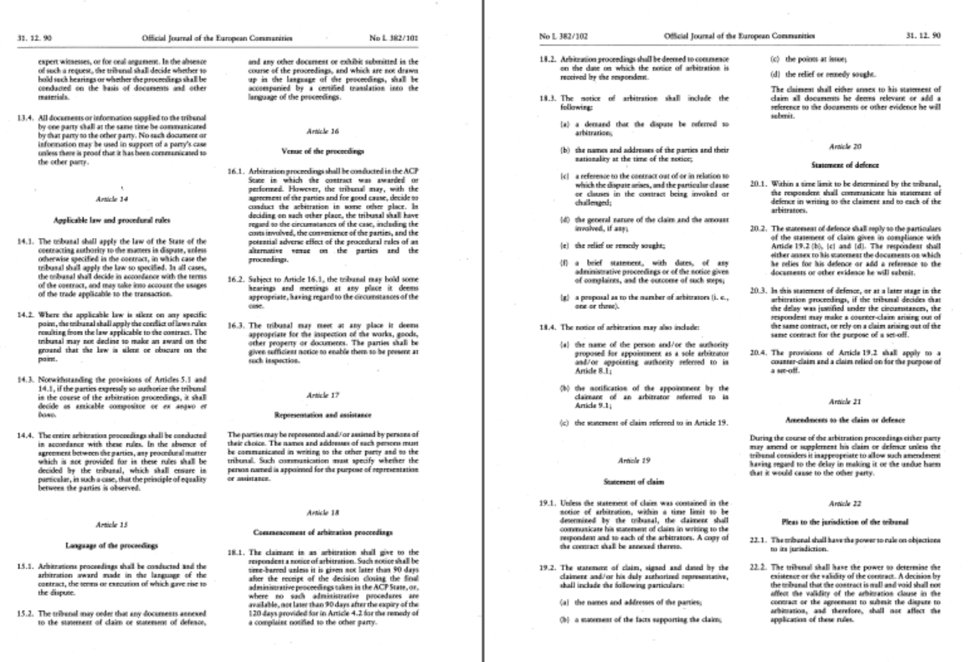

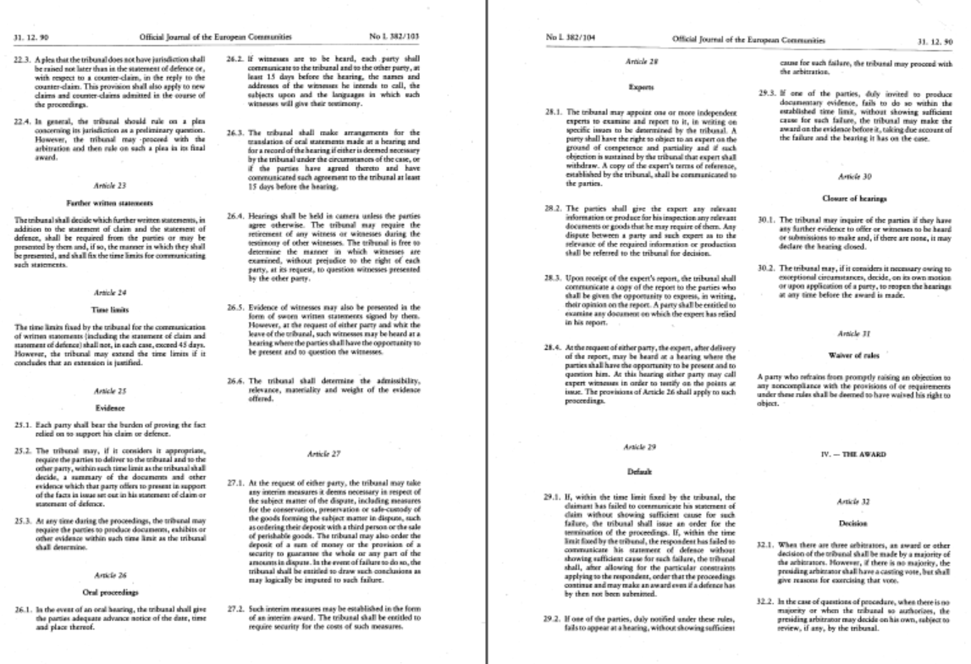

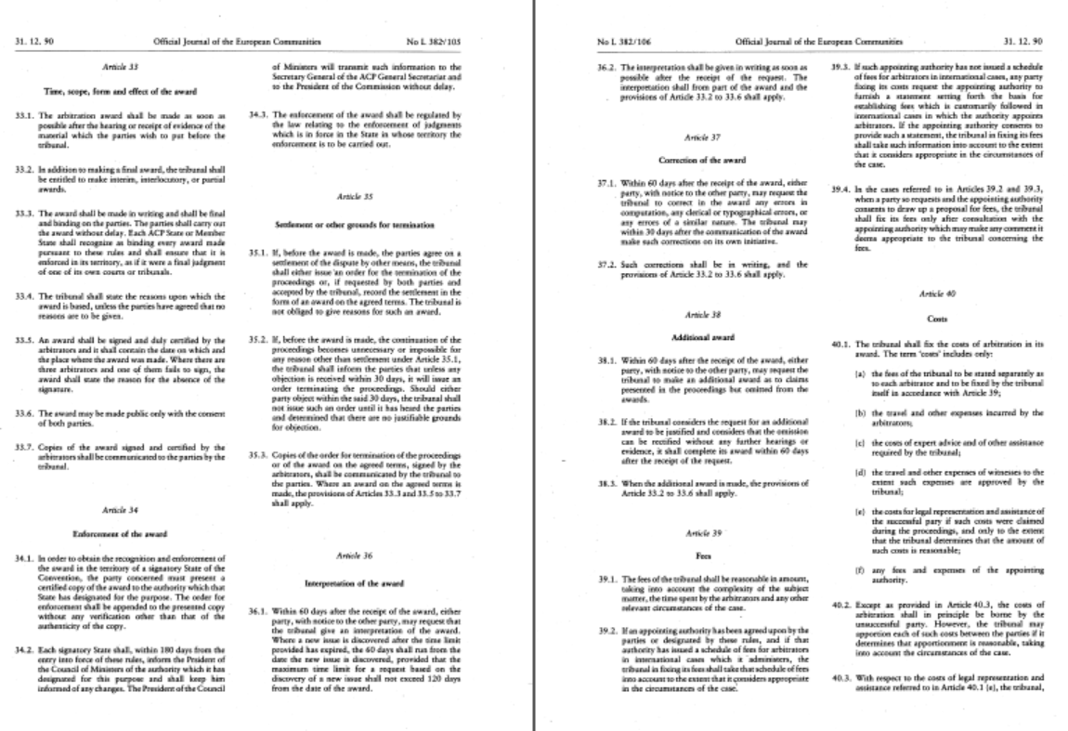

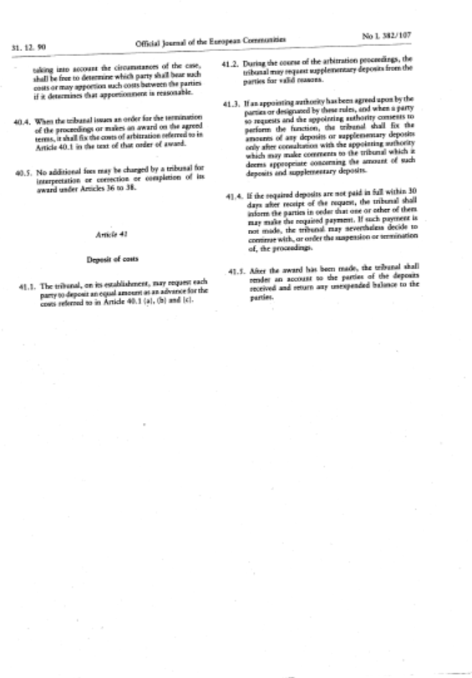

PART C

Other information

ADMINISTRATIVE COMPLIANCE GRID
Contract title : | SUPPLY, DELIVERY, INSTALLATION, COMMISSIONING AND AFTER-SALES SERVICE OF EQUIPMENT TO STRENGTHEN EARLY WARNING SYSTEMS IN SEYCHELLES | Publication reference : | COI/RDRM/AO/2024/007

Tender number | Name of tenderer | Is tenderer (consortium) nationality eligible?  (Y/N) | Is documentation complete?  (Y/N) | Is language as required?  (Y/N) | Is tender submission form complete?  (Y/N) | Is tenderer's declaration signed (by all consortium members if a consortium)? (Yes/No/ Not Applicable) | Declaration(s) of honour included? (Yes/No) | Other administrative requirements of the tender dossier?  (Yes/No/Not applicable) | Overall decision?  (Accept / Reject)
1
2
3
4

Chairperson's name
Chairperson's signature
Date

EVALUATION GRID

Contract title : | SUPPLY, DELIVERY, INSTALLATION, COMMISSIONING AND AFTER-SALES SERVICE OF EQUIPMENT TO STRENGTHEN EARLY WARNING SYSTEMS IN SEYCHELLES | Publication reference : | COI/RDRM/AO/2024/007

Tender No | Name of tenderer | Rules of origin respected?  (additional guidance)  (Y/N) | Economic & financial capacity? (OK/a/b/…) | Professional capacity? (OK/a/b/…) | Technical capacity? (OK/a/b/…) | Compliance with technical specifications? (OK/a/b/…) | Ancillary services as required? (OK/a/b/…/NA) | Subcontracting statement in accordance with art. 6 of the general conditions?  (Y/N) | Other technical requirements in tender dossier?  (Yes/No/Not applicable) | Technically compliant? Y/N) | Justification/  notes:
1
2
3
4

Evaluator's name & signature
Evaluator's name & signature
Evaluator's name & signature
Date

PART D

Tender submission form and Declaration on honour on exclusion criteria and selection criteria

TENDER FORM FOR A SUPPLY CONTRACT

Publication reference: COI/ RDRM /AO/2024/007
SUPPLY, DELIVERY, INSTALLATION, COMMISSIONING AND AFTER-SALES SERVICE OF EQUIPMENT TO STRENGTHEN EARLY WARNING SYSTEMS IN SEYCHELLES
<Place and date>
A: INDIAN OCEAN COMMISSION
Blue Tower, 3rd Floor, Rue de l’Institut, Ebène, Mauritius

One signed form must be supplied (for each lot, if the tender procedure is divided into lots), together with the number of copies specified in the instructions to tenderers. The form must include a signed declaration using the annexed format from each legal entity submitting this tender. Any additional documentation (brochure, letter, etc.) sent with the form will not be taken into consideration. Tenders being submitted by a consortium (i.e. either a permanent, legally-established grouping or a grouping which has been constituted informally for a specific tender procedure) must follow the instructions applicable to the consortium leader and its members. The attachments to this submission form (i.e. declarations, statements, proofs) may be in original or copy. If copies are submitted, the originals must be dispatched to the contracting authority upon request. For economical and ecological reasons, we strongly recommend that you submit your files on paper-based materials (no plastic folder or divider). We also suggest you use double-sided print-outs as much as possible.
Capacity-providing entities
An economic operator (i.e. tenderer) may, where appropriate and for a particular contract, rely on the capacities of other entities, regardless of the legal nature of the links which it has with them. If the economic operator relies on other entities it must in that case prove to the contracting authority that it will have at its disposal the resources necessary for the performance of the contract by producing with the tender documents a commitment by those entities to place those resources at its disposal. Such entities, for instance the parent company of the economic operator, must respect the same rules of eligibility and notably that of nationality as the economic operator relying on them and must comply with the selection criteria for which the economic operator relies on them. For the purpose of the present tender, the data for this third entity for the relevant selection criterion has to be included in a separate document. Proof of the capacity will also have to be provided when requested by the contracting authority.
With regard to technical and professional criteria, an economic operator may only rely on the capacities of other entities where the latter will perform the tasks for which these capacities are required.
With regard to economic and financial criteria, the entities upon whose capacity the economic operator relies, become jointly and severally liable for the performance of the contract.

1 SUBMITTED BY
 | Name(s) of tenderer(s) | Nationality
Leader
Member
Etc …

2 CONTACT PERSON (for this tender)
Name
Address
Telephone
Fax
E-mail
3 ECONOMIC AND FINANCIAL CAPACITY
Please complete the following table of financial data based on your annual accounts and your latest projections. If annual closed accounts are not yet available for the current year or past year, please provide your latest estimates in the columns marked with **. Figures in all columns must be calculated on the same basis to allow a direct, year-on-year comparison to be made (or, if the basis has changed, an explanation of the change must be provided as a footnote to the table). Any clarification or explanation which is judged necessary may also be provided.

Financial data | 2 years before last year  2022  € | Year before last year  2023  € | Last year  2024  € | Average  € | Past year  € ** | Current year  €**
Annual turnover, excluding this contract
Current assets
Current liabilities
[Current ratio (current assets/current liabilities) | Not applicable | Not applicable |  | Not applicable | Not applicable | Not applicable]

4 PERSONNEL
Please provide the following personnel statistics for the current year and the two previous years.
Annual manpower | Year before past year |  | Past year |  | Current year |  | Period average
 | Overall | Relevant fields | Overall | Relevant fields ¹¹ | Overall | Relevant fields¹¹ | Overall | Relevant fields¹¹
Permanent personnel
Other personnel
Total
Permanent personnel as a proportion of total personnel (%) | % | % | % | % | % | % | % %

5 FIELDS OF SPECIALISATION
Please use the table below to indicate the specialisms relevant to this contract of each legal entity making this tender, by using the names of these specialisms as the row headings and the name of the legal entity as the column headings. Show the relevant specialism(s) of each legal entity by placing a tick () in the box corresponding to those specialisms in which the legal entity has significant experience. [Maximum 10 specialisms]

 | Leader | Member 2 | Member 3 | Etc …
Relevant specialism 1
Relevant specialism 2
Etc …
6 EXPERIENCE
Please complete a table using the format below to summarise the major relevant supplies carried out over the past 3 years by the legal entity or entities making this tender. The number of references to be provided must not exceed 15 for the entire tender

Ref # (maximum 15) | Project title |  | …
Name of legal entity | Country | Overall supply value (EUR) | Proportion supplied by legal entity (%) | No of personnel provided | Name of client | Origin of funding | Dates | Name of members if any
… | … | … | … | … | … | … | … | …
Detailed description of supply |  |  |  |  |  | Related services provided
… |  |  |  |  |  | …

7 TENDERER’S DECLARATION(S)
As part of their tender, each legal entity identified under point 1 of this form, including every consortium member, as well as each capacity-providing entity and each subcontractor, must submit a signed declaration using this format, together with the declaration on honour on exclusion and selection criteria (Annex 1).

In response to your letter of invitation to tender for the above contract,
we, the undersigned, hereby declare that:

1 We have examined and accept in full the content of the dossier for invitation to tender No <……………………………….> of <date>. We hereby accept its provisions in their entirety, without reservation or restriction.

2 We offer to deliver, in accordance with the terms of the tender dossier and the conditions and time limits laid down, without reserve or restriction:
Lot 1 <description of supplies with indication of quantities and origin>
Lot 2 <description of supplies with indication of quantities and origin>

3 The price of our tender excluding spare parts and consumables, if applicable (excluding the discounts described under point 4) is:
Lot 1<insert price and currency>
Lot 2<insert price and currency>

4 We will grant a discount of [<…>%], or [<…………..>] [in the event of our being awarded lot … and lot … ………].

5 This tender is valid for a period of 90 days from the final date for submission of tenders.

6 If our tender is accepted, we undertake to provide a performance guarantee as required by Article 11 of the special conditions.

7 Our firm/company [and our subcontractors] has/have the following nationality:
<……………………………………………………………………>

8 We are making this tender in our own right [ourselves]*. We confirm that we are not tendering for the same contract in any other form. [We confirm, as a member in the consortium, that all members are jointly and severally liable by law for the execution of the contract, that the lead member is authorised to bind, and receive instructions for and on behalf of, each member, that the execution of the contract, including payments, is the responsibility of the lead member, and that all members in the joint venture/consortium are bound to remain in the joint venture/consortium for the entire period of the contract’s execution]. [We confirm, as capacity-providing entity to be jointly and severally bound in respect of the obligations under the contract, including for any recoverable amount.]

9 We undertake, if required, to provide the proof usual under the law of the country in which we are effectively established that we do not fall into any of the exclusion situations. The date on the evidence or documents provided will be no earlier than 1 year before the date of submission of the tender and, in addition, we will provide a statement that our situation has not altered in the period which has elapsed since the evidence in question was drawn up.
We also undertake, if required, to provide evidence of financial and economic standing and technical and professional capacity according to the selection criteria for this call for tender specified in the additional information about the contract notice. The documentary proofs required are listed in Section 2.6.11. of the practical guide.

10 We agree to abide by the ethics clauses in Clause 24 of the instructions to tenderers and, in particular, have no conflict of interests or any equivalent relation which may distort competition with other tenderers or other parties in the tender procedure at the time of the submission of this form.
We confirm that we, including all consortium members, if any, and subcontractors are not in the lists of EU restrictive measures (www.sanctionsmap.eu) and we understand that our tender may be rejected, if proved the contrary.

11 We will inform the contracting authority immediately if there is any change in the above circumstances at any stage during the implementation of the tasks. We also fully recognise and accept that any inaccurate or incomplete information deliberately provided in this tender may result in our exclusion from this and other contracts funded by the EU/EDF.

12 We note that the contracting authority is not bound to proceed with this invitation to tender and that it reserves the right to award only part of the contract. It will incur no liability towards us should it do so.

13 We fully recognise and accept that if the above-mentioned persons participate in spite of being in any of the situations listed in Section 2.6.10.1.1. of the practical guide or if the declarations or information provided prove to be false, they may be subject to rejection from this procedure and to administrative sanctions in the form of exclusion and financial penalties up to 10 % of the total estimated value of the contract being awarded and that this information may be published on the Commission website in accordance with the Financial Regulation in force.

14 We are aware that, for the purposes of safeguarding the EU's financial interests, our personal data may be transferred to internal audit services, to the early detection and exclusion system, to the European Court of Auditors, to the Financial Irregularities Panel, to the European Anti-Fraud Office or to the European Public Prosecutor’s Office.
[If this declaration is being completed by a consortium member:
The following table contains our financial data as included in the consortium’s tender form. These data are based on our annual closed accounts and our latest projections. Estimated figures (i.e. those not included in annual closed accounts) are given in italics. Figures in all columns have been provided on the same basis to allow a direct, year-on-year comparison to be made <except as explained in the footnote to the table>.
Financial data  Data requested in this table must be consistent with the selection criteria set in the additional information about the contract notice document | 2 years before last⁵  <specify>  EUR | Year before last year  <specify>  EUR | Last year  <specify>  EUR | Average⁶  EUR | Past year  EUR] | [Current year  EUR]
Annual turnover ⁷, excluding this contract
Current assets⁸
Current liabilities⁹
[Current ratio (current assets/current liabilities) | Not applicable | Not applicable |  | Not applicable | Not applicable | Not applicable]

The following table contains our personnel statistics as included in the consortium’s tender form:
Annual manpower | Year before past year |  | Past year |  | Current year |  | Period average
 | Overall | Relevant fields¹¹ | Overall | Relevant fields¹¹ | Overall | Relevant fields ¹¹ | Overall | Relevant fields ¹¹
Permanent personnel ¹²
Other personnel ¹³
Total
Permanent personnel as a proportion of total personnel (%) | % | % | % | % | % | % | % | %

Yours faithfully
Name and first name: <…………………………………………………………………>
Duly authorised to sign this tender on behalf of:
<……………………………………………………………………………………>
Place and date: <…………………………………………………………….………….>
Stamp of the firm/company:
This tender includes the following annexes:
<Numbered list of annexes with titles>

ANNEX 1 – DECLARATION ON HONOUR ON EXCLUSION CRITERIA AND SELECTION CRITERIA
Declaration on honour on
exclusion criteria and selection criteria
The undersigned [insert name of the signatory of this form], representing:
(only for natural persons) himself or herself | (only for legal persons) the following legal person:
ID or passport number:  (‘the person’) | Full official name:  Official legal form:  Statutory registration number:  Full official address:  VAT registration number:  (‘the person’)

The person is not required to submit the declaration on exclusion criteria if the same declaration has already been submitted for the purposes of another award procedure of the same contracting authority, provided the situation has not changed, and that the time that has elapsed since the issuing date of the declaration does not exceed one year.
In this case, the signatory declares that the person has already provided the same declaration on exclusion criteria for a previous procedure and confirms that there has been no change in its situation:
Date of the declaration | Full reference to previous procedure

I – Situations of exclusion concerning the person
- declares that the person is in one of the following situations: | YES | NO
- it is bankrupt, subject to insolvency or winding-up procedures, its assets are being administered by a liquidator or by a court, it is in an arrangement with creditors, its business activities are suspended or it is in any analogous situation arising from a similar procedure provided for under Union or national law;
- it has been established by a final judgement or a final administrative decision that the person is in breach of its obligations relating to the payment of taxes or social security contributions in accordance with the applicable law;
- it has been established by a final judgement or a final administrative decision that the person is guilty of grave professional misconduct by having violated applicable laws or regulations or ethical standards of the profession to which the person belongs, or by having engaged in any wrongful conduct which has an impact on its professional credibity where such conduct denotes wrongful intent or gross negligence, including, in particular, any of the following:
(i) fraudulently or negligently misrepresenting information required for the verification of the absence of grounds for exclusion or the fulfilment of eligibility or selection criteria or in the performance of a contract or an agreement;
(ii) entering into agreement with other persons with the aim of distorting competition;
(iii) violating intellectual property rights;
(iv) attempting to influence the decision-making process of the contracting authority during the award procedure;
(v) attempting to obtain confidential information that may confer upon it undue advantages in the award procedure;
- it has been established by a final judgement that the person is guilty of any of the following:
(i) fraud, within the meaning of Article 3 of Directive (EU) 2017/1371 and Article 1 of the Convention on the protection of the European Communities' financial interests, drawn up by the Council Act of 26 July 1995;
(ii) corruption, as defined in Article 4(2) of Directive (EU) 2017/1371 or active corruption within the meaning of Article 3 of the Convention on the fight against corruption involving officials of the European Communities or officials of Member States of the European Union, drawn up by the Council Act of 26 May 1997, or conduct referred to in Article 2(1) of Council Framework Decision 2003/568/JHA, or corruption as defined in other applicable laws;
(iii) conduct related to a criminal organisation, as referred to in Article 2 of Council Framework Decision 2008/841/JHA;
(iv) money laundering or terrorist financing, within the meaning of Article 1(3), (4) and (5) of Directive (EU) 2015/849 of the European Parliament and of the Council;
(v) terrorist offences or offences related to terrorist activities as well as of inciting, aiding, abetting or attempting to commit such offences as defined in Articles 3, 14 and Title III of Directive (EU) 2017/541 of the European Parliament and of the Council of 15 March 2017 on combating terrorism;
(vi) child labour or other offences concerning trafficking in human beings as referred to in Article 2 of Directive 2011/36/EU of the European Parliament and of the Council;
- it has shown significant deficiencies in complying with the main obligations in the performance of a contract or an agreement financed by the Union’s budget, which has led to its early termination or to the application of liquidated damages or other contractual penalties, or which has been discovered following checks, audits or investigations by a contracting authority, the European Anti-Fraud Office (OLAF) or the Court of Auditors;
- it has been established by a final judgment or final administrative decision that the person has committed an irregularity within the meaning of Article 1(2) of Council Regulation (EC, Euratom) No 2988/95;
- it has been established by a final judgment or final administrative decision that the person has created an entity under a different jurisdiction with the intent to circumvent fiscal, social or any other legal obligations in the jurisdiction of its registered office, central administration or principal place of business.
- (only for legal persons) it has been established by a final judgment or final administrative decision that the person has been created with the intent provided for in point (g).
- declares that, for the situations referred to in points (1) (c) to (1) (h) above, in the absence of a final judgement or a final administrative decision, the person is: | YES | NO
- subject to facts established in the context of audits or investigations carried out by the European Public Prosecutor's Office, the Court of Auditors, or the internal auditor, or any other check, audit or control performed under the responsibility of an authorising officer of an EU institution, of a European office or of an EU agency or body;
- subject to non-final judgments or non-final administrative decisions which may include disciplinary measures taken by the competent supervisory body responsible for the verification of the application of standards of professional ethics;
- subject to facts referred to in decisions of entities or persons being entrusted with EU budget implementation tasks;
- subject to information transmitted by Member States implementing Union funds;
- subject to decisions of the Commission relating to the infringement of Union competition law or of a national competent authority relating to the infringement of Union or national competition law;
- informed, by any means, that it is subject to an investigation by the European Anti-Fraud office (OLAF): either because it has been given the opportunity to comment on facts concerning it by OLAF, or it has been subject to on-the-spot checks by OLAF in the course of an investigation, or it has been notified of the opening, the closure or of any circumstance related to an investigation of the OLAF concerning it.

II – Situations of exclusion concerning natural or legal persons with power of representation, decision-making or control over the legal person and beneficial owners
Not applicable to natural persons, Member States and local authorities
- declares that a natural or legal person who is a member of the administrative, management or supervisory body of the above-mentioned legal person, or who has powers of representation, decision or control with regard to the above-mentioned legal person (this covers e.g. company directors, members of management or supervisory bodies, and cases where one natural or legal person holds a majority of shares), or a beneficial owner of the person (as referred to in point 6 of article 3 of Directive (EU) No 2015/849) is in one of the following situations: | YES | NO | N/A
Situation (1)(c) above (grave professional misconduct)
Situation (1)(d) above (fraud, corruption or other criminal offence)
Situation (1)(e) above (significant deficiencies in performance of a contract)
Situation (1)(f) above (irregularity)
Situation (1)(g) above (creation of an entity with the intent to circumvent legal obligations)
Situation (1)(h) above (person created with the intent to circumvent legal obligations)

III – Situations of exclusion concerning natural or legal persons assuming unlimited liability for the debts of the legal person
- declares that a natural or legal person that assumes unlimited liability for the debts of the above-mentioned legal person is in one of the following situations [If yes, please indicate in annex to this declaration which situation and the name(s) of the concerned person(s) with a brief explanation]: | YES | NO | N/A
Situation (a) above (bankruptcy)
Situation (b) above (breach in payment of taxes or social security contributions)

IV – Other Grounds for rejection from this procedure
- declares that the above-mentioned person: | YES | NO
Was previously involved in the preparation of the procurement documents used in this award procedure, where this entailed a breach of the principle of equality of treatment including distortion of competition that cannot be remedied otherwise.

V – Remedial measures
If the person declares one of the situations of exclusion listed above, it may indicate remedial measures it has taken to remedy the exclusion situation, in order to allow the authorising officer to determine whether such measures are sufficient to demonstrate its reliability. This may include e.g. technical, organisational and personnel measures to prevent further occurrence, compensation of damage or payment of fines or of any taxes or social security contributions. The relevant documentary evidence which illustrates the remedial measures taken must be provided in annex to this declaration. This does not apply for situations referred in point (1)(d) of this declaration.

VI – Evidence upon request
Upon request and within the time limit set by the contracting authority the person must provide information on natural or legal persons that are members of the administrative, management or supervisory body or that have powers of representation, decision or control, including legal and natural persons within the ownership and control structure and beneficial owners and appropriate evidence that none of those persons are in one of the exclusion situations referred to in (1) (c) to (f).
It must also provide the following evidence concerning the person itself and the natural or legal persons on whose capacity the person intends to rely, or a subcontractor and concerning the natural or legal persons which assume unlimited liability for the debts of the person:
For situations described in (1): (a), (c), (d), (f), (g) and (h) above, production of a recent extract from the judicial record is required or, failing that, an equivalent document recently issued by a judicial or administrative authority in the country of establishment of the person showing that those requirements are satisfied.
For the situation described in point (1) (a), (b), production of recent certificates issued by the competent authorities of the country of establishment. These documents must provide evidence covering all taxes and social security contributions for which the person is liable, including for example, VAT, income tax (natural persons only), company tax (legal persons only) and social security contributions. Where any document described above is not issued in the country concerned, it may be replaced by a sworn statement made before a judicial authority or notary or, failing that, a solemn statement made before an administrative authority or a qualified professional body in its country of establishment.
The person is not required to submit the evidence if it has already been submitted for another award procedure of the same contracting authority. The documents must have been issued no more than one year before the date of their request by the contracting authority and must still be valid at that date.
The signatory declares that the person has already provided the documentary evidence for a previous procedure and confirms that there has been no change in its situation:
Document | Full reference to previous procedure
Insert as many lines as necessary.
The person is not required to submit the evidence if it can be accessed on a national database free of charge.
The signatory declares that the following internet address of the database/identification data provide access to the evidence required.
Internet address of the database | Identification data of the document
Insert as many lines as necessary.

VII – Selection criteria
Selection criteria applicable to all consortium members/subcontractors/capacity providing entities

- declares that the above-mentioned person complies with the selection criteria applicable to it individually as provided in the tender documents: | YES | NO | N/A
- It has the legal and regulatory capacity to pursue the professional activity needed for performing the contract as required in section [insert] of the contract notice/Instructions to tenderers;
- It fulfills the applicable economic and financial criteria indicated in section [insert] of the contract notice/additional information about the contract notice/Instructions to tenderers;
- It fulfills the applicable technical criteria indicated in section [insert] of the contract notice/additional information about the contract notice /Instructions to tenderers.
- It fulfills the applicable professional criteria indicated in section [insert] of the contract notice/additional information about the contract notice/Instructions to tenderers.
- is not subject to conflicting interests which may negatively affect the contract performance.

Please adapt the table above to the criteria indicated in the tender documents (i.e. insert extra rows for each criterion or delete irrelevant rows).

Selection criteria applicable to the tenderer as a whole-consolidated assessment
(to be filled ONLY by the sole tenderer or the leader in case of consortium)

- if the above-mentioned person is the sole tenderer or the leader in case of consortium, declares that: | YES | NO | N/A
- the tenderer, including all members of the group in case of consortium and including subcontractors and entities on whose capacity the tenderer intends to rely if applicable, fulfils all the selection criteria for which a consolidated assessment will be made as provided in the tender documents.
- is not subject to conflicting interests which may negatively affect the contract performance.
In case of a procedure with lots the above statements apply to the lot(s) for which the request to participate/tender is submitted.

VIII – Evidence for selection
The signatory declares that the above-mentioned person is able to provide the necessary supporting documents listed in the relevant sections of the tender documents and which are not available electronically upon request and without delay.
Where the evidence is not required to be provided with the request to participate/tender, the person is invited to prepare in advance the documents related to the evidence, since the contracting authority may request to provide these in a short deadline.
The person is not required to submit the evidence if it has already been submitted for another procurement procedure of the same contracting authority. The documents must have been issued no more than one year before the date of their request by the contracting authority and must still be valid at that date.
The signatory declares that the person has already provided the documentary evidence for a previous procedure and confirms that there has been no change in its situation:
Document | Full reference to previous procedure
Insert as many lines as necessary.

The person is not required to submit the evidence if it can be accessed on a national database free of charge.
The signatory declares that the following internet address of the database/identification data provide access to the evidence required.
Internet address of the database | Identification data of the document
Insert as many lines as necessary.

IX - Declaration on honour on established debt to the union
(to be filled ONLY by the sole tenderer or the leader in case of consortium)
The person, being a sole tenderer/the leader in case of consortium, submitting a request to participate/tender for the above procedure, declares that:
the tenderer, including each member of the group in case of consortium, subcontractors, | YES | NO
does not have an established debt to the Union.

The above-mentioned person must immediately inform the contracting authority of any changes in the situations as declared.

The above-mentioned person may be subject to rejection from this procedure and to administrative sanctions (exclusion or financial penalty) if any of the declarations or information provided as a condition for participating in this procedure prove to be false.

Full name Date Signature

ANNEX V: MODEL PERFORMANCE GUARANTEE
To be completed on paper bearing the letterhead of the financial institution
For the attention of
<name and address of the contracting authority>
refered to below as the ‘contracting authority’
Subject: Guarantee No <insert number>
Performance guarantee for the full and proper execution of contract <contract number and title> (please quote number and title in all correspondence)

We the undersigned, <name and address of financial institution>, hereby irrevocably declare that we guarantee as primary obligor, and not merely as a surety on behalf of <contractor's name and address>, hereinafter referred to as ‘the contractor’, payment to the contracting authority of <amount of the performance guarantee>, representing the performance guarantee mentioned in Article 11 of the special conditions of the contract <contract number and title> concluded between the contractor and the contracting authority, hereinafter referred to as ‘the contract’.

Payment shall be made without objection or legal proceedings of any kind, upon receipt of your first written claim (sent by registered letter with confirmation of receipt) stating that the contractor has failed to perform its contractual obligations fully and properly. We shall not delay the payment, nor shall we oppose it for any reason whatsoever. We shall not under any circumstances benefit from the defences of the security. We shall inform you in writing as soon as payment has been made.

We accept notably that no amendment to the terms of the contract can release us from our obligation under this guarantee. We waive the right to be informed of any change, addition or amendment to the contract.

We note that the guarantee will be released within 60 days of the issue of the final acceptance certificate (except for such part as may be specified in the special conditions in respect of after sales service). [and in any case at the latest on (at the expiry of 18 months after the period of implementation of the tasks)].

The law applicable to this guarantee shall be that of the country in which the financial institution issuing the guarantee is established. Any dispute arising out of or in connection with this guarantee shall be referred to the courts of the country in which the financial institution issuing the guarantee is established.

This guarantee shall enter into force and take effect upon its signature.

Done at [insert place], on [insert date]
Signature: [signature]  Name:  [function at the financial institution/bank] | Signature: [signature]  Name:  [function at the financial institution/bank]

ANNEX A12

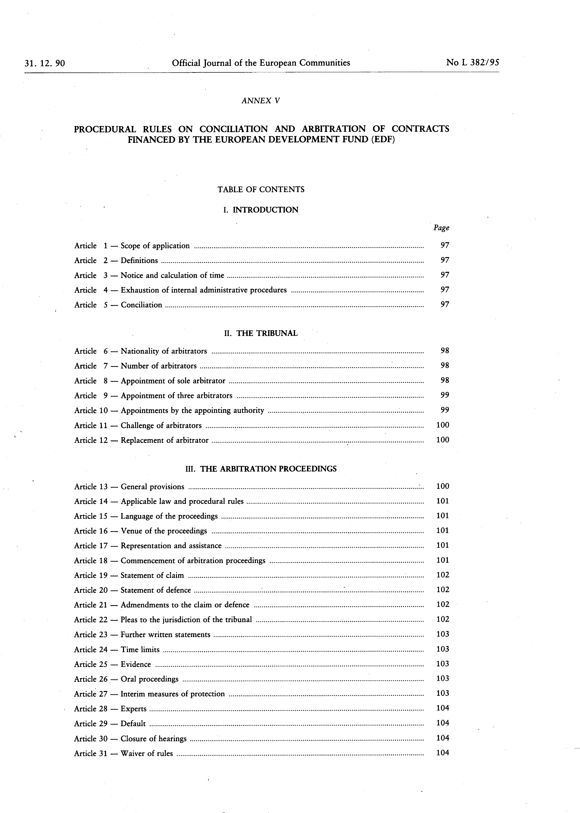

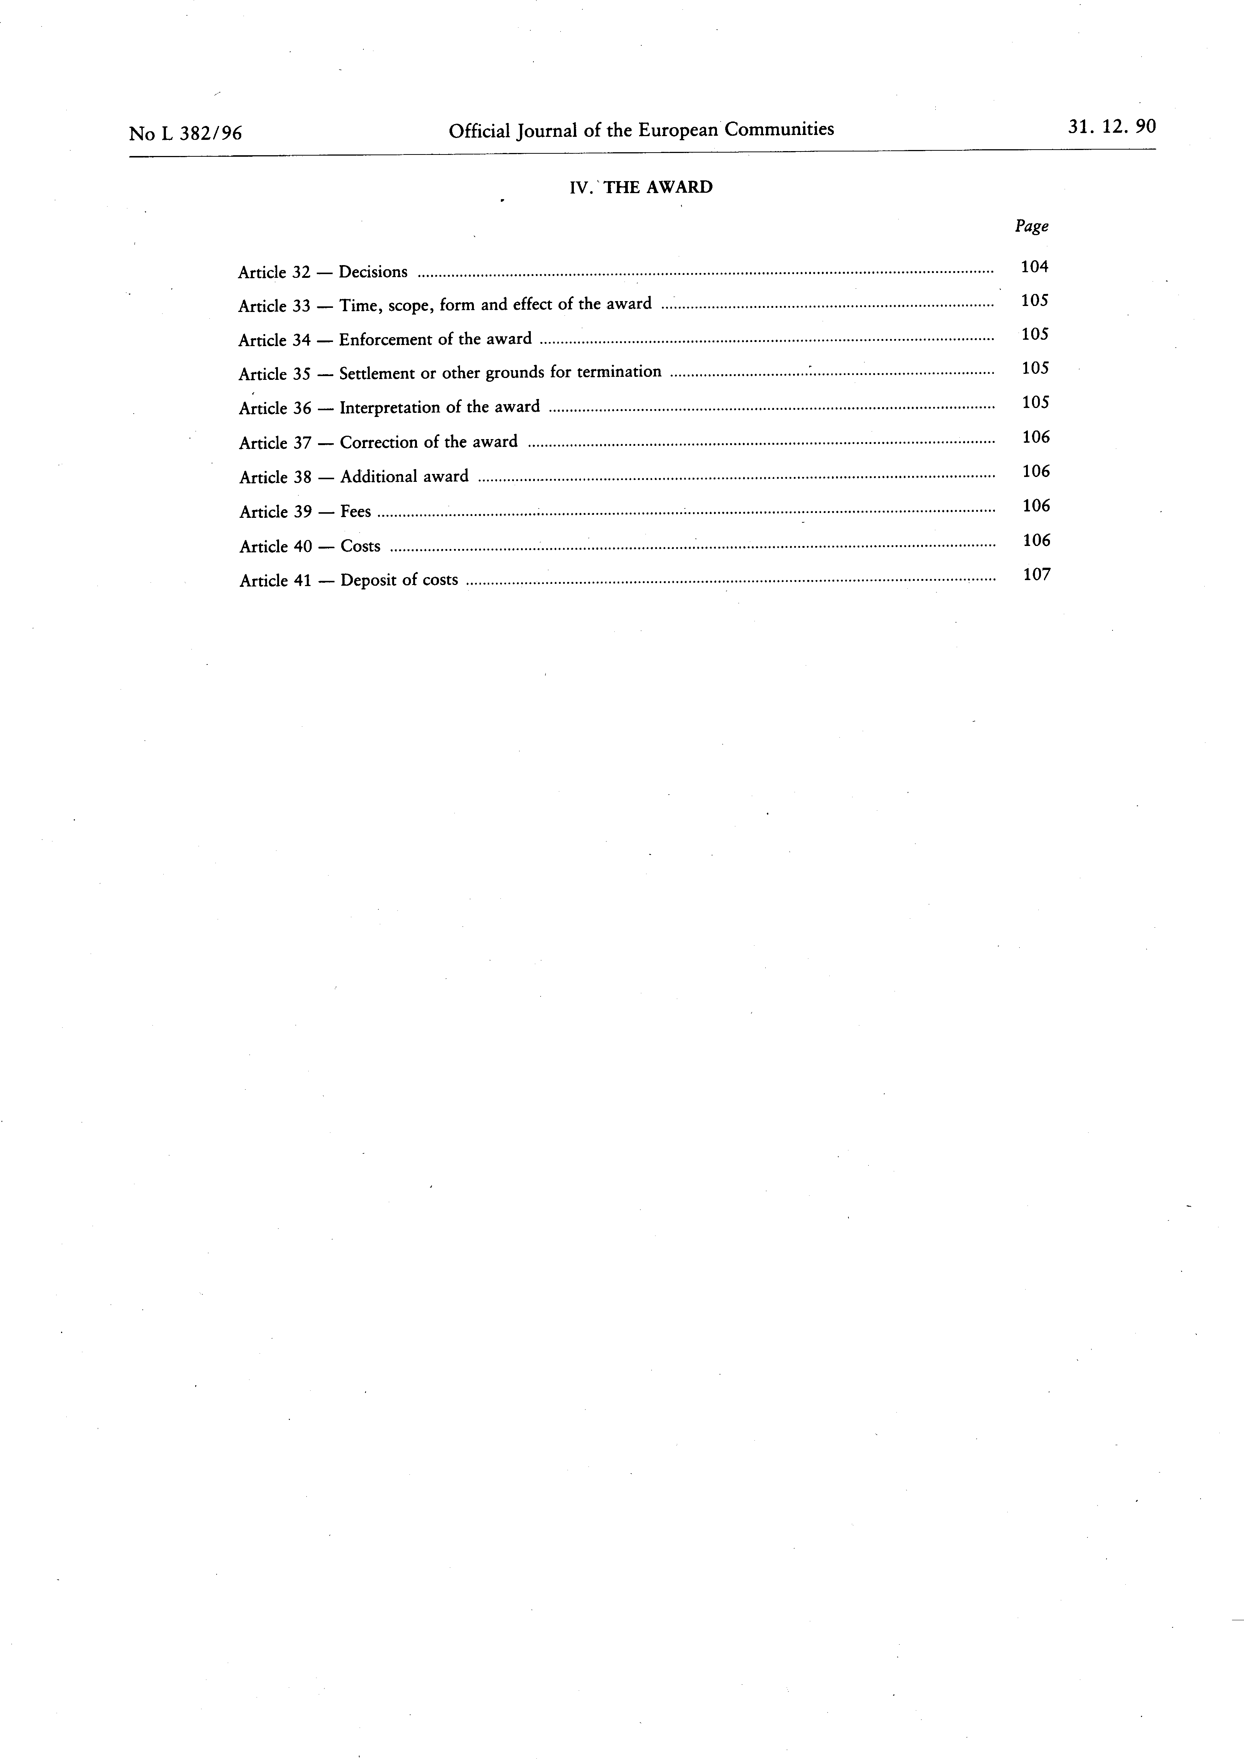

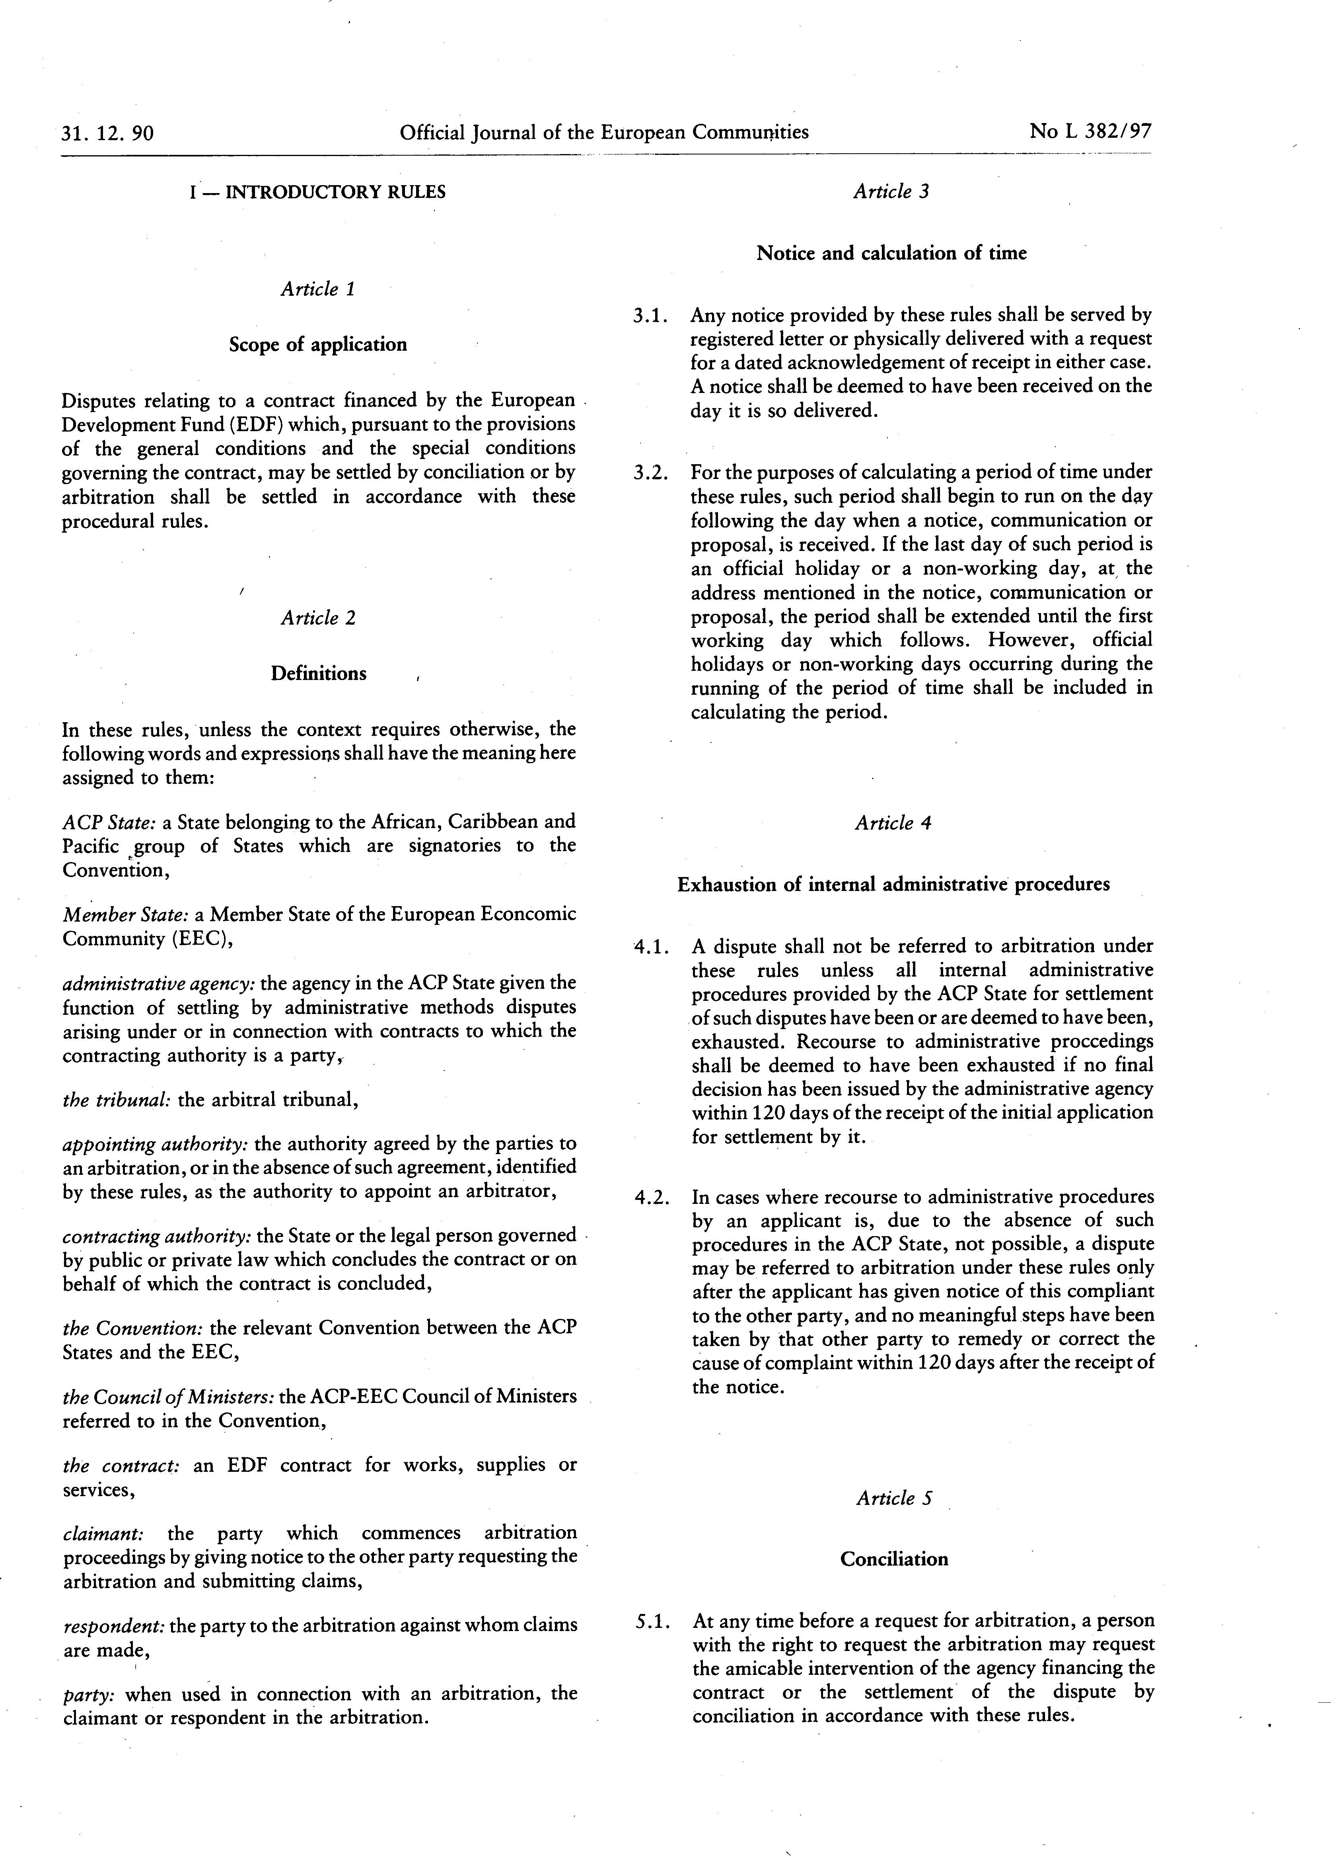

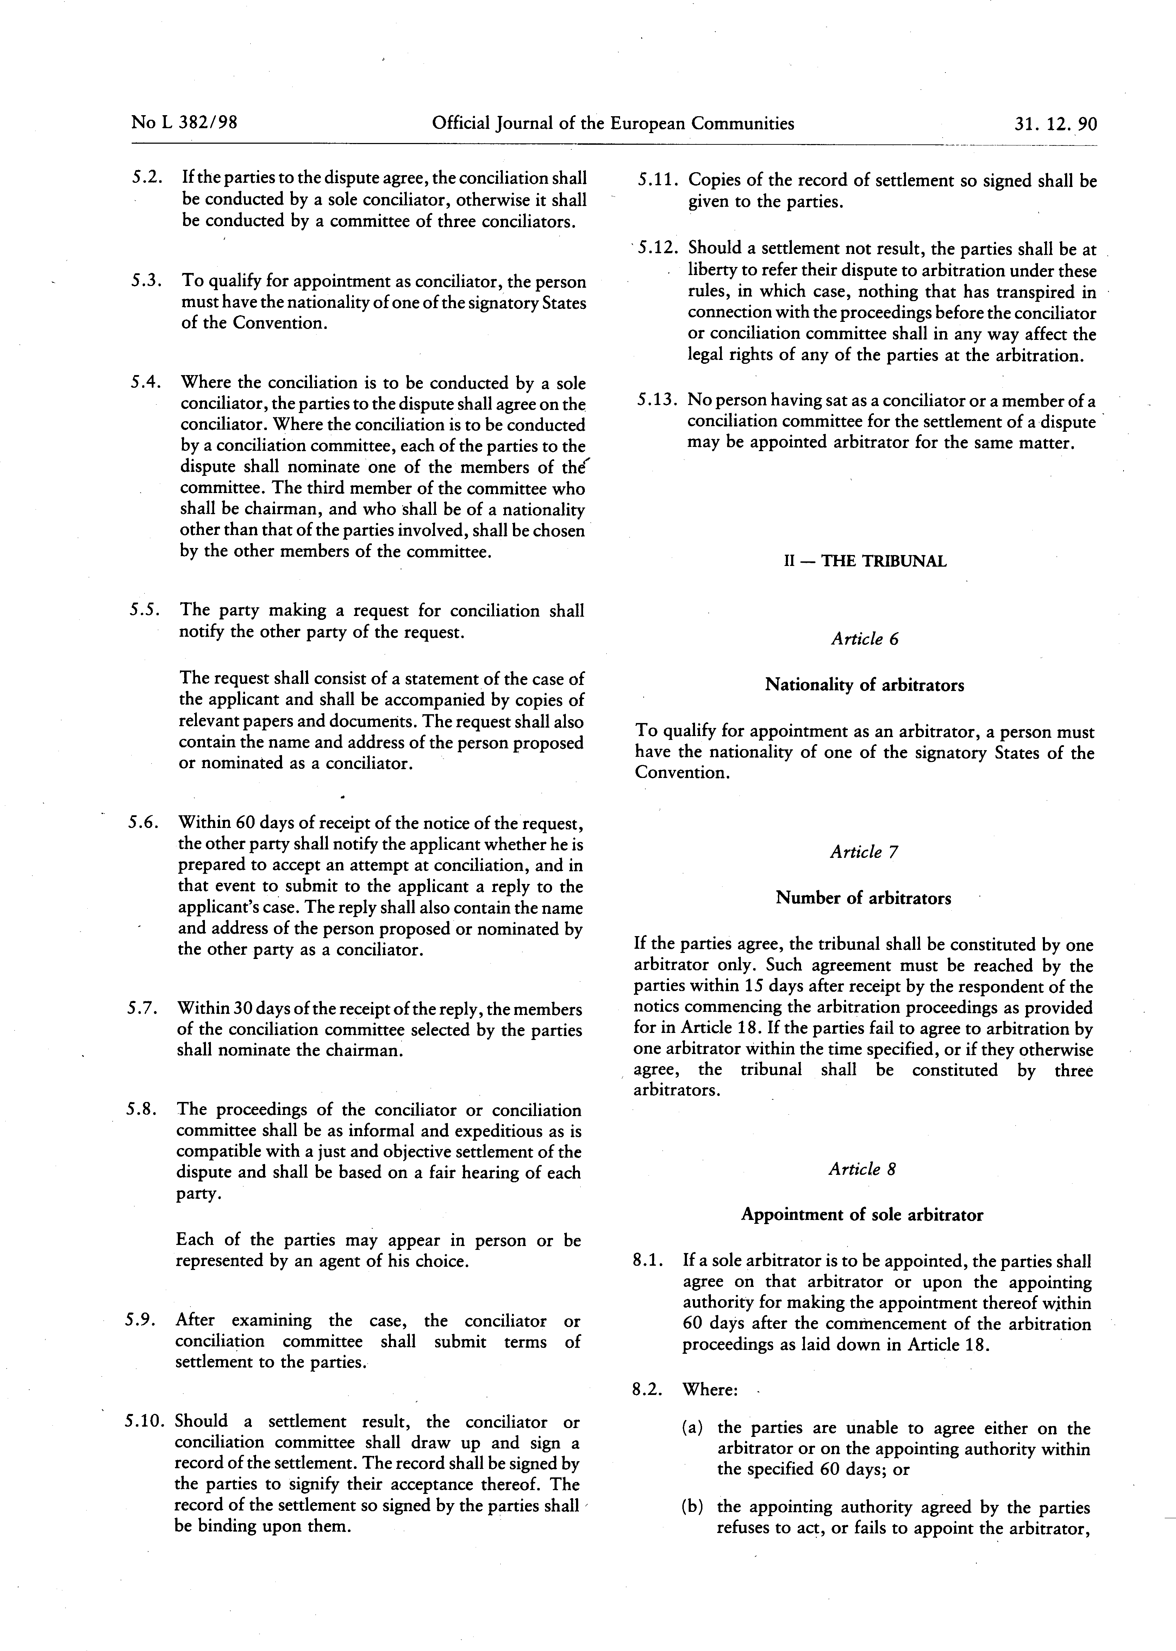

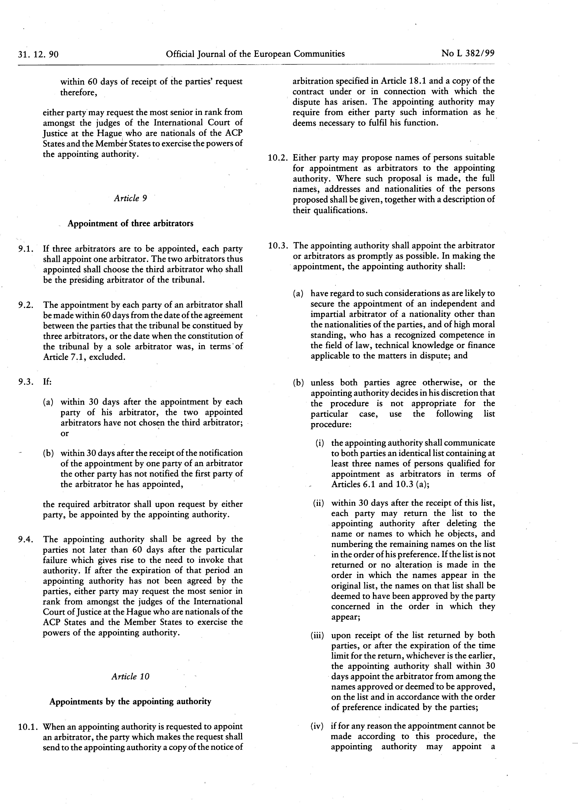

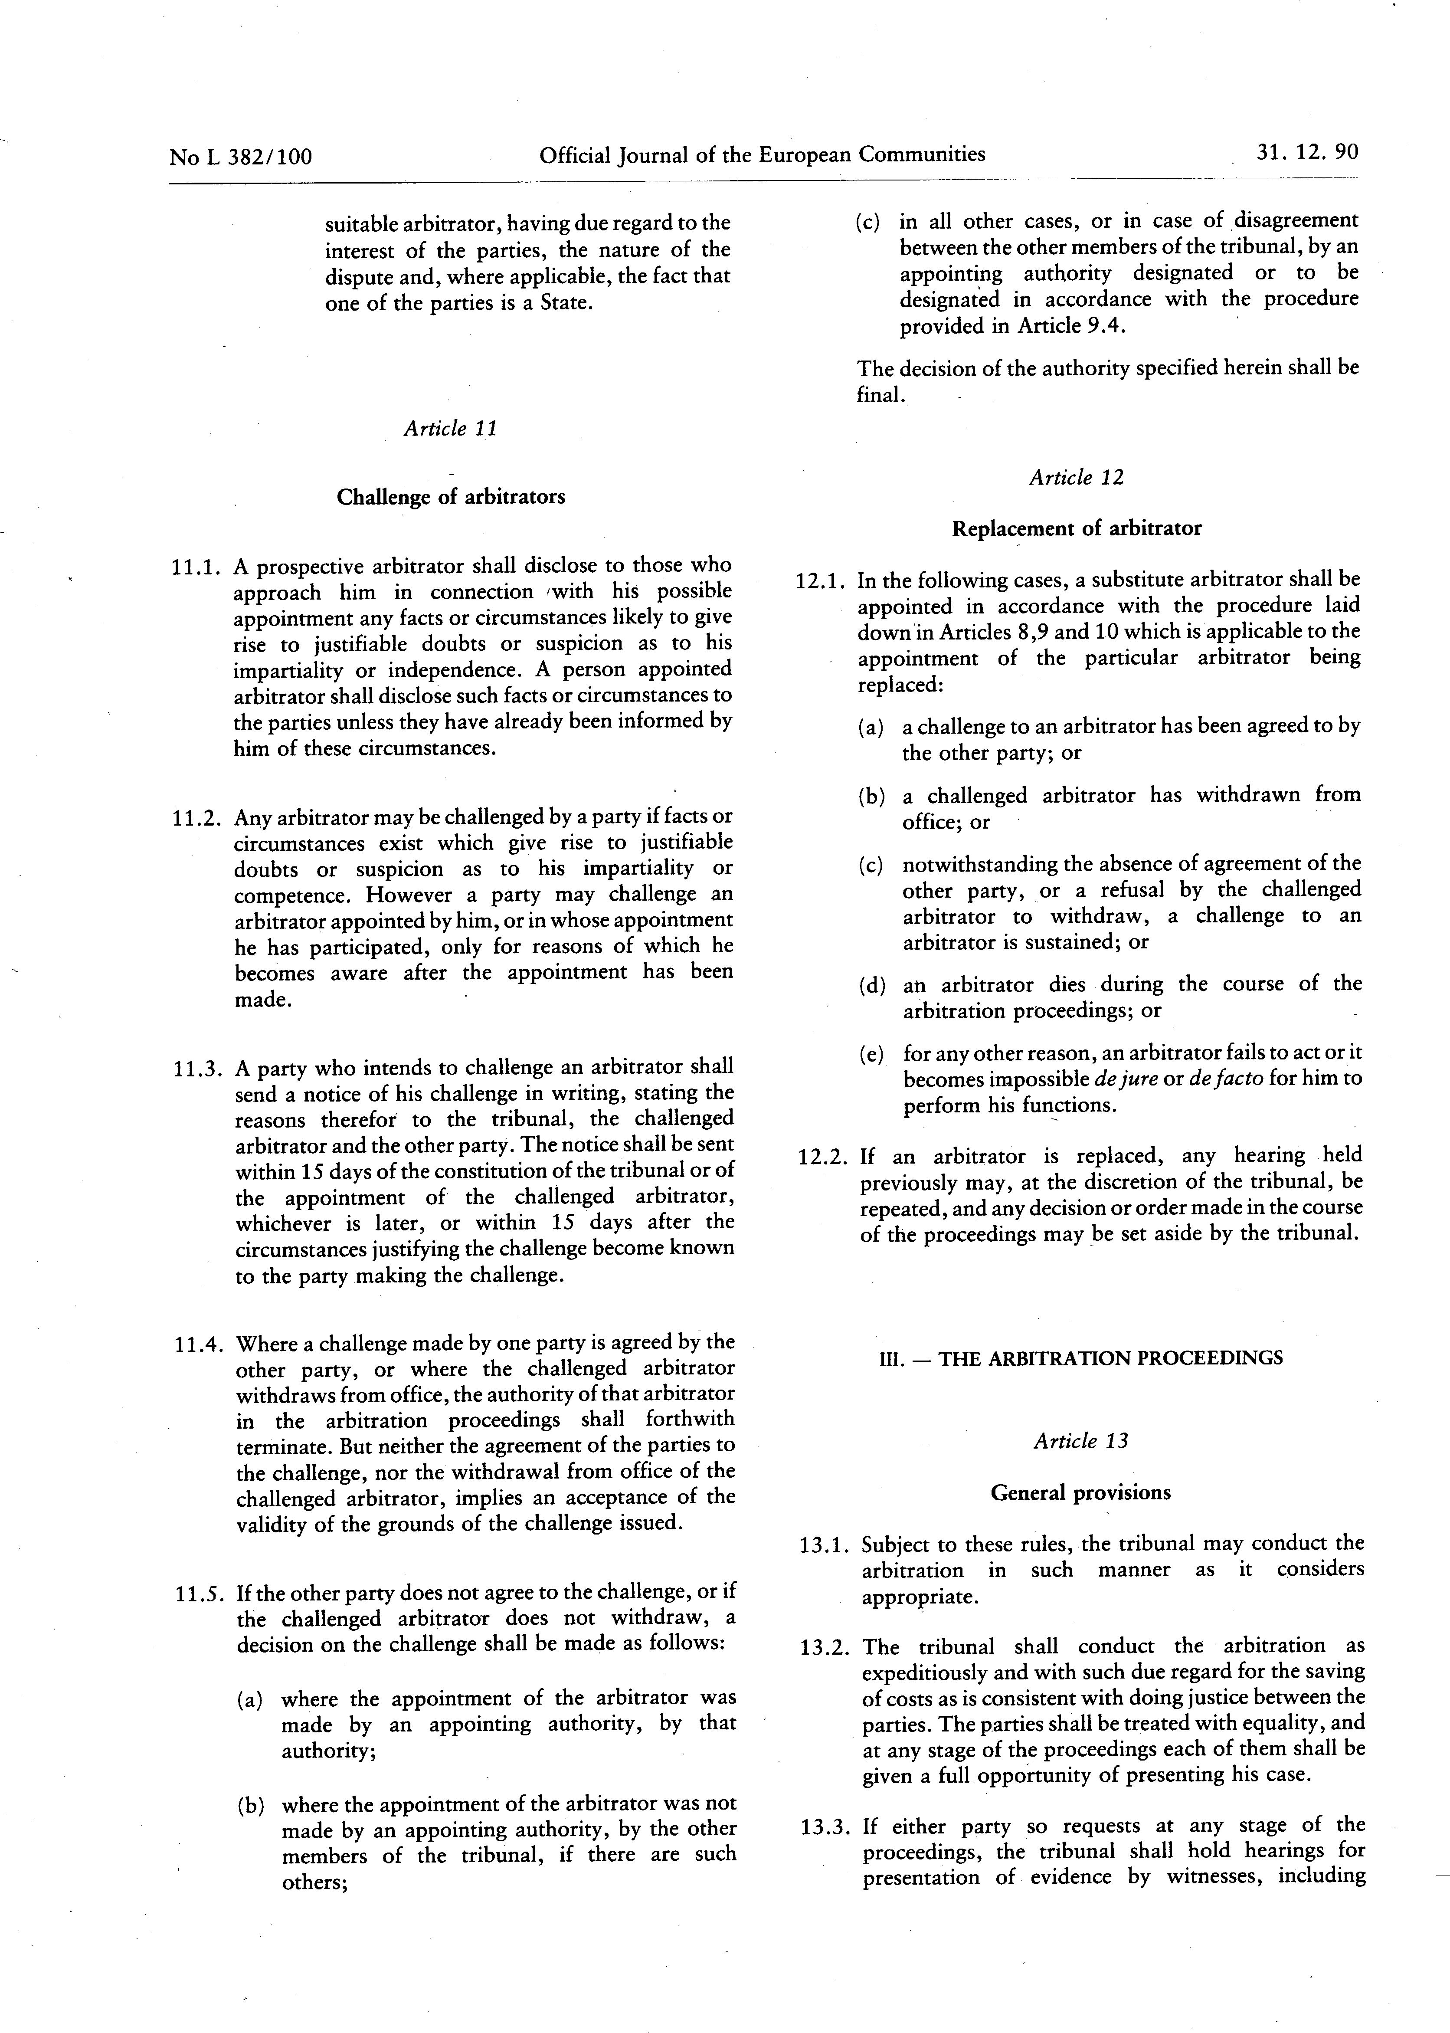

See PRAG Section 2.6.10.1.3 A)
The currency of tender shall be the currency of the contract and of payment
It is recommended to use registered mail in case the postmark would not be readable
The Common Procurement Vocabulary (CPV) is the mandatory reference nomenclature applicable to procurement contracts. The list of CPV codes is available on: http://simap.ted.europa.eu/en/web/simap/cpv
Where the contracting party is an individual.
Where applicable. For individuals, mention their ID card or passport or equivalent document – number.
Except where the contracting party is not VAT registered.
<DDP (Delivered Duty Paid)> - Incoterms 2020 International Chamber of Commerce - http://www.iccwbo.org/incoterms/
OJ L 205 of 21.11.2018, p. 39
If the tender has been submitted by a consortium, the nationalities of all the consortium members must be eligible.
Applicable only to contracts financed by a basic act under the MFF 2014-2020 (contracts/lots above EUR 100 000 under CIR and independently of the value for other instruments).
The selection criteria, in the previous section of this form, have to be met before the technical requirements are assessed.
Country in which the legal entity is registered.
Add/delete additional lines for members as appropriate. Note that a capacity providing entity/ subcontractor is not considered to be a member for the purposes of this tender procedure. Subsequently, the data on capacity providing entities/ subcontractor must not appear in the data related to the economic, financial and professional capacity but on a separate document. If this tender is being submitted by an individual tenderer, the name of the tenderer should be entered as ‘leader’ (and all other lines should be deleted).
Natural persons have to prove their capacity in accordance with the selection criteria and by the appropriate means.
If this tender form is submitted by a consortium, the data in the table above must be the sum of the data in the corresponding tables in the declarations provided by the consortium members — see point 7 of this tender form. Consolidated data are not requested for financial ratios.
Last year=last accounting year for which the entity's accounts have been closed.
Amounts entered in the ‘Average’ column must be the mathematical average of the amounts entered in the three preceding columns of the same row.
The gross inflow of economic benefits (cash, receivables, other assets) arising from the ordinary operating activities of the enterprise (such as sales of goods, sales of services, interest, royalties, and dividends) during the year.
A balance sheet account that represents the value of all assets that are reasonably expected to be converted into cash within one year in the normal course of business. Current assets include cash, accounts receivable, inventory, marketable securities, prepaid expenses and other liquid assets that can be readily converted to cash.
A company's debts or obligations that are due within one year. Current liabilities appear on the company's balance sheet and include short term debt, accounts payable, accrued liabilities and other debts.
If this tender is submitted by a consortium, the data in the table above must be the sum of the data in the corresponding tables in the declarations provided by the consortium members — see point 7 of this tender form. Consolidated data are not requested for financial ratios.
Corresponding to the relevant specialisms identified in point 5 below.
Personnel directly employed or contracted by the tenderer on a permanent basis (i.e. under indefinite contracts).
Other personnel directly employed or contracted by the tenderer on a non-permanent basis (i.e. under fixed-term contracts).
add/delete additional lines and/or rows as appropriate. If this tender is being submitted by an individual legal entity, the name of the legal entity should be entered as ‘Leader’ (and all other columns should be deleted).
References must be contracts implemented by the legal entity (or legal entities) submitting the-tender form (with the exception of documented cases of company buyout or universal succession). In the case of framework contracts (without contractual value), only specific contracts corresponding to assignments implemented under such framework contracts will be considered.
Amounts actually paid, without the effect of inflation.
The declaration under this point (2) is voluntary and it cannot have adverse legal effect on the economic operator until the conditions of Article 141(1) (a) FR are met.
Guidance on the verification of financial guarantees can be found in chapter 9.1 of the INTPA Companion. In indirect management, the contracting authority should seek guidance from the European Commission before accepting a financial guarantee.
This mention has to be inserted only where required, for example where the law applicable to the guarantee imposes a precise expiry date or where the guarantor can justify that he is unable to provide such a guarantee without expiry date.
The name(s) and position(s) of the persons signing on behalf of the guarantor must be shown in printed characters. Can be signed using a Qualified Electronic Signature (QES). Please note that only the qualified electronic signature (QES) within the meaning of Regulation (EU) No 910/2014 (eIDAS Regulation) will be accepted.
The name(s) and position(s) of the persons signing on behalf of the guarantor must be shown in printed characters. Can be signed using a Qualified Electronic Signature (QES). Please note that only the qualified electronic signature (QES) within the meaning of Regulation (EU) No 910/2014 (eIDAS Regulation) will be accepted.

